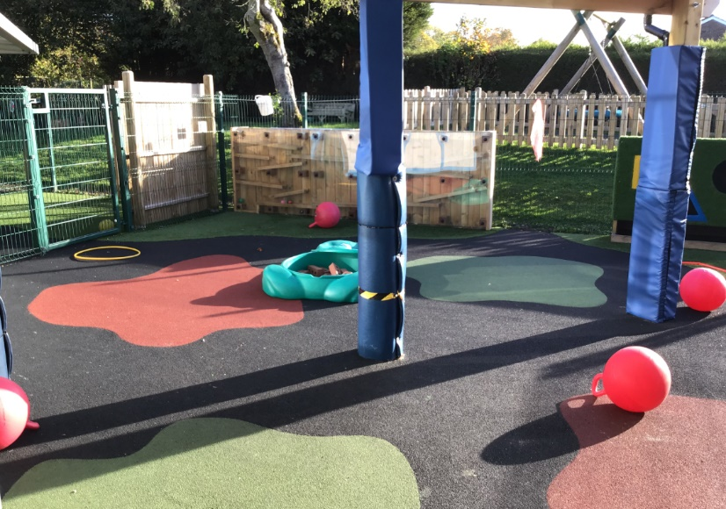
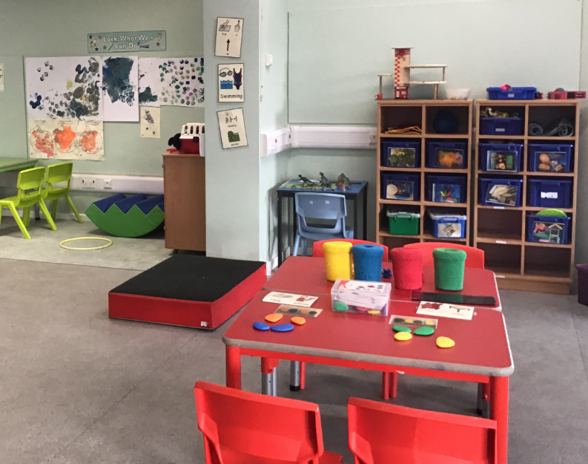
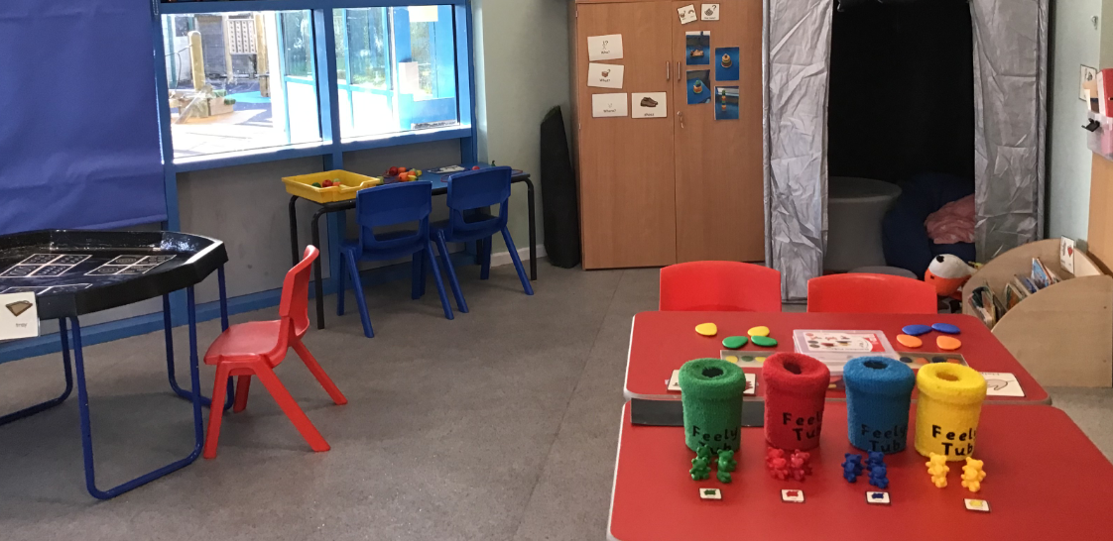
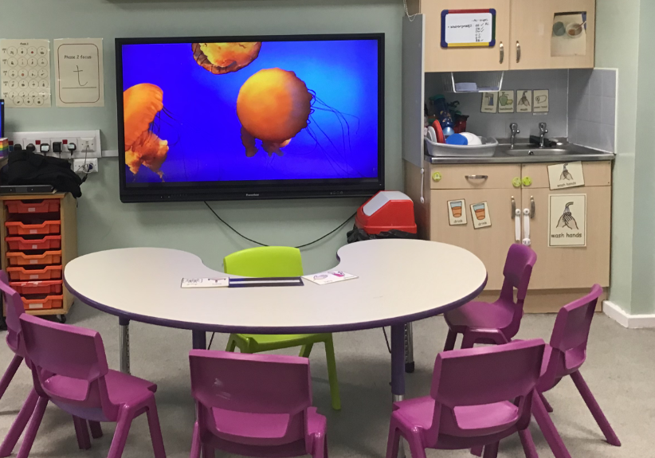
Welcome to Hedgehogs Classroom!

We have many learning areas including our group table, mark making table, work stations, choice areas and 1:1 activity tables.
We also have a reading area, a cosy den, and a sensory diet area within our classroom.
We share our playground with Butterflies class too

