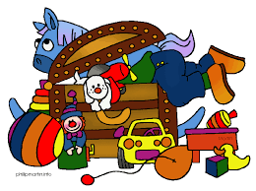
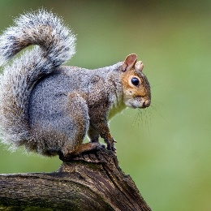
Squirrels Class Autumn 1 Homework
Topic – Toys

Here is a list of homework tasks to try. Children can do as many or as few as they can manage; the idea is that they try a task each week. It doesn’t matter if it is the same task.
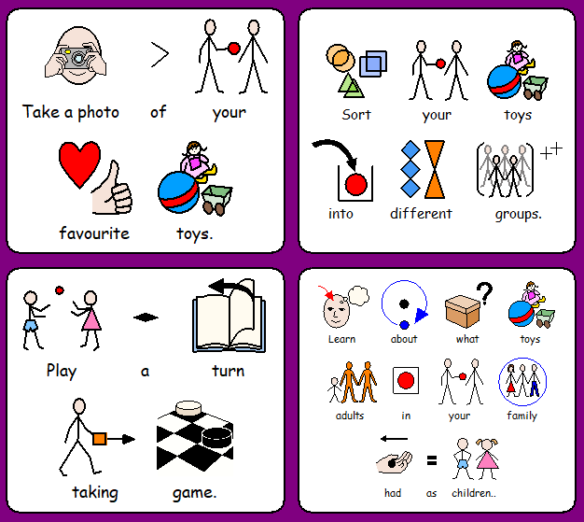
If you can send some photos or work in, we can celebrate it and display it in our classroom: squirrels@springfield.staffs.sch.uk
