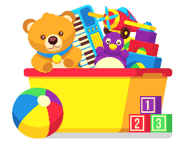
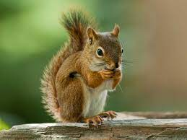
Squirrels Class Blog
Week Commencing 26th September 2022
Our topic this term is: Toys
Our focus book this week is: Toys in Space by Mini Grey

Monday | This morning we listened to our new book The Toys in Space and retold in English. In Maths we have been adding 1 more. In the afternoon we tested materials to find out if they were magnetic.
Tuesday | This morning we enjoyed swimming and well-being. After lunch we sorted toy by there age in topic and learned to ask “how are you?" in French.
Wednesday | This morning, in English we explored the front and back covers and their features. In the afternoon had P.E -indoor athletics. We also had a visit from some exotic animals to celebrate Animal Day.
Thursday | In English we matched labels to the book covers with a focus on the key features like title, author, and blurb. In Maths we continued to work on 1 more. In the afternoon in Art we created a digital art picture of our favourite toys.
Friday | Today we did our weekly phonics/spelling assessments and had 1:1 reading time. In the afternoon it was choice. Some of us were able to spend our Springfield pounds.

We also do phonics, mental maths and reading for pleasure each day.

Lucie and the Squirrels team

Our focus next week is: Diwali



