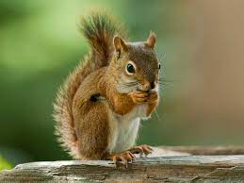
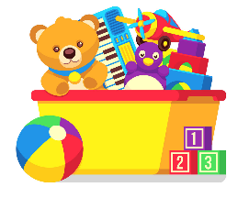
Squirrels Class Blog
Week Commencing 26th September 2022
Our topic this term is: Toys
Our focus book this week is: Traction Man by Mini Grey
Monday | This morning we went swimming in 2 groups – it was so much fun! Our new pool is great and so is the new mural on the wall. We practised getting in and out safely, floating like a starfish, walking across the pool and kicking our legs. The rest of us stayed in the classroom and we had wellbeing time plus 1:1 reading.  In the afternoon we did History – we explored some old fashion toys. We also did French, saying our names. “Je m’appelle Lucie!”
Tuesday | In English we practised our mark-making skills by following some super hero patterns or writing some superhero words. In Maths we compared numbers using weighing scales and number pebbles: greater than, less than or equal to. In the afternoon we practised our skipping skills in PE.
Wednesday | In English we thought about what our super power would be, then created a sentence using colourful semantics. In Maths we compared numbers by sticking stickers into our books and choosing which number the crocodile would eat (>, < or =).  In the afternoon we did some more PE – we practised our jumping and skipping skills.
Thursday | In English we wrote the sentence we created yesterday. In Maths we practised our greater than/less than/equal to skills using numbers, numicon or base ten. In the afternoon we did some Music – listening to and joining in with fast and slow beats. We then went to the sensory garden to make a collage of Traction Man.
Friday | This morning we did RE. We explored Hinduism and cut and stuck some pictures and words into our books. In the afternoon we had choice time: we played with toys and watched Toy Story.

We also do phonics, mental maths and reading for pleasure each day.

Our focus book next week is: Toys in Space by Mini Grey

