Squirrels Class Medium Term Planning for Art Spring Term 2024
Topic: Traditional Tales
- Artist – Kandinsky
- Swamp paintings inspired by Kandinsky shapes.
- Drawing – using chalk to blend colours

Lesson 1 – Link it  Use chalk as a familiar resource to mark make different shapes on black card. Introduce chalk blending. Save artwork or photos to link to next week’s session. | Lesson 2 – Learn it  Introduction to Kandinsky.  Cut and stick shapes to create own inspired artwork.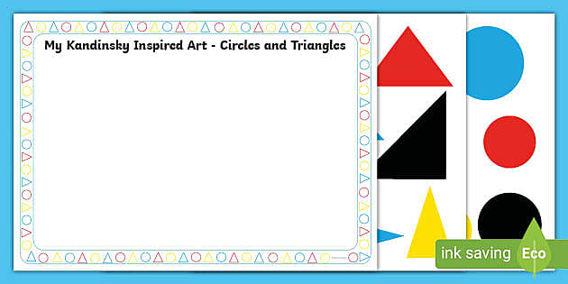 | Lesson 3 – Learn it  Further learning on Kandinsky.  Use paint to create ‘swamp’ circle artwork, using green and brown colours.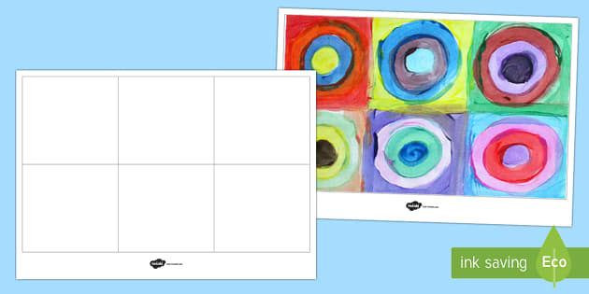 | Lesson 4 – Learn it  Further learning on Kandinsky.  Create inspired artwork. Draw lines with rulers and freehand then colour the spaces. Could use Microsoft paint on computer as an alternative media. | Lesson 5 – Show it/Know it  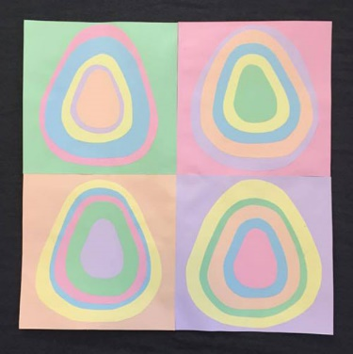  Create a Kandinsky inspired Easter card.

Substantive Knowledge (Content) | Disciplinary Knowledge (Skills)
Key stage 1  Pupils should be taught:  - to use a range of materials creatively to design and make products  - to use drawing, painting and sculpture to develop and share their ideas, experiences and imagination  - to develop a wide range of art and design techniques in using colour, pattern, texture,  - line, shape, form and space | EYFS - Expressive Arts and Design (Exploring and Using Media and Materials)  Children safely use and explore a variety of materials, tools and techniques, experimenting with colour, design, texture, form and function.  EYFS - Expressive Arts and Design (Being Imaginative)  Children use what they have learnt about media and materials in original ways, thinking about uses and purposes. They represent their own ideas, thoughts and feelings through design and technology, art, music, dance, role play and stories.  Work of Other Artists:  KS1  A describe the work of famous, notable artists and designers;  b express an opinion on the work of famous, notable artists;  c use inspiration from famous, notable artists to create their own work and compare  d use key vocabulary to demonstrate knowledge and understanding in this strand

