DRAFT

Springfield School

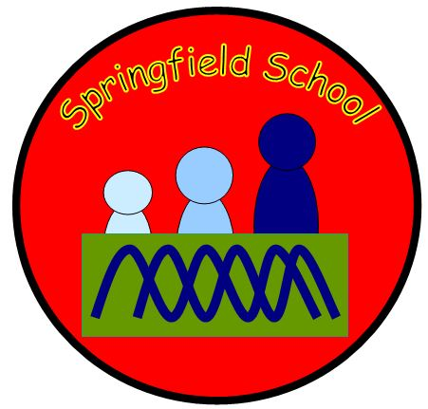

PE CURRICULUM DOCUMENT

This curriculum document has been designed to give you an overview of how PE is taught at Springfield School.

The PE curriculum overview document shows the range of activities that pupils will be taught throughout each group. It is up to the teacher in the year group/class as to how long they will spend on each activity area and this should be based on the physical the needs and interests of the pupils in that year group/class. Swimming is the exception to this as it will be taught as one of the two sessions of PE throughout the year.

The subject and generic concept tables give details to some of the main areas of focus we are hoping to develop through the PE curriculum. The coverage tables detail which of the subject and generic concepts will be highlighted and focussed on during which unit throughout the year groups. The times covered column – shows how many times each concept will be focused on throughout the planned PE curriculum.

The progression of skills table gives a breakdown of the EYFS and National Curriculum objectives that pupils will be working on in each year group. Although teachers will use and adjust this as fits the needs and abilities of pupils in their class.

The subject specific vocabulary and resource pages in this document act as a reminder to staff of the resources available to help the planning and delivery of individual sessions. All of these resources can be found on the staff shared area.

PE Curriculum Overview
Nursery | Rec | Year 1 | Year 2 | Year 3 | Year 4 | Year 5 | Year 6
Dance | Dance | Dance | Dance | Dance | Dance | Dance | Dance
Gymnastics | Gymnastics | Gymnastics | Gymnastics | Gymnastics | Gymnastics | Gymnastics | Gymnastics
Health & Fitness | Health & Fitness | Health & Fitness | Health & Fitness | Health & Fitness | Health & Fitness | Health & Fitness | Health & Fitness
Fundamental movement skills | Fundamental movement skills | Athletics (Indoor & outdoor) | Athletics (Indoor & outdoor) | Athletics (Indoor & outdoor) | Athletics (Indoor & outdoor) | Athletics (Indoor & outdoor) | Athletics (Indoor & outdoor)
 |  | Fundamental movement skills | Fundamental movement skills | Invasion Games (Football, netball, basketball, hockey, dodgeball, rugby) | Invasion Games  (Football, netball, basketball, hockey, dodgeball, rugby) | Invasion Games  (Football, netball, basketball, hockey, dodgeball, rugby) | Invasion Games  (Football, netball, basketball, hockey, dodgeball, rugby)
 |  | Games (playground games/ skipping games or introduction to certain sports) | Games (playground games/ skipping games or introduction to certain sports) | Striking & Fielding Games (Cricket & rounders) | Striking & Fielding Games (Cricket & rounders) | Striking & Fielding Games (Cricket & rounders) | Striking & Fielding Games (Cricket & rounders)
 |  |  |  | Net & Wall Games (tennis) | Net & Wall Games (tennis) | Net & Wall Games (tennis) | Net & Wall Games (tennis)
Water confidence sessions | Water confidence sessions | Water confidence sessions | Swimming | Swimming | Swimming | Swimming | Swimming
Yoga/ stretching | Yoga/ stretching | Yoga/ stretching | Yoga/ stretching | Yoga/ stretching | Yoga/ stretching | Yoga/ stretching | Yoga/ stretching
Forest school  activities | Forest school  activities | Forest school activities | Outdoor and adventurous activities/ forest school | Outdoor and adventurous activities/ forest school | Outdoor and adventurous activities/ forest school | Sports Leadership Award | Outdoor and adventurous residential
Enrichment Days

Parachute Games |  | Circus Skills |  | Bhangra Dance Project |  | Outdoor & adventurous residential
Whole School PE, Sport, Health themed weeks or initiatives

Mental Health awareness day |  | Sports Relief |  | School sports week |  | Olympics

It is an expectation that 2 sessions of PE are taught each week. One of these sessions will always be swimming for our pupils.
It is up to you when you deliver each unit - Please highlight in colours indicated below when each area has been covered: Colour code: Autumn – Blue Spring – Green Summer – Yellow
Notes: You do not have to teach each area at a certain time but must cover all areas over the year. Each year group has 2 half terms of dance and gymnastics which should provide a minimum of 12 hours for each area. Some year groups have a choice of game activities within their curriculum. They may choose to teach through a variety of different activities or through one activity they’d like to specialise in.

Subject Concepts
Subject concept |  | Definition | Times covered
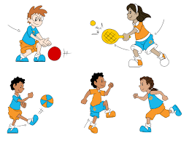 | Movement | Fundamental movement skills are the various gross motor skills such as running, jumping, balancing, throwing, catching, kicking etc. These skills are the basis for all physical activity that we do in sports, dance, gymnastics and other physical activities. It is important that these skills are learnt so that children feel confident in accessing all forms of sport and exercise. | 8
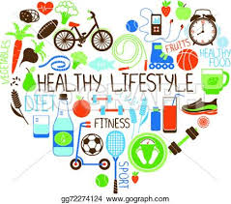 | Fitness & Health | Health means a person has good physical health, no injuries, diseases or issues, and good mental health and well being. ... Fitness is a state or condition of being physically active. Fitness is a result of general nutrition and proper conditioning, and fitness is a state of general physical and mental well-being. | 11
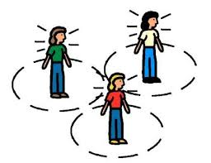 | Body & Spatial Awareness | Body awareness is the ability to understand where our bodies are in space and how our bodies move. Spatial awareness is the ability to be aware of oneself in space. It is an organised knowledge of objects in relation to oneself in that given space. Spatial awareness also involves understanding the relationship of these objects when there is a change of position. | 9
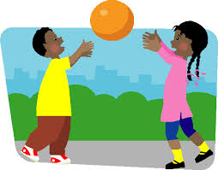 | Control | Object control skills can be defined as those abilities that an athlete displays that move or receive an item with accuracy and control. Manipulative skills are related and can be defined as the ability to move an object with the feet, hands, or even the body. The two terms are often referred to synonymously. | 7
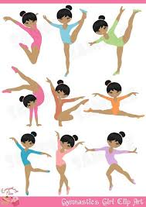 | Sequencing | The combination of fundamental movement skills and movement elements to enable the body and/or objects to move in response to a stimulus. | 5
 | Health & Safety | Health and safety refers to guidelines and procedures that protect the safety, welfare and health of any person engaged in work or employment. Pupils should understand and be actively involved in the health and safety procedures for PE. Ensuring these are followed correctly so they can help to prevent accidents and reduce the risk of injury and illness. | 7
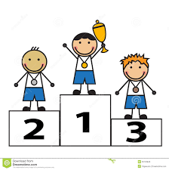 | Competition & performance | Pupils should have the opportunity to take part in a variety of events and competitions which allow them to understand and follow rules, experience the concept of winning and losing, being part of a team and trying their best. They should also have the opportunity to perform to an audience. | 6

Generic Concepts
Generic concept |  | Definition | Times examined
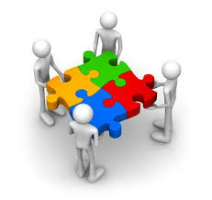 | Teamwork | Teamwork is the combined action and efforts of a group to make them effective and efficient. Pupils should experience being part of a team and playing their part in working towards a variety of goals and achievements. | 7
 | Communication | Communication is the imparting or exchanging of information by speaking, writing, or using some other medium. Pupils should be able to understand the importance of good communication to achieve desired outcomes. | 7
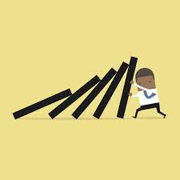 | Resilience | Resilience is the capacity to recover quickly from difficulties. Pupils should learn to persevere when problem solving, when trying to achieve a difficult goal or when faced with adversity. | 8
 | Organisation | Organisation means to arrange systematically, to order, to make arrangements or preparations for (an event or activity). Pupils should learn to be able to organise themselves for the events and activities they are going to take part in. They should also have knowledge of organising equipment and materials necessary to undertake the activities. | 7
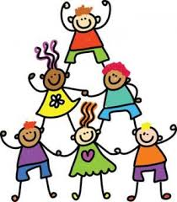 | Co-operation | Co-operation is the action or process of working together to the same end. Pupils should be able to co-operate in various ways on different tasks and activities. | 8
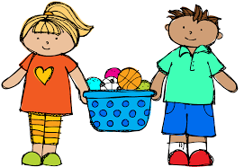 | Fairness | Fairness is the ability to be impartial and just in the treatment or behaviour towards others without favouritism or discrimination. Pupils should learn to involve everyone in activities, to encourage each other and to keep to any rules of games. | 7
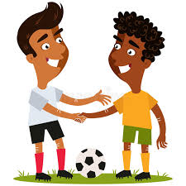 | Respect | Respect is showing due regard for the feelings, wishes, or rights of others. Pupils should show respect for themselves, each other and adults and demonstrate this in the activities they are part of. | 7

Coverage of Subject & Generic Concepts
Nursery
Dance
movement | fitness& health | awareness | control | sequencing | health& safety | comp/ perform
teamwork | communication | resilience | organisation | cooperation | fairness | respect
Gymnastics/ Yoga/ Stretching
movement | fitness& health | awareness | control | sequencing | health& safety | comp/ perform
teamwork | communication | resilience | organisation | cooperation | fairness | respect
Health & Fitness
movement | fitness& health | awareness | control | sequencing | health& safety | comp/ perform
teamwork | communication | resilience | organisation | cooperation | fairness | respect
Fundamental Movement Skills
movement | fitness& health | awareness | control | sequencing | health& safety | comp/ perform
teamwork | communication | resilience | organisation | cooperation | fairness | respect
Water Confidence Sessions
movement | fitness& health | awareness | control | sequencing | health& safety | comp/ perform
teamwork | communication | resilience | organisation | cooperation | fairness | respect
Forest School Activities
movement | fitness& health | awareness | control | sequencing | health& safety | comp/ perform
teamwork | communication | resilience | organisation | cooperation | fairness | respect

Reception
Dance
movement | fitness& health | awareness | control | sequencing | health& safety | comp/ perform
teamwork | communication | resilience | organisation | Cooperation | fairness | respect
Gymnastics/ Yoga/ Stretching
movement | fitness& health | awareness | control | sequencing | health& safety | comp/ perform
teamwork | communication | resilience | organisation | Cooperation | fairness | respect
Health & Fitness
movement | fitness& health | awareness | control | sequencing | health& safety | comp/ perform
teamwork | communication | resilience | organisation | Cooperation | fairness | respect
Fundamental Movement Skills
movement | fitness& health | awareness | control | sequencing | health& safety | comp/ perform
teamwork | communication | resilience | organisation | Cooperation | fairness | respect
Water Confidence Sessions
movement | fitness& health | awareness | control | sequencing | health& safety | comp/ perform
teamwork | communication | resilience | organisation | Cooperation | fairness | respect
Forest School Activities
movement | fitness& health | awareness | control | sequencing | health& safety | comp/ perform
teamwork | communication | resilience | organisation | Cooperation | fairness | respect

Year 1
Dance
movement | fitness& health | awareness | control | sequencing | health& safety | comp/ perform
teamwork | communication | resilience | organisation | Cooperation | fairness | respect
Gymnastics/ Yoga/ Stretching
movement | fitness& health | awareness | control | sequencing | health& safety | comp/ perform
teamwork | communication | resilience | organisation | Cooperation | fairness | respect
Health & Fitness
movement | fitness& health | awareness | control | sequencing | health& safety | comp/ perform
teamwork | communication | resilience | organisation | Cooperation | fairness | respect
Fundamental Movement Skills/ Games/ Athletics
movement | fitness& health | awareness | control | sequencing | health& safety | comp/ perform
teamwork | communication | resilience | organisation | Cooperation | fairness | respect
Water Confidence Sessions
movement | fitness& health | awareness | control | sequencing | health& safety | comp/ perform
teamwork | communication | resilience | organisation | Cooperation | fairness | respect
Forest School Activities
movement | fitness& health | awareness | control | sequencing | health& safety | comp/ perform
teamwork | communication | resilience | organisation | Cooperation | fairness | respect

Year 2
Dance
movement | fitness& health | awareness | control | sequencing | health& safety | comp/ perform
teamwork | communication | resilience | organisation | Cooperation | fairness | respect
Gymnastics/ Yoga/ Stretching
movement | fitness& health | awareness | control | sequencing | health& safety | comp/ perform
teamwork | communication | resilience | organisation | Cooperation | fairness | respect
Health & Fitness
movement | fitness& health | awareness | control | sequencing | health& safety | comp/ perform
teamwork | communication | resilience | organisation | Cooperation | fairness | respect
Fundamental Movement Skills/ Games/ Athletics
movement | fitness& health | awareness | control | sequencing | health& safety | comp/ perform
teamwork | communication | resilience | organisation | Cooperation | fairness | respect
Swimming
movement | fitness& health | awareness | control | sequencing | health& safety | comp/ perform
teamwork | communication | resilience | organisation | Cooperation | fairness | respect
Outdoor and Adventurous/ Forest School Activities
movement | fitness& health | awareness | control | sequencing | health& safety | comp/ perform
teamwork | communication | resilience | organisation | Cooperation | fairness | respect

Year 3
Dance
movement | fitness& health | awareness | control | sequencing | health& safety | comp/ perform
teamwork | communication | resilience | organisation | Cooperation | fairness | respect
Gymnastics/ Yoga/ Stretching
movement | fitness& health | awareness | control | sequencing | health& safety | comp/ perform
teamwork | communication | resilience | organisation | Cooperation | fairness | respect
Health & Fitness
movement | fitness& health | awareness | control | sequencing | health& safety | comp/ perform
teamwork | communication | resilience | organisation | Cooperation | fairness | respect
Athletics
movement | fitness& health | awareness | control | sequencing | health& safety | comp/ perform
teamwork | communication | resilience | organisation | Cooperation | fairness | respect
Invasion/ Net & Wall/ Striking & Fielding Games
movement | fitness& health | awareness | control | sequencing | health& safety | comp/ perform
teamwork | communication | resilience | organisation | Cooperation | fairness | respect
Swimming
movement | fitness& health | awareness | control | sequencing | health& safety | comp/ perform
teamwork | communication | resilience | organisation | Cooperation | fairness | respect
Outdoor and Adventurous/ Forest School Activities
movement | fitness& health | awareness | control | sequencing | health& safety | comp/ perform
teamwork | communication | resilience | organisation | Cooperation | fairness | respect

Year 4
Dance
movement | fitness& health | awareness | control | sequencing | health& safety | comp/ perform
teamwork | communication | resilience | organisation | Cooperation | fairness | respect
Gymnastics/ Yoga/ Stretching
movement | fitness& health | awareness | control | sequencing | health& safety | comp/ perform
teamwork | communication | resilience | organisation | Cooperation | fairness | respect
Health & Fitness
movement | fitness& health | awareness | control | sequencing | health& safety | comp/ perform
teamwork | communication | resilience | organisation | Cooperation | fairness | respect
Athletics
movement | fitness& health | awareness | control | sequencing | health& safety | comp/ perform
teamwork | communication | resilience | organisation | Cooperation | fairness | respect

Year 4
Invasion/ Net & Wall/ Striking & Fielding Games
movement | fitness& health | awareness | control | sequencing | health& safety | comp/ perform
teamwork | communication | resilience | organisation | Cooperation | fairness | respect
Swimming
movement | fitness& health | awareness | control | sequencing | health& safety | comp/ perform
teamwork | communication | resilience | organisation | Cooperation | fairness | respect
Outdoor and Adventurous/ Forest School Activities
movement | fitness& health | awareness | control | sequencing | health& safety | comp/ perform
teamwork | communication | resilience | organisation | Cooperation | fairness | respect

Year 5
Dance
movement | fitness& health | awareness | control | sequencing | health& safety | comp/ perform
teamwork | communication | resilience | organisation | Cooperation | fairness | respect
Gymnastics/ Yoga/ Stretching
movement | fitness& health | awareness | control | sequencing | health& safety | comp/ perform
teamwork | communication | resilience | organisation | Cooperation | fairness | respect
Health & Fitness
movement | fitness& health | awareness | control | sequencing | health& safety | comp/ perform
teamwork | communication | resilience | organisation | Cooperation | fairness | respect
Athletics
movement | fitness& health | awareness | control | sequencing | health& safety | comp/ perform
teamwork | communication | resilience | organisation | Cooperation | fairness | respect
Invasion/ Net & Wall/ Striking & Fielding Games
movement | fitness& health | awareness | control | sequencing | health& safety | comp/ perform
teamwork | communication | resilience | organisation | Cooperation | fairness | respect
Swimming
movement | fitness& health | awareness | control | sequencing | health& safety | comp/ perform
teamwork | communication | resilience | organisation | Cooperation | fairness | respect
Leadership
movement | fitness& health | awareness | control | sequencing | health& safety | comp/ perform
teamwork | communication | resilience | organisation | Cooperation | fairness | respect

Year 6
Dance
movement | fitness& health | awareness | control | sequencing | health& safety | comp/ perform
teamwork | communication | resilience | organisation | Cooperation | fairness | respect
Gymnastics/ Yoga/ Stretching
movement | fitness& health | awareness | control | sequencing | health& safety | comp/ perform
teamwork | communication | resilience | organisation | Cooperation | fairness | respect
Health & Fitness
movement | fitness& health | awareness | control | sequencing | health& safety | comp/ perform
teamwork | communication | resilience | organisation | Cooperation | fairness | respect
Athletics
movement | fitness& health | awareness | control | sequencing | health& safety | comp/ perform
teamwork | communication | resilience | organisation | Cooperation | fairness | respect
Invasion/ Net & Wall/ Striking & Fielding Games
movement | fitness& health | awareness | control | sequencing | health& safety | comp/ perform
teamwork | communication | resilience | organisation | Cooperation | fairness | respect
Swimming
movement | fitness& health | awareness | control | sequencing | health& safety | comp/ perform
teamwork | communication | resilience | organisation | Cooperation | fairness | respect
Outdoor and Adventurous/ Forest School Activities
movement | fitness& health | awareness | control | sequencing | health& safety | comp/ perform
teamwork | communication | resilience | organisation | Cooperation | fairness | respect

Progression of skills

Year group | Key Skills | National Curriculum
Nursery | - Moves freely and with pleasure and confidence in a range of ways, such as slithering, shuffling, rolling, crawling, walking, running, jumping, skipping, sliding and hopping.  - Mounts stairs, steps or climbing equipment using alternate feet.  - Walks downstairs, two feet to each step while carrying a small object.  - Runs skilfully and negotiates space successfully, adjusting speed or direction to avoid obstacles.  - Can stand momentarily on one foot when shown.  - Can catch a large ball.  - Draws lines and circles using gross motor movements.  - Can tell adults when hungry or tired or when they want to rest or play.  - Observes the effects of activity on their bodies.  - Understands that equipment and tools have to be used safely.  - Can usually manage washing and drying hands.  - Dresses with help, e.g. puts arms into open-fronted coat or shirt when held up, pulls up own trousers, and pulls up zipper once it is fastened at the bottom. | Early Learning Goals  Children show good control and co-ordination in large and small movements. They move confidently in a range of ways, safely negotiating space. They handle equipment and tools effectively, including pencils for writing.  Children know the importance for good health of physical exercise, and a healthy diet, and talk about ways to keep healthy and safe. They manage their own basic hygiene and personal needs successfully, including dressing and going to the toilet independently.
Reception | - Experiments with different ways of moving.  - Jumps off an object and lands appropriately.  - Negotiates space successfully when playing racing and chasing games with other children, adjusting speed or changing direction to avoid obstacles.  - Travels with confidence and skill around, under, over and through balancing and climbing equipment.  - Shows increasing control over an object in pushing, patting, throwing, catching or kicking it.  - Uses simple tools to effect changes to materials.  - Handles tools, objects, construction and malleable materials safely and with increasing control.  - Shows a preference for a dominant hand.  - Eats a healthy range of foodstuffs and understands need for variety in food.  - Shows some understanding that good practices with regard to exercise, eating, sleeping and hygiene can contribute to good health.  - Shows understanding of the need for safety when tackling new challenges, and considers and manages some risks.  - Shows understanding of how to transport and store equipment safely.  - Practices some appropriate safety measures without direct supervision.
Year 1 | - Manage space safely showing good awareness of each other.  - Perform basic gymnastics actions including travelling, rolling, jumping, climbing and balancing.  - Copy and explore basic body actions and movement patterns.  - Show some control and accuracy with the basic actions for rolling, underarm throwing, striking a ball and kicking.  - Describe own and others performance  - React to a range of stimuli  - Sustain effort throughout lesson  - Respectful of each other and equipment  - Engaged and on task throughout lessons | Master basic movements including running, jumping, throwing and catching, as well as developing balance, agility and co-ordination, and begin to apply these in a range of activities  Participate in team games, developing simple tactics for attacking and defending  Perform dances using simple movement patterns.
Year 2 | - Devise and repeat and perform short sequences in which there is a clear beginning, middle and end.  - Explore ideas moves and feelings by improvising and experimenting with actions in response to stimuli.  - Show a good awareness of others in running, chasing and avoiding games.  - Know how to score and keep to rules of simple games.  - Sustain energy levels  - Compare performances
Year 3 | - Show control, accuracy and fluency of movement when performing actions on their own and with a partner on both floor and apparatus.  - Perform short dances whilst working with a partner or small group, incorporating different qualities and dynamics into their movements.  - Pass receive and dribble the ball keeping control of possession.  - Strike a ball with intent and throw it more accurately when bowling or fielding.  - Are familiar with and use set rules and play fairly within these.  - Run consistently and smoothly at different speeds, demonstrating different combinations of jumps, showing control and co-ordination.  - Throw a range of implements into a target.  - OAA Understand the purpose of the activity and plan actions to solve the problems they are set.  - Compare performances  - Assist in leading small groups in activities  - Respond to a range stimuli  - Sustain energy levels  - Be determined to improve performance | Use running, jumping, throwing and catching in isolation and in combination  Play competitive games, modified where appropriate [for example, badminton, basketball, cricket, football, hockey, netball, rounders and tennis], and apply basic principles suitable for attacking and defending  Develop flexibility, strength, technique, control and balance [for example, through athletics and gymnastics]  Perform dances using a range of movement patterns  Take part in outdoor and adventurous activity challenges both individually and within a team  Compare their performances with previous ones and demonstrate improvement to achieve their personal best.
Year 4 | - Combine travelling, rolling, jumping and balancing actions and maintain the quality of performance when performing at the same time as a partner on both floor and apparatus.  - Use different compositional ideas such as unison, canon (same action performed one after each other), opposition when creating longer, more complex dance phrases.  - Continue to pass receive and dribble the ball keeping control of possession with greater accuracy.  - Choose and use batting and throwing skills to make the game hard for their opponents.  - Work well as a team to make it hard for the batter beginning to think about tactics to work as a team.  - Swimming – see standards.  - Run consistently and smoothly at different speeds, demonstrating different combinations of jumps, showing control and co-ordination.  - Recognise that there are different styles of running, jumping and throwing and select the best for a particular challenge.  - Throw a range of implements into a target.  - Work with determination and sustain effort and energy levels  - Describe and evaluate the effectiveness and quality of performance  - Recognise aspects of performance that require improving
Year 5 | - Repeat accurately longer sequences with more complex actions, with an emphasis on quality of movement.  - Adapt sequences to include apparatus, partner or small group work.  - Perform specific skills and movement patterns for different dance styles.  - Respond consistently in the games they play, selecting and applying skills which meet the needs of the situation.  - Use a variety of tactics to keep the ball e.g. changing speed and direction.  - Develop methods of defending their goal for example marking the opposition and positional awareness.  - Sustain their pace over longer distances, throwing and jumping with greater control and accuracy.  - Be able to perform basic relay changeovers  - Devise and carry out small group warm ups.  - Judge the strengths and weaknesses of performance and be able to make changes that improve their team and or individual performance  - Work persistently to achieve desired outcomes
Year 6 | - Increase complexity of sequences by varying directions, levels and pathways.  - Perform fluently with control when working individually, with a partner or a small group.  - Select and use a range of compositional ideas to create motifs that demonstrate their dance idea.  - Begin to choose and use different formations to suit the needs of a game.  - Plan to outwit the opposition individually, as a pair or as a team when batting, bowling or fielding.  - Hit the ball with purpose, varying the speed, height and direction in order to outwit their opponent.  - Sustain their pace over longer distances, throwing and jumping with greater control and accuracy.  - Use physical and teamwork skills well in a variety of different challenges.  - Use a variety of maps and plans accurately recognising symbols and features.  - Take the lead when devising and delivering group warm ups and skill development drills  - Watch own and others performances and suggest improvements for specific purposes.

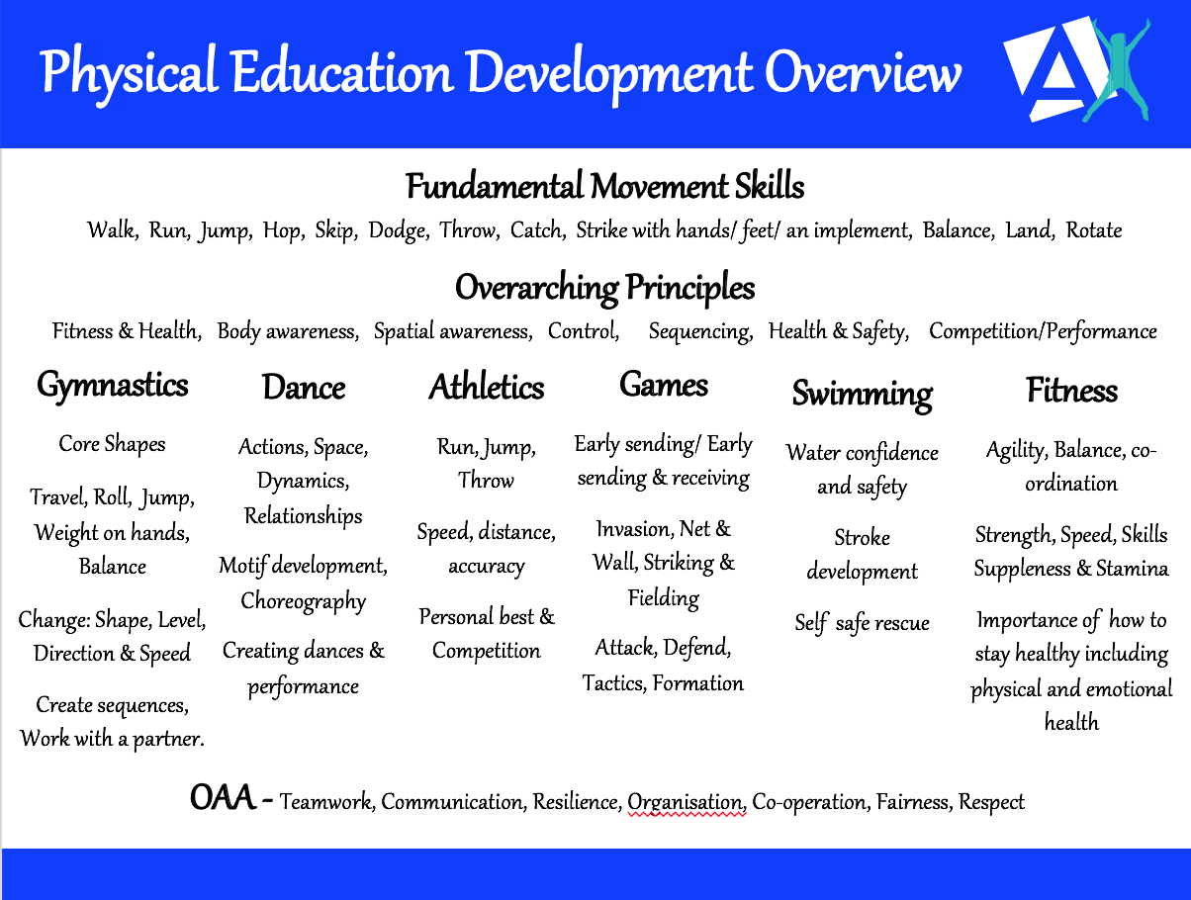

Subject Specific Vocabulary

Gymnastics

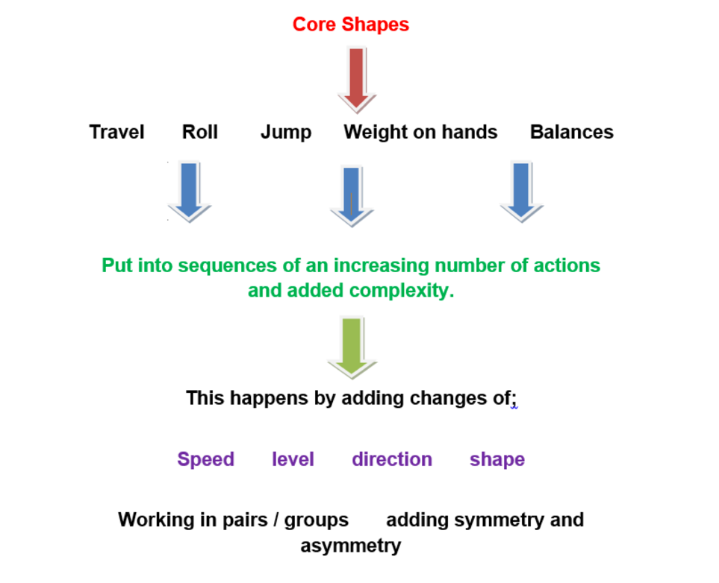

Dance
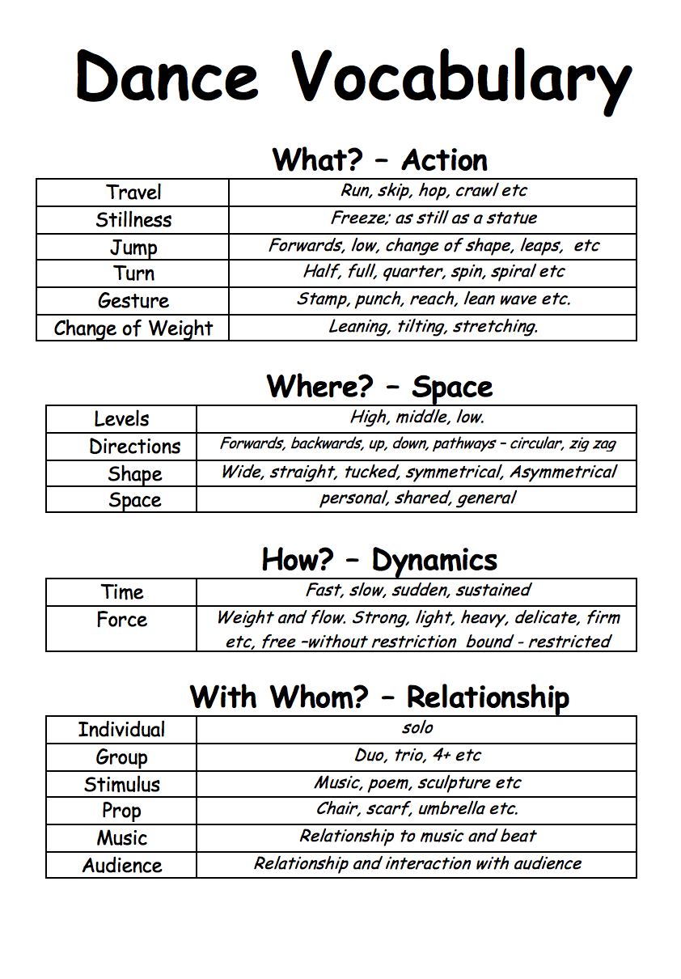

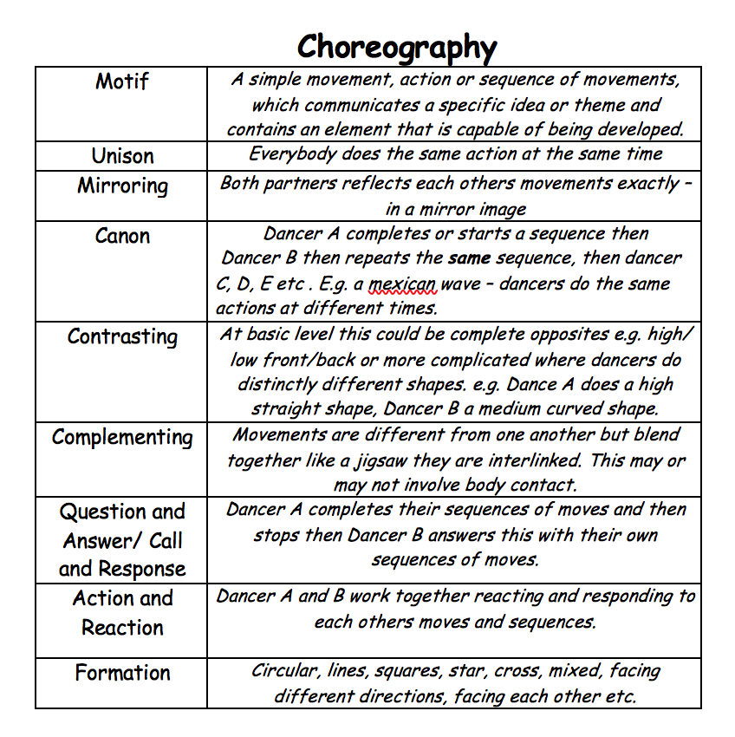

Useful Resources to Support Delivery

All these resources are on our staff shared area for PE and can be used to support your planning, delivery and assessment.

Subject Specific Vocabulary Posters, teaching cards and challenge cards:

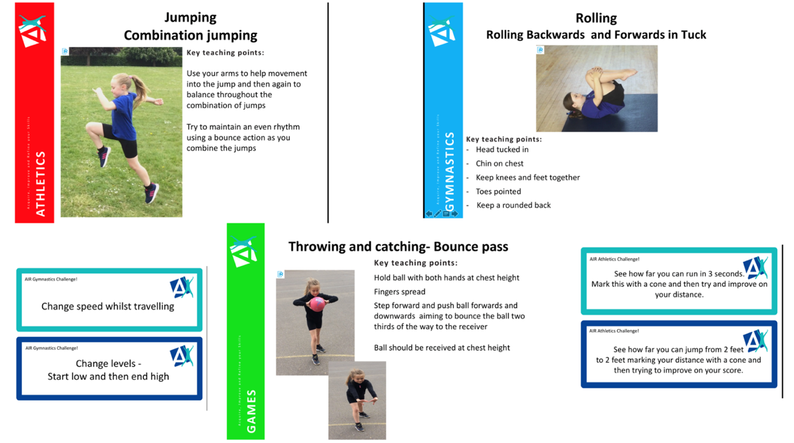

Resources that show games and activities you can use

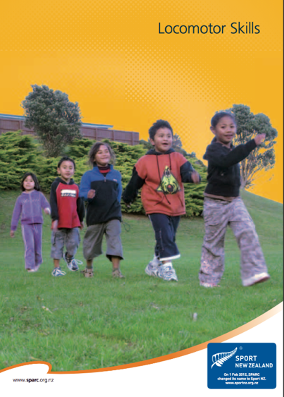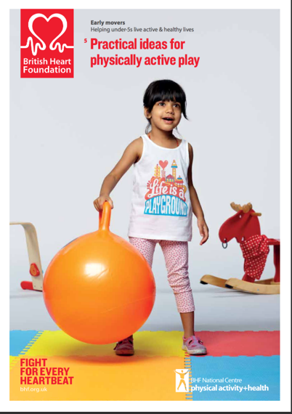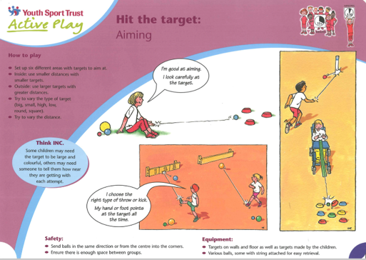

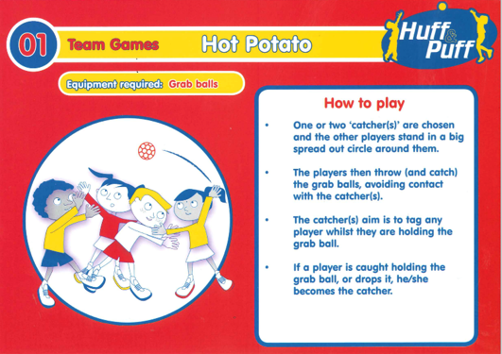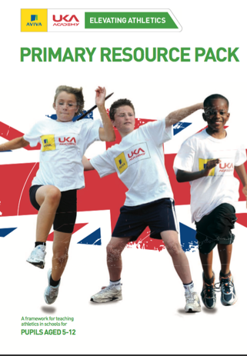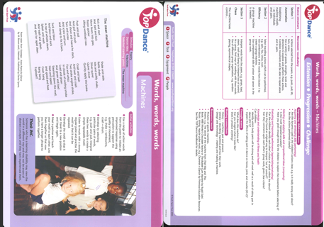

Resources to help with organisation

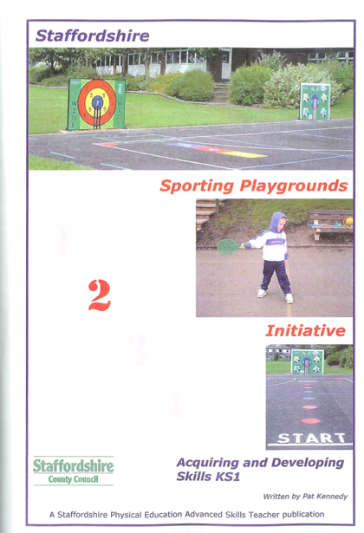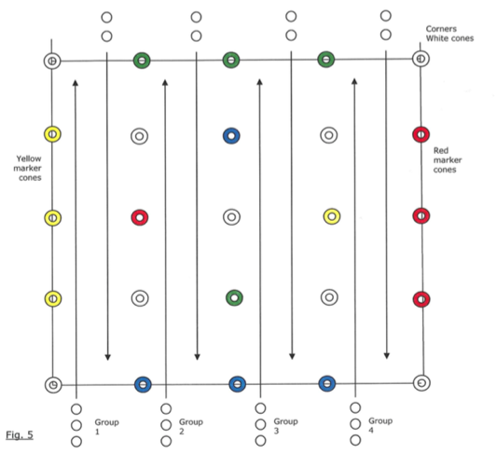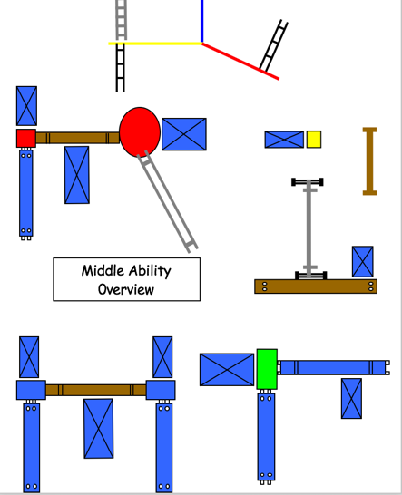

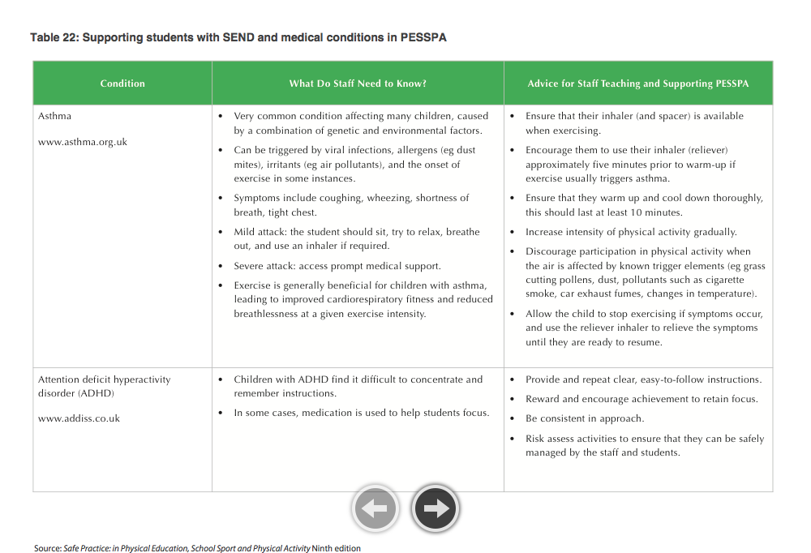
Resources for health and safety

