Here are some independence skills that you can work on throughout the Spring term to increase your child’s independence.
These can be broken down into smaller steps that are appropriate for your child. For example:
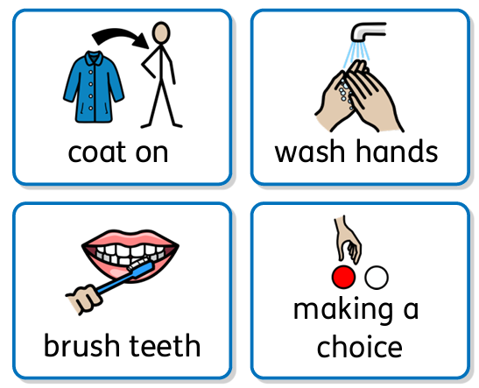
‘Coat on’ could include:
- Getting your coat when prompted
- Attempting to put your coat on
- Zipping the zip up or down
- Taking your coat off and putting it away

‘Wash hands’ could include:
- Wetting your hands with a flannel
- Putting your hands in water
- Pressing the soap dispenser
- Rubbing your hands together
- Drying your hands

‘Brush teeth’ could include:
- Tasting the toothpaste
- Touching the toothpaste/ toothbrush
- Feeling the toothbrush against your skin
- Putting the toothbrush in your mouth
- Holding the toothbrush
- And eventually, tolerating your teeth bring brushed (or doing it yourself!)

‘Making a choice’ could include:
- Choosing from objects (starting with 2 objects)
- Choosing from photos
- Choosing from pictures
- Using PECS/ symbols/ words

Please send in photo or video evidence, if you can, of your child completing any of these steps towards developing their independence skills so that we can celebrate these in school too!

