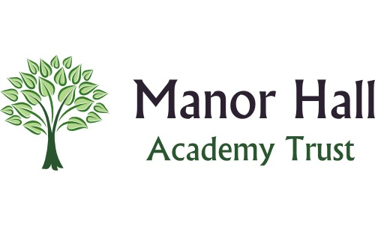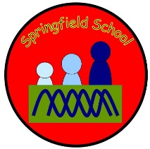 **Springfield Newsletter**

Welcome back everyone! We hope you have had a great half term!

**Key Dates for Spring Second Half Term 2023**

**Fair trade fortnight – Beginning 27th February**

**World Book Day – 2nd March – WOW day in school**

**Comic Relief – Red Nose Day – 17th March**

**Mother’s Day – 19th March**

**World Water Day – 22nd March**

**Attendance**

Where attendance is too low, you will have received a letter letting you know about this on the last day of term (17th Feb). We are here to support you, so please contact us if you would like to talk about your child’s attendance.

All children will receive notification at the end of this term (March 31st) of what their current attendance percentage is at. There will be a chart showing our expected levels of attendance so that you can see how your child is doing. There will then be a further term to increase this percentage.

**Celebrations**

If your child attends clubs out of school and they receive awards / achievements please let us know so that we can celebrate this with them in school.

