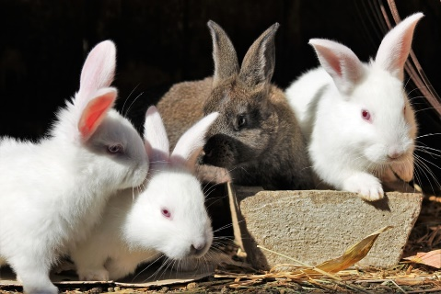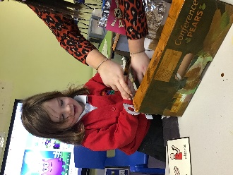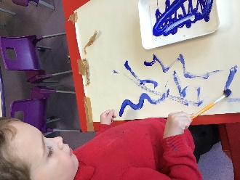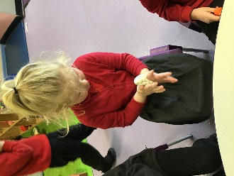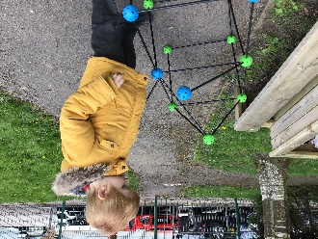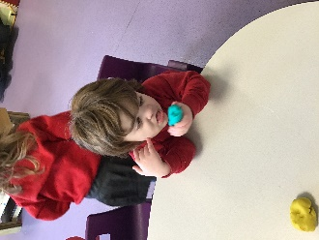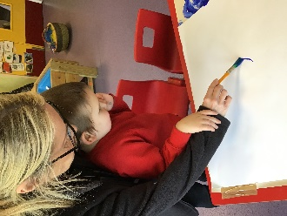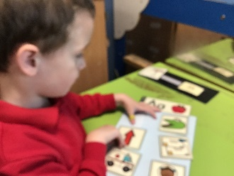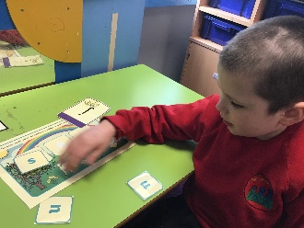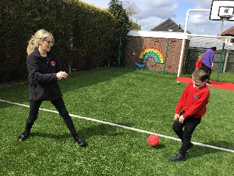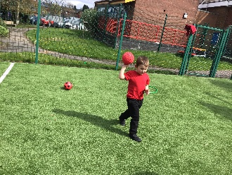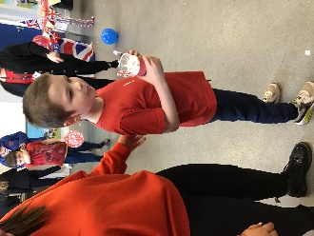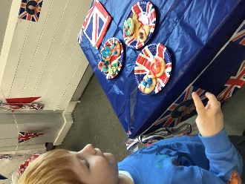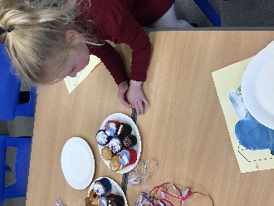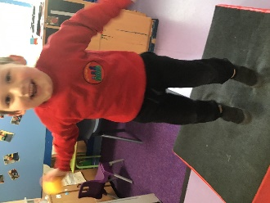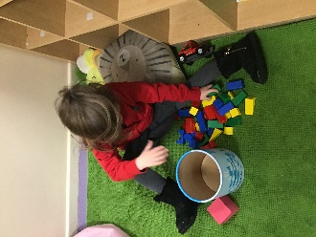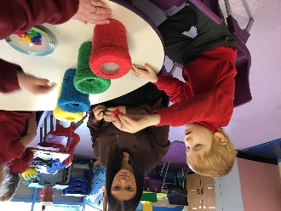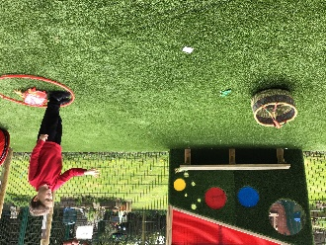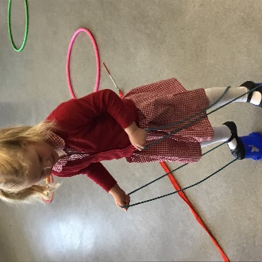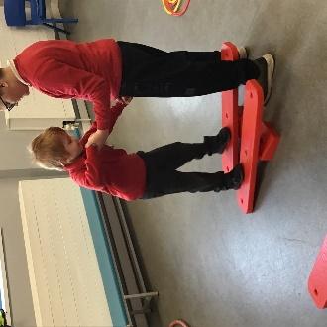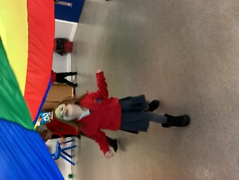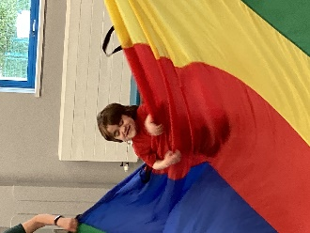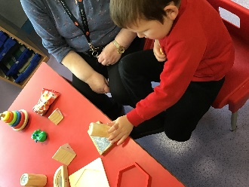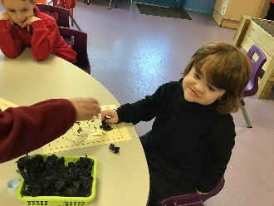

Rabbits Blog

Spring 1

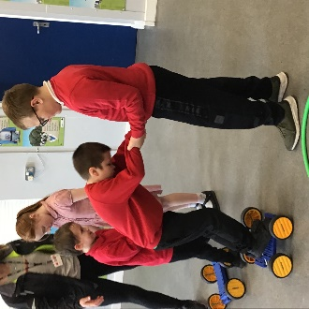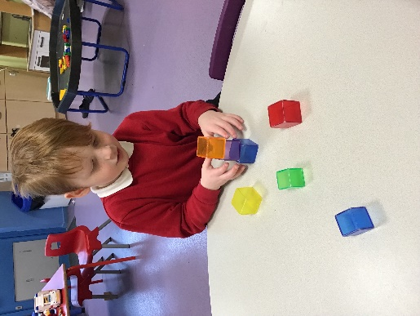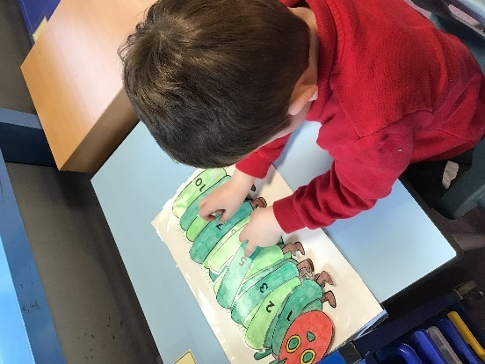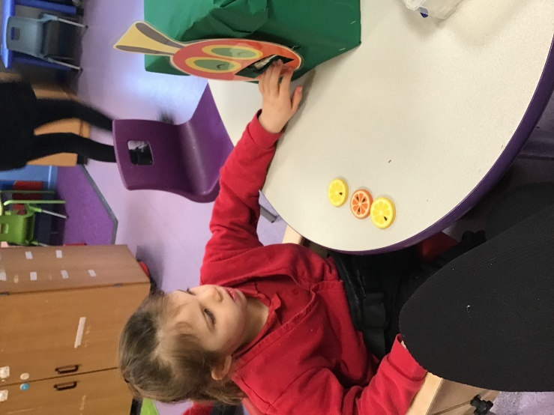

After a lovely Christmas break, we have returned to school happy and ready to start the new term. During this term we have welcomed a new pupil and his family to our class. His name is Aaron and he has settled in really well.

Although it has been a short term, we seem to have packed a lot into it. Our new topic is ‘Down in the Garden’ and we have been doing lots of activities relating to this. We have been exploring our Sensory Garden on a Monday afternoon and making pictures out of leaves and flowers. We have also planted some flowers from seeds which are beginning to grow some shoots. We are so excited! Following on with the same theme, our story is ‘The Hungry Caterpillar’, which we have enjoyed so much. We have been exploring the sensory objects and some of us tried some of the foods the caterpillar ate. Yum! Yum! In Maths we have been looking at More/ Less and patterns. Using concrete objects, we have been building towers, and producing patterns of colours using Lego. Some of us needed a little support to do this.

Although Swimming has started this term, we have struggled to support this. Apart from Aaron, I believe all the pupils have been able to partake in at least 1 session. Hopefully this will increase next term. In P.E we have all taken part in Gymnastics. Our confidence is really growing in this area and we have all tried really hard travelling along beams and apparatus.

We would like to take this opportunity to wish you all a super holiday, enjoy yourselves.

