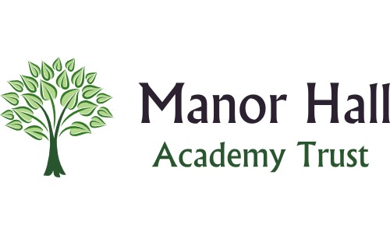
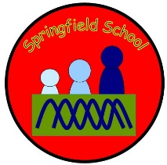 Springfield Newsletter
Welcome back everyone! We hope you have had a fantastic Christmas and enjoyed some precious family
time. Here is some information to start us of with the Spring Term.
Assemblies
Last term saw the reintroduction of assemblies in the school hall. We continued to have class assemblies throughout the last few years and now we have begun our celebration assemblies. Currently we rotate between KS2 and KS1 / EYFS on a Friday afternoon. The children are enjoying have their successes celebrated amongst the classes.
Attendance
As you will know attendance is high on every school’s priority list this year. We have sent out a letter that identifies how we will let you know your child’s attendance figures.
We will also celebrate those pupils that are doing well with their attendance and for significant improvement too.
Key Dates for Spring Term 2023
Chinese New Year – from 22/1/2023 This is the year of the Rabbit.
Safer internet Day – 7th February
Shrove Tuesday – 21st February
Fair trade fortnight – Beginning 27th February
Mother’s Day – 19th March
World Water Day – 22nd March

Springfield Pounds
We began a new reward system last term in school called Springfield Pounds. This runs across school and gives the children opportunities to earn money (these are red coins that are about the size of a real pound) related to work, behaviour and attitudes in class. At the end of the week children get the opportunity to spend their money in the Springfield shop. We have a range of items to buy from sweets, small toys to larger items such as bubbles, pencil cases, balls that children are encouraged to save up for. This helps children to learn the concept of saving.

