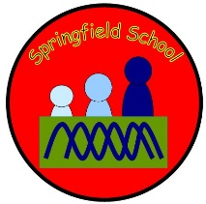
Springfield School
School Term and Holiday Dates 2023-2024

Autumn Term 2023
Inset Day: Monday 4th September & Tuesday 5th September
Term Starts: Wednesday 6th September
Inset Day: 9th October
Half Term: Monday 30th October – Friday 3rd November
Term ends: Friday 22nd December
Holiday: Monday 25th December – Friday 5th January

Spring Term 2024
Inset Day: Monday 8th January
Term Starts: Tuesday 9th January
Half Term: Monday 12th February – Friday 16th February
Term ends: Friday 22nd March
Holiday: Monday 25th March – Friday 5th April

Summer Term 2024
Term starts: Monday 8th April
May Day: Monday 6th May
Half Term: Monday 27th May – Friday 31st May
Term ends: Friday 19th July
Monday 22nd July will be an inset day but closed in lieu of twilight training.
Holiday: Monday 22nd July – Friday 30th August

