Recovery Curriculum
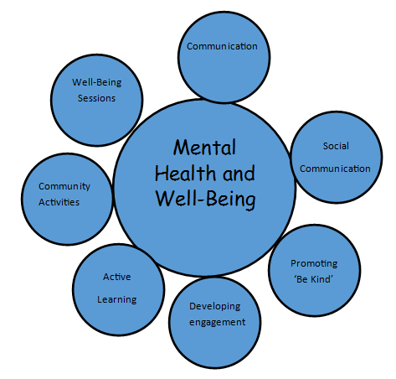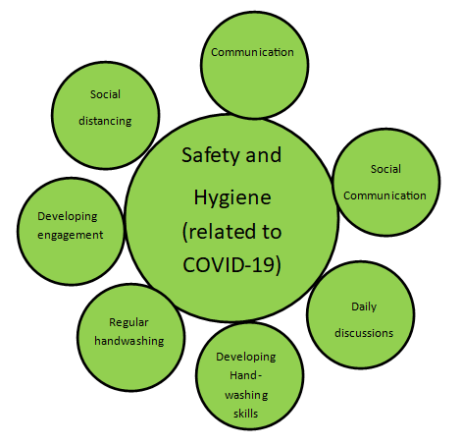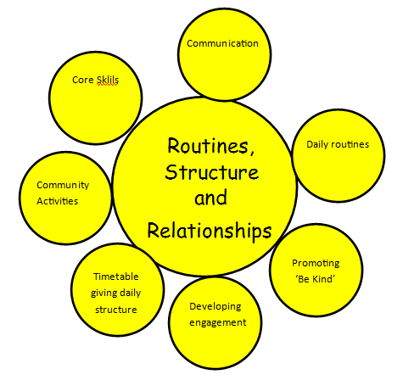
Mental Health and Well Being | How this will be carried out in school | Safety and Hygiene (related to COVID-19) | How this will be carried out in school | Routines, structure and relationships | How this will be carried out in school
Well being | relaxation sessions  sensory activities, relaxation, mindfulness creative arts; art, crafts, drama and music. | Social distancing | Signage  Regular reminders from staff  Modelling from all staff  Discussions around social distancing.  Where else will they see people social distancing? | Daily routines | Structured Timetable throughout the school.  Structure personalised during lessons for those that are unable to communicate without it or those that cannot regulate their behaviours without it.
Communication | Working with others – pairs and team work  Communicating needs | Communication | Working with others – pairs and team work  Communicating needs | Communication | Working with others – pairs and team work  Communicating needs
Social Communication | Regular ‘chats’ with individuals  Chats with our friends  Support to talk with others. | Social Communication | Regular ‘chats’ with individuals  Chats with our friends  Support to talk with others. | Timetable giving daily structure | Whole school timetable
Promoting ‘be kind’ | Develop this concept in each ‘bubble’  Teach being kind  How does it relate to COVID-19 | Daily discussions | Taught lessons around COVID-19 age and level appropriate. Focus on social distancing and hygiene. | Promoting ‘be kind’ | Develop this concept in each ‘bubble’  Teach being kind  How does it relate to COVID-19
Developing engagement | Where children are identified with showing signs of disengagement. The Engagement model will be used to identify next steps of support. | Developing handwashing skills | Regular timetable handwashing in class, to give time to develop and teach handwashing skills. | Community activities | Make links with aspects of the community.  Write letters to other schools,  Grow Moorlands, Beatrice Charity, local Food Bank, Churches, Fire Station, Police etc
Get Active | Range of outside activities. Resources will initially be limited.  Running, daily mile, dancing and aerobics. | Regular handwashing | Handwashing at toilet times.  Handwashing after contact with others, coughing, sneezing etc.  Timetabled handwashing | Core Skills | English and Maths skills at level appropriate for each child. Some re-assessment will be needed for some.
Community Activities | Make links with aspects of the community.  Write letters to other schools, elderly patients in local care homes, write a prayer to be emailed to the local church for the Vicar to share online with his congregation. | Developing engagement | Where children are identified with showing signs of disengagement. The Engagement model will be used to identify next steps of support. | Developing engagement | Where children are identified with showing signs of disengagement. The Engagement model will be used to identify next steps of support.

Wellbeing
Wellbeing sessions will support pupils’ emotional development and equip them with the tools for a secure stress-regulation system that should enable them to settle, to feel safe, to concentrate, to be curious and to be willing to work alongside their peers and work in collaborative ways. Wellbeing sessions we aim to develop pupils’ resilience and work towards supporting them engaging in structured learning again. The more they practise activities which support them being able to self-regulate, in time, the less time in will take them to settle after an incident of stress, and more successful they will be.
Within these sessions there will be a focus on supporting the fulfilment of pupils’ basic needs – supporting knowledge and understanding about areas such as sleep, hygiene, healthy diet, wellbeing, safety needs and understanding.
Activities during these sessions will include: sensory activities, relaxation and mindfulness and creative arts; art, crafts, drama and music, which will also link into community and compassion sessions.
Get Active
Physical activity is key to supporting stress management and emotional regulation. Engagement in exercise varies for our pupils so activities will be wide-ranging. Regular opportunities for sensory regulation will be key as pupils are likely to be on heightened alert; more affected than ever by certain things such as crowds or sounds like people coughing/clearing their throat.
Communication
Relationship building: This is one of the key levers for a Recovery Curriculum. For our pupils it will be important for them to feel listened to and to process their emotional experiences of lockdown; discussing what happened, how it affected them, what sense they made of it and how they managed it. Talktime with a trusted staff member will therefore be a crucial element of their recovery. Relationship building with staff and developing their trust and confidence will be key. It is about:
- Understanding how an individual feels
- Enabling students to discuss how they feel
- Promoting change in how they deal with how they feel.
Social, emotional and mental health interventions will be planned tailored to the individual student.
There will also need to be relationship building with pupils who are new to their class, rebuilding where there were incidents prior to lockdown or where there have been conflicts online during lockdown.
Expressive and social communication: This is an area pupils are likely to have had limited experience of during lockdown; spending increased time at home, many in their bedrooms and engaging in narrow social communication opportunities such as online gaming. Regular practise developing confidence and skills in speaking and listening activities and social communication will be key – through group discussions, turn taking games, team building, social communication games and drawing and talking therapy etc, A high level of adult modelling and scaffolding will be required.
Receptive communication: Giving processing time will be key. Social communication skills such as turn taking in conversation, active listening and respecting others’ viewpoints are also likely to require considerable focus, modelling and scaffolding.

Community
The focus of this area of learning for pupils is ‘be kind’; both to themselves as they build up their confidence being out and about in the community again and to others, as ‘compassion’ is a key element in recovering from trauma as it is actively good for our mental health, as demonstrated by neruroscience. As community usually forms a key part of our curriculum it will be about forging new links in the community where compassion is at the heart and undertaking projects related to this which may involve writing or creative arts. We will also be utilising the community for outdoor learning, as appropriate within the constraints of the current government guidance and school risk assessments.
Core skills
Routine is important to our pupils so elements of core learning skills such as English and maths will be introduced early on for all pupils to establish routine. Considering engagement and a manageable level of challenge will be key in the current climate – games, for example, would be a good starting point to re-engage pupils in English as they may have engaged in less English than maths when working from home. Considering how they learn having maybe engaged or not in home learning for a significant period of time will be important. For some pupils, core skills will only be worked on in context, e.g. as part of community projects or personal modules.

Personal Return to School Plan
Return to school | Comments  Date when child returns to school – part-time and full-time.
Contact Parents - when in part time.
What has gone well at home? What difficulties have they had?
What knowledge do SLT / Class teacher already have about (each child) name, from the lockdown period?
Are other agencies involved?
Have they been involved during lockdown?
What is their input?
Do other agencies need to be contacted that have not been able to be in contact during lockdown?
Is any new support identified?
Teacher brief observations on NAME’s part-time return to school.
Further actions to take
Return to school – full time
Contact parents
How is NAME coping? Any successes / difficulties? Identify any support needed.
Teacher brief observations on NAME’s full-time return to school.
Personal Return to School Plan
Highlight yellow for what is in place Highlight blue for priority
Mental Health and Well Being | How this will be carried out in school | Safety and Hygiene (related to COVID-19) | How this will be carried out in school | Routines, structure and relationships | How this will be carried out in school
Well being | relaxation sessions  sensory activities, relaxation, mindfulness creative arts; art, crafts, drama and music. | Social distancing | Signage  Regular reminders from staff  Modelling from all staff  Discussions around social distancing.  Where else will they see people social distancing? | Daily routines | Structured Timetable throughout the school.  Structure personalised during lessons for those that are unable to communicate without it or those that cannot regulate their behaviours without it.
Communication | Working with others – pairs and team work  Communicating needs | Communication | Working with others – pairs and team work  Communicating needs | Communication | Working with others – pairs and team work  Communicating needs
Social Communication | Regular ‘chats’ with individuals  Chats with our friends  Support to talk with others. | Social Communication | Regular ‘chats’ with individuals  Chats with our friends  Support to talk with others. | Timetable giving daily structure | Whole school timetable
Promoting ‘be kind’ | Develop this concept in each ‘bubble’  Teach being kind  How does it relate to COVID-19 | Daily discussions | Taught lessons around COVID-19 age and level appropriate. Focus on social distancing and hygiene. | Promoting ‘be kind’ | Develop this concept in each ‘bubble’  Teach being kind  How does it relate to COVID-19
Developing engagement | Where children are identified with showing signs of disengagement. The Engagement model will be used to identify next steps of support. | Developing handwashing skills | Regular timetable handwashing in class, to give time to develop and teach handwashing skills. | Community activities | Make links with aspects of the community.  Write letters to other schools,  Grow Moorlands, Beatrice Charity, local Food Bank, Churches, Fire Station, Police etc
Get Active | Range of outside activities. Resources will initially be limited.  Running, daily mile, dancing and aerobics. | Regular handwashing | Handwashing at toilet times.  Handwashing after contact with others, coughing, sneezing etc.  Timetabled handwashing | Core Skills | English and Maths skills at level appropriate for each child. Some re-assessment will be needed for some.
Community Activities | Make links with aspects of the community.  Write letters to other schools, elderly patients in local care homes, write a prayer to be emailed to the local church for the Vicar to share online with his congregation. | Developing engagement | Where children are identified with showing signs of disengagement. The Engagement model will be used to identify next steps of support. | Developing engagement | Where children are identified with showing signs of disengagement. The Engagement model will be used to identify next steps of support.

Data Comparison
Name_____________
Progression Steps
Subject | Data in March 2020 | Data in December 2020 | Intervention required
Reading
Spoken
Maths

Engagement Steps
Area | Data in March 2020 | Data in December 2020 | Intervention required
Responsiveness
Expressive Communication
Social, emotional and mental health

The Recovery Curriculum for Springfield School has been based upon the work of Carpenter and Carpenter 2020 ‘A Recovery Curriculum Loss and Life’. It takes into consideration the Provision of the Recovery Curriculum for Churchward School and the research that surrounds this. A full list of references are available on the next page.

REFERENCES/BIBLIOGRAPHY
Barnados. “All About Relationships”. May 2020. https://www.youtube.com/watch?v=0RyD-ueKCOc&feature=share. Accessed 23 May 2020.
Cairns, Kate. “COVID-19, Toxic Stress and Community Resilience”. Kate Cairns Associates. May 2020. https://kca.training/?course=covid_19. Accessed 20 May 2020.
Carpenter, Barry and Carpenter, Matthew. Thinkpiece: “A Recovery Curriculum: Loss and Life for our children and our schools post-pandemic”. 23rd April 2020. https://barrycarpentereducation.files.wordpress.com/2020/04/recovery-curriculum-loss-and-life-for-our-children-and-schools-post-pandemic.pdf. Accessed 23 April 2020
Carpenter, B. et al (2015). ‘Engaging Learners with Complex Needs’, London, Routledge.
Dayton, Tian. “When hidden grief gets triggered during COVID-19 confinement”. April 2020. First published by The Meadows 15/04/20. https://www.acesconnection.com/g/Parenting-with-ACEs/blog/when-hidden-grief-gets-triggered-during-covid-19-confinement?fbclid=IwAR0cuI0A6-oKWhbyjVAKVz61wehYB1Rs1EsJ46uFEUDe9RmBXJbFDYZ7JsQ. Accessed 23 May 2020.
Fraser, Keith. “Engage and connect session”. 19th May 2020. https://engageintheirfuture.org/whats-new/. Accessed 25 May 2020.
Knightsmith, Pooky. “Nurture: The most important part of the school curriculum right now?” Pooky Knightsmith Mental Health. May 2020. https://www.youtube.com/watch?v=eicqCHk8dYg&feature=share Accessed 16 May 2020.
LearningShared Podcast: “Episode 1 – A Recovery Curriculum Part 1 (Loss and Life for our children and schools post pandemic)”. https://www.recoverycurriculum.org/mentalhealth/. May 2020. Accessed 17 May 2020.
LearningShared Podcast. Special Episode for Mental Health Awareness Week – “When will we talk about the mental health of our children?” https://www.recoverycurriculum.org/mentalhealth/ May 2020. Accessed 25 May 2020.
McCann, Lynn. “Preparing Autistic and SEND children for going back to school”. May 2020. https://www.schudio.tv/courses/preparing-autistic-send-children-for-going-back-to-school . Accessed 23 May 2020.
Mental Health Foundation. Kindness research briefing. May 2020. https://www.mentalhealth.org.uk/campaigns/mental-health-awareness-week/kindness-research. Accessed 25 May 2020.
Northumbria University Newcastle. “5 Ways Psychology Explains Our Behaviour During the Covid-19 Pandemic”. https://www.northumbria.ac.uk/distance-learning/social-psychology-coronavirus-dlpsyc/ Accessed 24 May 2020.
Quinlivan, Dr. Kara. “Return to School: A Trauma Informed Approach. 15th May 2020. https://www.raftpsychology.com/news/gyid0efdmvfmjw4r9xxly04rwrjd0o. Accessed 25 May 2020.
Rae, Dr. Tina and D’Amario, Dr. Ali. “The Role of the Mental Health Lead in Schools following the Pandemic”. 15th May 2020. https://www.youtube.com/watch?v=WB8v7on-Dtk&feature=youtu.be . Accessed 25 May 2020.
Restore our schools. “How we plan for the return to the classrooms, playgrounds and corridors of schools”. https://restoreourschools.wordpress.com/. Accessed 14 May 2020

