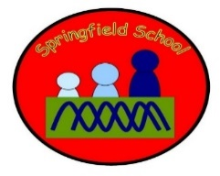 Rabbits Class Medium Term Planning for Maths Summer Term 2 2023

Focus | Differentiated Activities
Size – Empty and Full  Weeks 1 and 2 | Put objects into containers and take them out again  Water play – emptying and filling  Match full and empty symbols to real examples.  Messy food play – filling and emptying | Pouring drinks for each other  Filling bottles  Filling boxes with toys.  Sorting bottles into two sets – full and empty. | Half full / empty  Fill a container when requested to with use of symbol.
Sequencing and Order  Weeks 3 and 4 | Counting like behaviour, making sounds like counting in sequence.  Lining up toys. | Order numerals (0-3)  Match numbers on a number line | Order numerals (0-5) (0-10) (0-20)  Match numbers on a number line  Remove some numbers and fill in the missing numerals.  Use a blank number line - place the numbers back on in order.  Give child a pile of numerals and ask them to place them in order.
Size – Numerals  Week 5 and 6 | Show interest in numberblocks  Explore numbers in messy play  Match number to number – task. Match number (eg magnetic number) to number card. | Sorting numbers into sets. | Find numbers of request.  Tell you what a number is when it is held up / shown.  Begin to match amounts to numbers.

