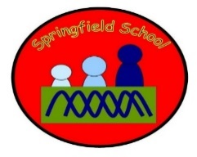 Rabbits Class Medium Term Planning for Maths Summer Term 1 2023

Focus | Differentiated Activities
Categorising  Weeks 1 and 2 | Put objects into containers and take them out again  Exploring sets of objects  Matching object to photo | Sorting colours  Sorting tasks  Sorting plates / bowls / cutlery | Identify the category – What are all of these?  Show me (symbols board)
3D Shapes  Weeks 3 and 4 | Watch 3D shape songs  Match shape to photo | Match shapes to symbol  Match shape to shape – in a task  Sort shapes into sets. | Sort shapes into sets.  Begin to name shapes. Identify same shape on a symbols board.
Number (counting)  Week 5 and 6 | Matching – numeral and amount  (structured tasks) | Matching amounts to numbers – independent play activity.  Matching to different configurations.  Sort the cards into piles of the same. Counting objects and matching the numeral. | Show a numeral and child gives the requested amount.  Counting objects and matching the numeral.

