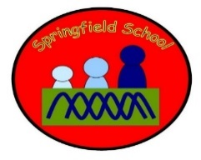 Rabbits - Medium Term Planning - English Summer 1 2024
Topic: Off on an Adventure
Whatever Next!
(Week 1-3)
We’re Going on a Bear Hunt
(Week 4-6)
Summer: Season Week
(Week 7)
Communication – through gesture / objects of reference | Communication – PECS and the use of symbols to aid communication | Communication - Makaton
Attention Autism – linked to texts /theme | Intensive Interaction | Dough disco
Individual SALT programmes | Fine motor skills | Squiggle Time – Mark making
Phonics - for identified pupils | Gross motor skills – Including sensory circuits | Matching tasks

