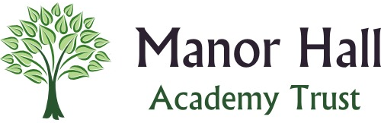
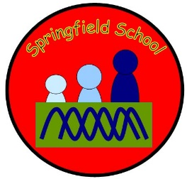
Springfield Newsletter – May 2020
Dear Parents/Carers
I hope this letter finds you all well and safe?
We continue to be missing all the children, but know that they are in the safest place at home with their families.
Those of you with emails continue to receive some ideas and links from the teachers on Mondays. Please do not feel you have to complete any of the tasks, they are just ideas which you can take or leave.
Many of the activities involve using resources within your homes, gardens and localities. They promote English, maths, and science skills as well as creative, self-help and independence which are all so important in the preparation for adulthood!
The main priority is that you all stay safe and healthy and hopefully you are making lots of happy memories along the way. We know it isn’t easy for any of us at this time so try not to get stressed or worried about completing certain tasks unless you and your child wants to.
Thank you to all of you who are keeping in touch by email and sending us photographs and giving us a little insight into the lives of your wonderful children at home. We miss them all so much. I am so PROUD of all you parents, you are doing a fabulous job!! Well done!!
I am sure you will all have seen the little video from the staff – if we are still in lockdown in a few weeks’ time, I am sure I can convince them to do another! BUT let’s keep our fingers crossed that we can see you all for real.
Makaton: for those of you who enjoy learning new signs please go to the website below, sign up and they will send you a new sign to learn each week:-
https://wetalkmakaton.org/
Please keep a look out on our website as Jayne is updating it quite regularly with resources, links and information as it comes through to her. Plus, our Newsletters too!
Remember that if you need to and have any serious concerns please contact;

Family Support Workers -
- Our Family Support team will be available during normal school hours via email to respond to any appropriate concerns.
kieron.edridge@themeadows.manorhall.academy
julie.roberts@themeadows.manorhall.academy
- If you have any concerns regarding Safeguarding please email our Designated Safeguarding Lead – Sarah Rubanski s.rubanski@springfield.staffs.sch.uk
- If you have any concerns regarding Health Issues not related to coronavirus or usual things you would go via your G.P - please email Specialschools.staffs@nhs.net

As always I am very happy for you to get in touch with me at any time if you have any questions by email at headteacher@springfield.staffs.sch.uk, and I will endeavour to get back to you as soon as possible. I may not have any answers but I will try my best to help.
I had hoped that by the time I did this Newsletter, I would have some clearer information to share with you. However, unfortunately we continue to be in a worrying and uncertain time and I am unable to tell you when things may return to some sort of normality. Hopefully after this week we may have some clearer guidance from the Government. I think we are all aware that the “new norm” will be very different to where we left off.
So all I can do is to continue to wish you and your family and friends all the very best and hope that you all remain healthy and safe.
It is V.E day on Friday and this week we would have been celebrating in school and having our Garden Party. But I hope that as families you can enjoy the day and join in the Nation’s thanks to our past and current heroes.
On behalf of myself and all the Springfield Staff Team can I tell you that we are missing you and all the children so much and can’t wait for when we can all get back together.
WE WILL MEET AGAIN!! and our Springfield Family will be united!
Very best wishes to you all. I will be in-touch again as soon as we have some information to share!
Diane
Headteacher
STAY  SAFE | PROTECT  THE N.H.S. | SAVE  LIVES

