**,**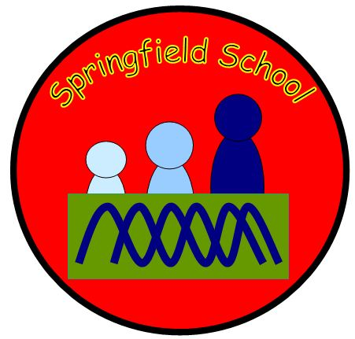

**Springfield Newsletter – April 2020**

Dear Parents/Carers

Well I certainly didn’t expect to be writing this from the comfort of my own home!

I can’t believe how much all our lives have changed within the last couple of weeks. All our staff are doing ok at the moment, many are either “Self-Isolating” and/or “Shielding” like myself for the next 12 weeks!!

We are all missing the children terribly but know that they are in the safest place at home with their families.

Those of you with emails will have received some ideas and links from the teachers. They will continue to send these out on Mondays until further notice. Please do not feel you have to complete any of the tasks they are just ideas which you can take or leave.

Many of the activities involve using resources within your homes, gardens and localities. They promote English, maths, and science skills as well as creative, self-help and independence which are all so important in the preparation for adulthood!

The main priority is that you all stay safe and healthy and hopefully you are making lots of happy memories along the way. We know it isn’t easy for any of us at this time so try not to get stressed or worried about completing certain tasks unless you and your child wants to.

On another point – I am aware that there are lots of fabulous FREE resources you can access on line – however, please also be aware that there are lots of SCAMS too so be extra vigilant if you get asked to give either your personal or bank details!!

Please keep a look out on our website as Jayne is updating it quite regularly with resources, links and information as it comes through to her. Plus, our Newsletters too!

We will be sending occasional text messages, and obviously the emails on a weekly basis from the Classes.

**Family Support Workers** - if you have any serious concerns or issues please remember: -

* Our Family Support team will be available during normal school hours via email to respond to any appropriate concerns.

[kieron.edridge@themeadows.manorhall.academy](mailto:kieron.edridge@themeadows.manorhall.academy)

[julie.roberts@themeadows.manorhall.academy](mailto:julie.roberts@themeadows.manorhall.academy)

* If you have any concerns regarding Safeguarding please email our Designated Safeguarding Lead – Sarah Rubanski [s.rubanski@springfield.staffs.sch.uk](mailto:s.rubanski@springfield.staffs.sch.uk)
* If you have any concerns regarding Health Issues not related to coronavirus or usual things you would go via your G.P - please email [Specialschools.staffs@nhs.net](mailto:Specialschools.staffs@nhs.net)

As always I am very happy for you to get in touch with me at any time if you have any questions by email at [headteacher@springfield.staffs.sch.uk](mailto:headteacher@springfield.staffs.sch.uk), and I will endeavour to get back to you as soon as possible. I may not have any answers but I will try my best to help.

We continue to be in a worrying and uncertain time and I am unable to tell you when things may return to some sort of normality. All I can do is to wish you and all your family and friends all the very best and hope that you all remain healthy and safe.

On behalf of myself and all the Springfield Staff Team can I wish you all a very Happy Easter period – a celebration of hope and new life. We hope and pray that we can all get back together very soon as we miss you all so much!

WE WILL MEETAGAIN!! and our Springfield Family will be unitied!

Very best wishes to you all. I will be in touch again soon.

Diane ☺

Headteacher

|  |  |  |
| --- | --- | --- |
| **STAY**  **SAFE** | **PROTECT**  **THE N.H.S.** | **SAVE**  **LIVES** |

