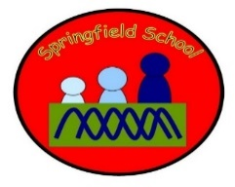 Rabbits Class Medium Term Planning for Music Summer Term 2023
Topic: Pirates and Seaside  Musical Elements: Singing, playing, listening, responding, moving to music. | Music this term will be based around reactive and proactive levels. (Resources Tuning in cards 2 and 3)  *Show me the sounds that everyday things and musical instruments can make.  *Encourage me to make sounds with my voice,  Continuous provision will also enhance the opportunities to explore music and sound on a daily basis.  (Learn MAKATON with ALL SONGS)

Week 1 - 3 sessions  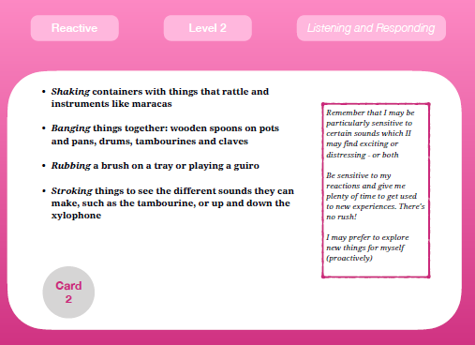 | Week 4-6  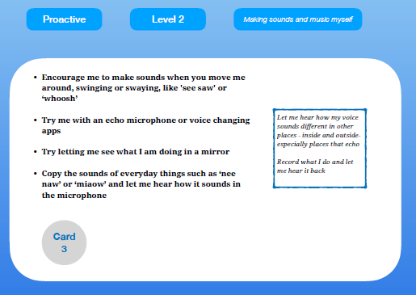

Take the objectives for the LO stickers from this section
Substantive Knowledge (Content) | Disciplinary Knowledge (Skills)
Children sing a range of well-known nursery rhymes and songs. Children perform songs, rhymes, poems and stories with others, and (when appropriate) try to move in time with music. | - Make sounds with everyday objects  - Make sounds with musical instruments.  - Make sounds with my voice.  - Show attention to sounds and music.  - Respond emotionally and physically to music when it changes.  - Move and dance to music.  - Anticipate phrases and actions in rhymes and songs, like ‘Peepo’.  - Explore their voices and enjoy making sounds.  - Join in with songs and rhymes, making some sounds.  - Make rhythmical and repetitive sounds.  - Explore a range of soundmakers and instruments and play them in different ways.  - Enjoy and take part in action songs, such as ‘Twinkle, Twinkle Little Star’.  - Listen with increased attention to sounds.  - Explore and engage in music making and dance, performing solo or in groups.

Progression of Learning
‘Link It’ | ‘Learn It’ | ‘Check It’ | ‘Show It’ | ‘Know It’
Previous learning of pupils  - What do they do with everyday objects to make a sound from them?  - How do they access musical instruments?  - Let them explore  - How do they make sounds now? | Activities provided during lesson  Resources  Teach them to tap, scrape, shake, pluck, stroke.  Intensive interaction sessions – copying sounds / words / rhymes. | Independent activities linked to lesson  Resources  Let the children explore the everyday items and instruments, if they let you join in, model how to play them.  Use microphones to make sounds | How will the pupils share knowledge during or end of lesson  Children becoming more independent making sounds from everyday items and instruments.  Use microphones to make and record sounds – listen back to own sounds. | Retrieve or generalization of learning after lesson  Perform to others with or without backing music.

