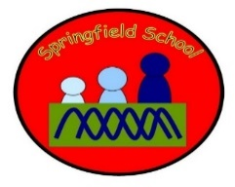 Hedgehogs Class Medium Term Planning for Music Summer Term 2024
Topic: Animals and wildlife  Charanga –  SEND Scheme Anyone can play:  Unit 11 – loud and quiet (term 1)  Unit 12 – boogie train (term 2) | Music will have dedicated slots throughout the week. There will be specific planned opportunities to support the children’s progress and may be altered to suit the needs of the children during the term.  Music will also be explored through Intensive Interaction using the ‘Tuning in’ cards with children on an individual basis to increase their interaction, attention and listening skills and to promote their engagement with Music.  Continuous provision will enhance the opportunities to explore music and sound on a daily basis.  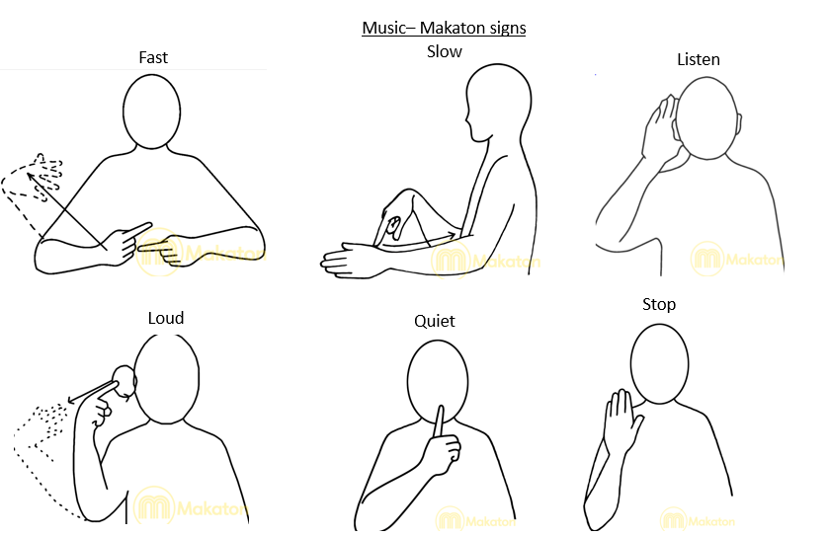

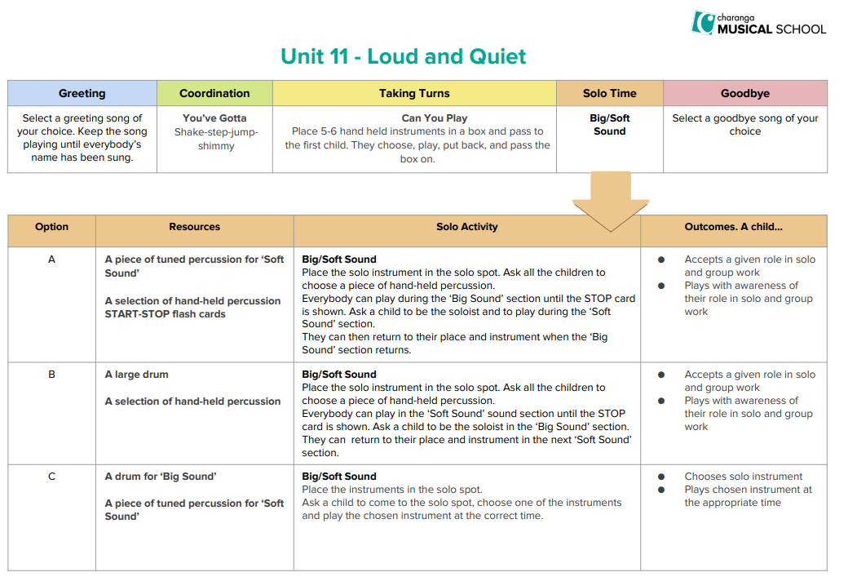
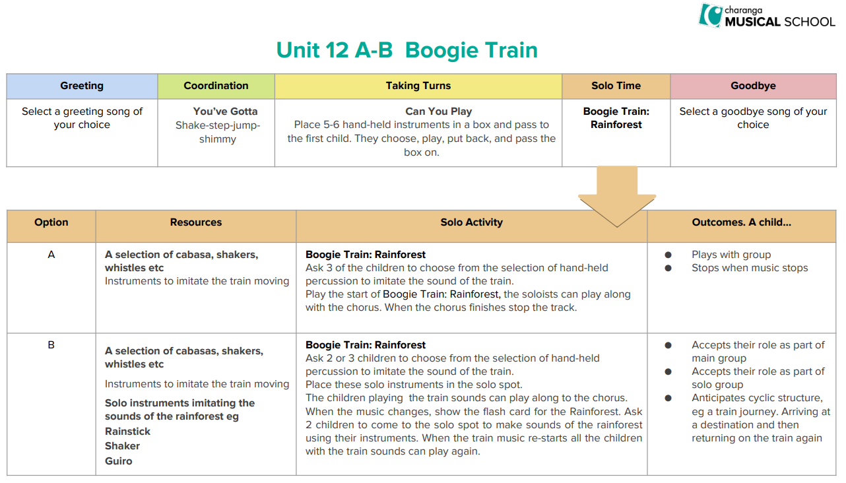

Take the objectives for the LO stickers from this section
Substantive Knowledge (Content) | Disciplinary Knowledge (Skills)
EYFS –  - Children sing a range of well-known nursery rhymes and songs.  - Children perform songs, rhymes, poems and stories with others, and (when appropriate) try to move in time with music.  Key Stage One –  - use their voices expressively and creatively by singing songs and speaking chants and rhymes;  - play tuned and untuned instruments musically;  - listen with concentration and understanding to a range of high quality live and recorded music;  - experiment with, create, select and combine sounds using the inter-related dimensions of music. | EYFS -  - Join in with songs and rhymes, copying sounds, rhythms, tunes, and tempo  - Show attention to sounds and music.  - Move and dance to music.  - Anticipate phrases and actions in rhymes and songs, like ‘Peepo’.  - Explore their voices and enjoy making sounds.  - Join in with songs and rhymes, making some sounds.  - Make rhythmical and repetitive sounds.  - Explore a range of soundmakers and instruments and play them in different ways.  - Listen with increased attention to sounds.  - Respond to what they have heard, expressing their thoughts and feelings.  - Sing the pitch of a tone sung by another person (‘pitch match’).  - Sing the melodic shape (moving melody, such as up and down, down and up) of familiar songs.  - Play instruments with increasing control to express their feelings and ideas.  - Listen carefully to rhymes and songs, paying attention to how they sound.  - Listen attentively, move to and talk about music, expressing their feelings and responses.  - Explore and engage in music making and dance, performing solo or in groups.  Key Stage One -  - Use voices to create descriptive sounds  - Identify and keep a steady beat using instruments  - Play percussion instruments at different speeds (tempi)  - Explore sounds on instruments and find different ways to vary their sound  - Use instruments to create descriptive sounds  - Recognise and respond to changes in tempo in music  - Identify a repeated rhythm pattern  - Understand musical structure by listening and responding through movement  - Explore and develop an understanding of pitch using the voice and body movements  - Explore different sound sources and materials  - Play fast, slow, loud, and quiet sounds on percussion instruments

Progression of Learning
‘Link It’ | ‘Learn It’ | ‘Check It’ | ‘Show It’ | ‘Know It’
Previous learning of pupils  Greeting  Exploring familiar instruments independently | Activities provided during lesson  Co-ordination  Exploring sounds using instruments to accompany songs | Independent activities linked to lesson  Taking turns  Taking turns – exploring turn taking using instruments, practicing waiting and developing our listening skills | How will the pupils share knowledge during or end of lesson  Solo time  Solo time – performing using instruments alongside music | Retrieve or generalization of learning after lesson  Perform  Children will confidently perform to a piece of music – some children might sing along

