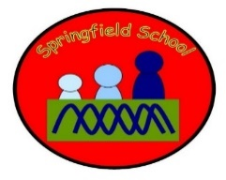Hedgehogs Class Medium Term Planning for Music Summer Term 2023
Topic: Places  Music Express –  Going Places (F) – high and low (pitch) | Music will have dedicated slots throughout the week. There will be specific planned opportunities to support the children’s progress and may be altered to suit the needs of the children during the term.  Continuous provision and Intensive Interaction using the ‘tuning in cards’ will also enhance the opportunities to explore music and sound on a daily basis.  Key vocabulary:  - High, low
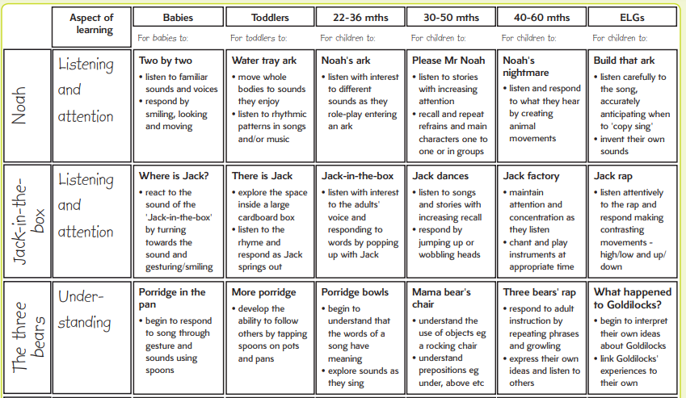

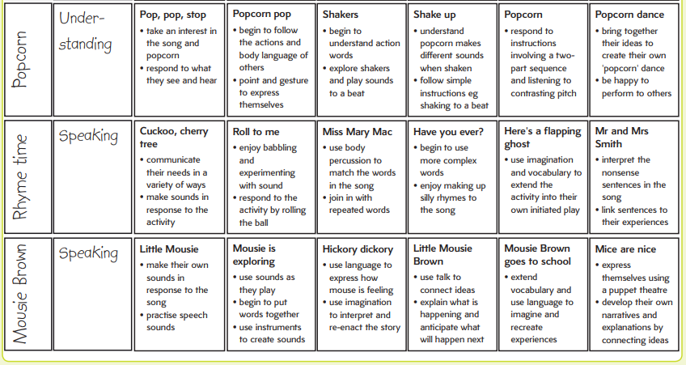

Take the objectives for the LO stickers from this section
Substantive Knowledge (Content) | Disciplinary Knowledge (Skills)
EYFS –  - Children sing a range of well-known nursery rhymes and songs.  - Children perform songs, rhymes, poems and stories with others, and (when appropriate) try to move in time with music.  Key Stage One –  - use their voices expressively and creatively by singing songs and speaking chants and rhymes;  - play tuned and untuned instruments musically;  - listen with concentration and understanding to a range of high quality live and recorded music;  - experiment with, create, select and combine sounds using the inter-related dimensions of music.  Music Express objectives:  - Perform a rap using high and low vocal and instrumental sounds to represent different animal voices.  - Sing songs with high and low notes reinforced with matching hand or body positions.  - Perform a rap with high, medium, and low vocal sounds.  - Sing a song with steps and leaps, accompanied by pitched instruments.  - Sing high and low notes, and develop listening skills through matching movement to pitch.  - Sing stepping notes that move up and down accompanied by tuned percussion and hand actions. | EYFS -  - Enjoy singing, music and toys that make sounds  - Enjoy songs and rhymes, tuning in and paying attention.  - Join in with songs and rhymes, copying sounds, rhythms, tunes, and tempo.  - Say some of the words in songs and rhymes.  - Copy finger movements and other gestures.  - Sing songs and say rhymes independently, for example, singing whilst playing.  - Show attention to sounds and music.  - Respond emotionally and physically to music when it changes.  - Move and dance to music.  - Anticipate phrases and actions in rhymes and songs, like ‘Peepo’.  - Explore their voices and enjoy making sounds.  - Join in with songs and rhymes, making some sounds.  - Make rhythmical and repetitive sounds.  - Explore a range of soundmakers and instruments and play them in different ways.  - Enjoy and take part in action songs, such as ‘Twinkle, Twinkle Little Star’.  - Listen with increased attention to sounds.  - Listen carefully to rhymes and songs, paying attention to how they sound.  - Learn rhymes, poems and songs.  - Sing in a group or on their own, increasingly matching the pitch and following the melody.  Key Stage One -  - Combine voices and movement to perform a chant and a song  - Use voices to create descriptive sounds  - Identify and keep a steady beat using instruments  - Play percussion instruments at different speeds (tempi)  - Explore sounds on instruments and find different ways to vary their sound  - Use instruments to create descriptive sounds  - Recognise and respond to changes in tempo in music  - Identify a sequence of sounds (structure) in a piece of music  - Respond to music through movement  - Identify a repeated rhythm pattern  - Understand musical structure by listening and responding through movement  - Explore, create and place vocal and body percussion sounds  - Explore different sound sources and materials  - Explore sounds on instruments and find different ways to vary their sound  - Play fast, slow, loud, and quiet sounds on percussion instruments

