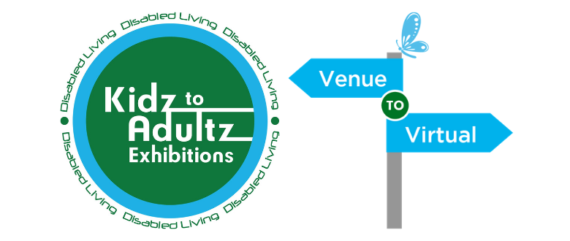

Only One Month to Go Until  
Kidz to Adultz  
Venue to Virtual!

**FREE online event - Week Commencing 1st March**

Dedicated to children and young adults with disabilities and additional needs, their parents, carers, and the professionals who support them right across the UK and much further afield. This free virtual event will take place during week commencing 1st March 2021. The online platform offers visitors virtual access to the many exhibitors, companies, voluntary and support organisations who will be showcasing their products, equipment and outlining details of their services at various times during the week-long event.

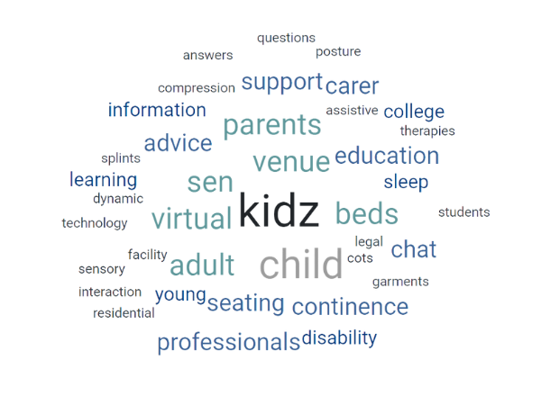

Come and join us!

|  |
| --- |
| [**Find out more information on each of our exhibitors HERE!**](https://disabledliving.us3.list-manage.com/track/click?u=c4660c83f3c22e2b51b4b8598&id=bb56889f0f&e=40508c5539) |



|  |
| --- |
|  |
| |  |  |  |  |  |  |  |  |  |  |  |  |  |  |  |  |  |  |  |  |  |  |  |  |  |  |  |  |  |  | | --- | --- | --- | --- | --- | --- | --- | --- | --- | --- | --- | --- | --- | --- | --- | --- | --- | --- | --- | --- | --- | --- | --- | --- | --- | --- | --- | --- | --- | --- | | |  |  |  |  |  |  |  |  |  |  |  |  |  |  |  |  |  |  |  |  |  |  |  |  |  |  |  |  |  | | --- | --- | --- | --- | --- | --- | --- | --- | --- | --- | --- | --- | --- | --- | --- | --- | --- | --- | --- | --- | --- | --- | --- | --- | --- | --- | --- | --- | --- | | |  |  |  | | --- | --- | --- | | |  |  | | --- | --- | | |  | | --- | |  | | |  |  |  |  | | --- | --- | --- | | |  |  | | --- | --- | | |  | | --- | |  | | |  |  |  | | --- | --- | | |  | | --- | |  | |  |  |  | | --- | --- | | |  | | --- | |  | |  |  |  | | --- | --- | | |  | | --- | |  | |  |  | | --- | |  |  |  |  | | --- | --- | | |  | | --- | |  | |  |  |  | | --- | --- | | |  | | --- | |  | |  |  |  | | --- | --- | | |  | | --- | | [**FREE visitors registration HERE!**](https://disabledliving.us3.list-manage.com/track/click?u=c4660c83f3c22e2b51b4b8598&id=b9292e50d8&e=40508c5539) | |  |  |  | | --- | --- | | |  | | --- | | [**Interested in exhibiting? Click HERE!**](https://disabledliving.us3.list-manage.com/track/click?u=c4660c83f3c22e2b51b4b8598&id=2b79060bba&e=40508c5539) | |  |  |  | | --- | --- | | |  | | --- | |  | |  |  |  |  | | --- | --- | --- | | |  |  | | --- | --- | | |  | | --- | | Dates for your Diary | | |  |  |  | | --- | --- | | |  | | --- | | https://mcusercontent.com/c4660c83f3c22e2b51b4b8598/images/3a47c777-8ada-4e7a-b970-c8874e24bbb5.png | | | | |
| |  |  |  |  |  |  |  |  |  |  |  |  |  |  |  |  |  |  |  |  |  |  | | --- | --- | --- | --- | --- | --- | --- | --- | --- | --- | --- | --- | --- | --- | --- | --- | --- | --- | --- | --- | --- | --- | | |  |  |  |  |  |  |  |  |  |  |  |  |  |  |  |  |  |  |  |  |  | | --- | --- | --- | --- | --- | --- | --- | --- | --- | --- | --- | --- | --- | --- | --- | --- | --- | --- | --- | --- | --- | | |  |  |  | | --- | --- | --- | | |  |  | | --- | --- | | |  | | --- | | Follow Kidz to Adultz | | |  |  |  |  |  |  |  |  |  |  |  |  |  |  |  | | --- | --- | --- | --- | --- | --- | --- | --- | --- | --- | --- | --- | --- | --- | | |  |  |  |  |  |  |  |  |  |  |  |  |  | | --- | --- | --- | --- | --- | --- | --- | --- | --- | --- | --- | --- | --- | | |  |  |  |  |  |  |  |  |  |  |  |  | | --- | --- | --- | --- | --- | --- | --- | --- | --- | --- | --- | --- | | |  |  |  |  |  |  |  |  |  |  |  | | --- | --- | --- | --- | --- | --- | --- | --- | --- | --- | --- | | |  |  |  |  |  |  |  |  |  |  | | --- | --- | --- | --- | --- | --- | --- | --- | --- | --- | | |  | | --- | | [Facebook](https://disabledliving.us3.list-manage.com/track/click?u=c4660c83f3c22e2b51b4b8598&id=2a70b45684&e=40508c5539) | | |  | | --- | | [Twitter](https://disabledliving.us3.list-manage.com/track/click?u=c4660c83f3c22e2b51b4b8598&id=3ce8649d01&e=40508c5539) | | |  | | --- | | [Link](https://disabledliving.us3.list-manage.com/track/click?u=c4660c83f3c22e2b51b4b8598&id=fa963a6a6a&e=40508c5539) | | |  | | --- | | [Website](https://disabledliving.us3.list-manage.com/track/click?u=c4660c83f3c22e2b51b4b8598&id=bd4fb11eb9&e=40508c5539) | | |  | | --- | | [LinkedIn](https://disabledliving.us3.list-manage.com/track/click?u=c4660c83f3c22e2b51b4b8598&id=8a7cabcc17&e=40508c5539) | | | | | |  |  |  |  | | --- | --- | --- | | |  |  | | --- | --- | | |  | | --- | | Copyright © 2021 Disabled Living | | | | | |