SEND and Inclusion Hub Newsletter

ISSUE 35 27th February 2023

This newsletter is published to share useful links, training & resources for the Moorlands district. This is for Staff, Children & their families. **In this edition there is information for parents on various initiatives and activities taking place throughout the summer holidays. Please share via your school website, FB page or newsletter.**

**SERVICES COMMISIONED FOR PDIP**

**SEND and INCLUSION HUB**

CAMHS Trailblazer 16 Schools involved

**Please note: Shane Knott is no longer seconded to the PDIP for Inclusion Support.**

**Helpdesk**

We encourage Schools to use the weekly helpdesk held on a Tuesday 1.30p.m. to 3.30p.m. You need to complete a referral and send it to the Moorlands SEND/Inclusion inbox [SendInclusionMoorlands@staffordshire.gov.uk](mailto:SendInclusionMoorlands@staffordshire.gov.uk). The aim is to facilitate the Earliest Help available and to avoid crisis point. The helpdesk is primarily run by Reggie Hodge EPDO Moorlands/SEND & Inclusion Coordinator, however other partners will sit at this helpdesk as and when required for example: Pam Clulow – Cedars Education Inclusion: Claire Butters and Visyon: Louise Marsh. This is not a decision- making helpdesk it is for advice & guidance only and will still be discussed at the PDIP but a helpdesk update will be given

**SEND/Inclusion referral form**



Schools are asked that any student who receives 3 or more fixed term exclusions within the current term, should be brought to the helpdesk for further guidance/support.

Information on the SEND/Inclusion process is outlined on the last pages of this bulletin

SEND/Inclusion Hub referral form



**Non Attendance**

**If Schools are unable to attend the SEND/Inclusion Hub and you have made a referral, please could you email an update to the SEND/Inclusion inbox prior to the Hub meeting. Should Schools make a referral and not attend either the helpdesk or the SEND/inclusion hubs on 3 occasions the referral will be closed and a new referral will need to be made.**

**INFORMATION FOR SCHOOLS ON THE SEND/INCLUSION PROCESS**

Please see the information below for the SEND/Inclusion process.

**Only schools** can refer into the SEND & Inclusion Hub.

**Educational Psychology**

* All School’s will be able to access their own Educational Psychologist, you do not need refer into the SEND/Inclusion Hub. If you are unsure of who your EP is please contact [lesley.schofield@staffordshire.gov.uk](mailto:lesley.schofield@staffordshire.gov.uk)

**EHCP**

* Any Child with an EHCP, can still be referred into the SEND/Inclusion hub, however the contents, hours & alternative provision cannot be discussed. Please raise this at your next annual review if you have any concerns.

**Earliest Help: What Does It Mean?**

* We are clear that helping children and families as early as possible when issues first arise is a priority. Children, young people and families receive Earliest Help through universal services and organisations (including: schools, colleges, academies, community groups/projects and universal health services). These services and organisations have their roots in local neighbourhoods and villages, and are therefore   well-placed to both provide support to families with relative informality, and to apply a practical approach to meeting needs. Earliest Help is provided through a range of organisations. Some examples are:

* Schools, Academies, alternative education providers & Colleges
* Children & Families Groups
* Faith Organisations & Groups
* School Nurses
* Wellbeing Services
* Voluntary Organisations
* Children’s Centres SPACE Summer Programme (OPCC)
* Individuals

* Early Years / Pre-School Settings
* Maternity Services / Health Visitors
* Private Sector Providers
* GP’s / Primary Care Services
* National Citizenship Programme
* Sporting/Leisure Organisations
* Volunteers & Locally Elected Members

**Early Help : What Does It Mean?**

* Children, young people and families that are most in need of support, receive support through a multi-agency service response through an Early Help Assessment. The emphasis on targeting Early Help resources for those children, young people and families that most need support is a key element of the Building Resilient Families and Communities programme. Our Early Help Offer continues to harness the engagement of the wider economy of services that touch the lives of families in one way or another is crucial if we are to identify and address issues as soon as possible. Some examples of services are below:
* Families First
* Direct Health Services (e.g. Primary Care)
* Crime Prevention Service (SYOS)
* Police Vulnerability Hubs
* Emotional Wellbeing & Mental Health Services
* Building Resilient Families Programmes
* Families First Edge of Care Services
* Parenting & Families Programme’s
* Commissioned Organisations & Providers
* Health Visitors / Schools Nurses
* National Charities & Organisations
* Organisations, services and groups providing Earliest Help
* Locality Team Partnership Meetings

**Staffordshire Connects**

* To access the SEND/Inclusion Processes and the Assess, Plan, Do, Review please use the following link <https://www.staffordshireconnects.info/kb5/staffordshire/directory/home.page>

**SEND Local Offer**

* https://www.staffordshireconnects.info/kb5/staffordshire/directory/localoffer.page?lo[calofferchannel=0](https://www.staffordshireconnects.info/kb5/staffordshire/directory/localoffer.page?localofferchannel=0)
* <https://www.facebook.com/StaffordshireSENDLocalOffer/>

An extensive and invaluable directory of support and services available to schools and communities.

<https://www.staffordshireconnects.info/kb5/staffordshire/directory/advice.page?id=0rWBovMeR5E>

**Useful links and resources**

**Staffordshire Smart Alert**

We’ve launched a new LiveChat function so you can contact us to report non-emergencies online.

You can now message us directly on our 24/7 LiveChat where one of our Force Control Room Operators will be available to talk to you directly about a crime or any concerns you may have.

The introduction of the new LiveChat function means we will no longer be responding to private Facebook or Twitter messages, but you can still call us on 101 to report a non-emergency or 999 in an emergency.

To access the LiveChat function visit our website <https://www.staffordshire.police.uk/> and click the LiveChat button.

Find out more about the changes here: <https://www.staffordshire.police.uk/news/staffordshire/news/2023/february/new-livechat-function-to-change-how-you-contact-us/>

**Biddulph Youth & Community Zone**

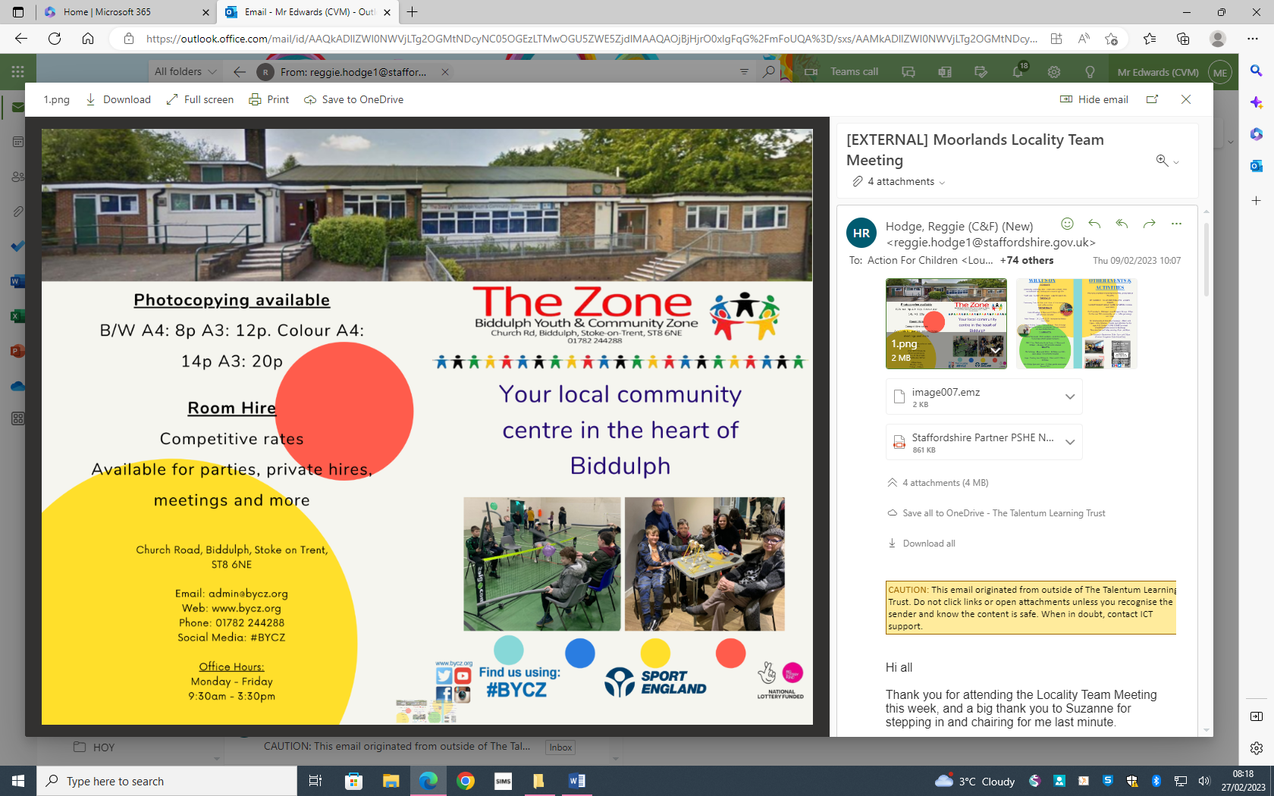

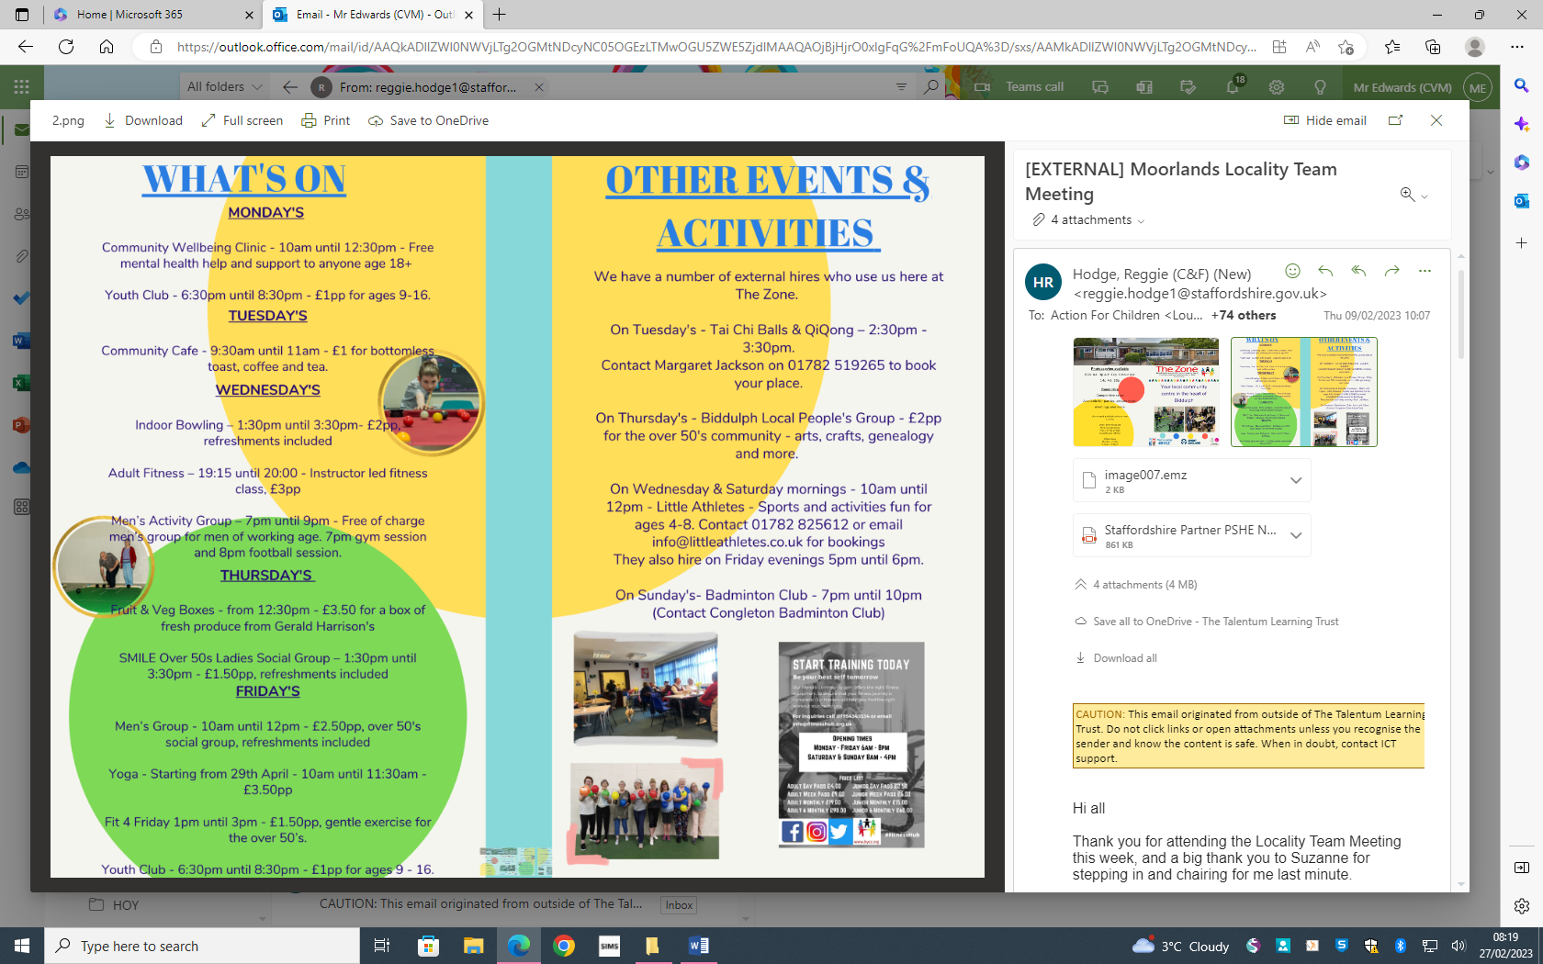

**Training**

[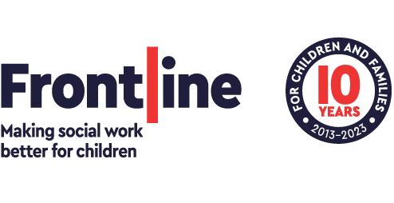](https://thefrontline.org.uk/)

Frontline have an exciting opportunity for Practice Supervisors to get an insight into the Frontline Pathways programme and how it can support leadership and development.

Pathway 1, for Practice Supervisors, will empower you to model and develop excellent social work practice and leadership in others. Whether this is your first step into leadership, or you are looking to develop your skills further, the programme will help take your leadership to the next level.

Join online on **Wednesday, 8 February 2023** at **12.30pm** to hear how Pathway 1 can support you in your leadership journey.

You will have the opportunity to hear:

* What you will learn on the Pathways programme
* How you and your team will benefit from Pathway 1
* How to submit your application

Register for the event [here](https://frontline.zoom.us/meeting/register/tZEvf--opzwoHtLwCkZBocOlDNJY-RKsB3DL)

You can also learn more and apply on our [website](https://thefrontline.org.uk/pathways-programme/pathways-programme-apply/)

If you have any questions please reach out to [partnerships@thefrontline.org.uk](mailto:partnerships@thefrontline.org.uk)



[Lunch & Learn Sessions (staffordshire.gov.uk)](https://learn.staffordshire.gov.uk/mod/facetoface/view.php?id=11388)

[Working with Separated Parents - practical tips (staffordshire.gov.uk)](https://learn.staffordshire.gov.uk/mod/facetoface/view.php?id=11016)

[Promoting Healthy Parental Relationships – understanding parental conflict (staffordshire.gov.uk)](https://learn.staffordshire.gov.uk/course/view.php?id=1618)

[When couples become carers – parental relationships where children have SEND (staffordshire.gov.uk)](https://learn.staffordshire.gov.uk/course/view.php?id=1622)

[Having Courageous Conversations with parents and carers (staffordshire.gov.uk)](https://learn.staffordshire.gov.uk/course/view.php?id=1619)

[Working with Dads and Significant Males (staffordshire.gov.uk)](https://learn.staffordshire.gov.uk/course/view.php?id=1621)

**Child death prevention newsletter**

Please see below attached:



**Probation training**

Please see below attached:



**Spring SUN Session dates**

Please see below attached:



**Careers support Club**

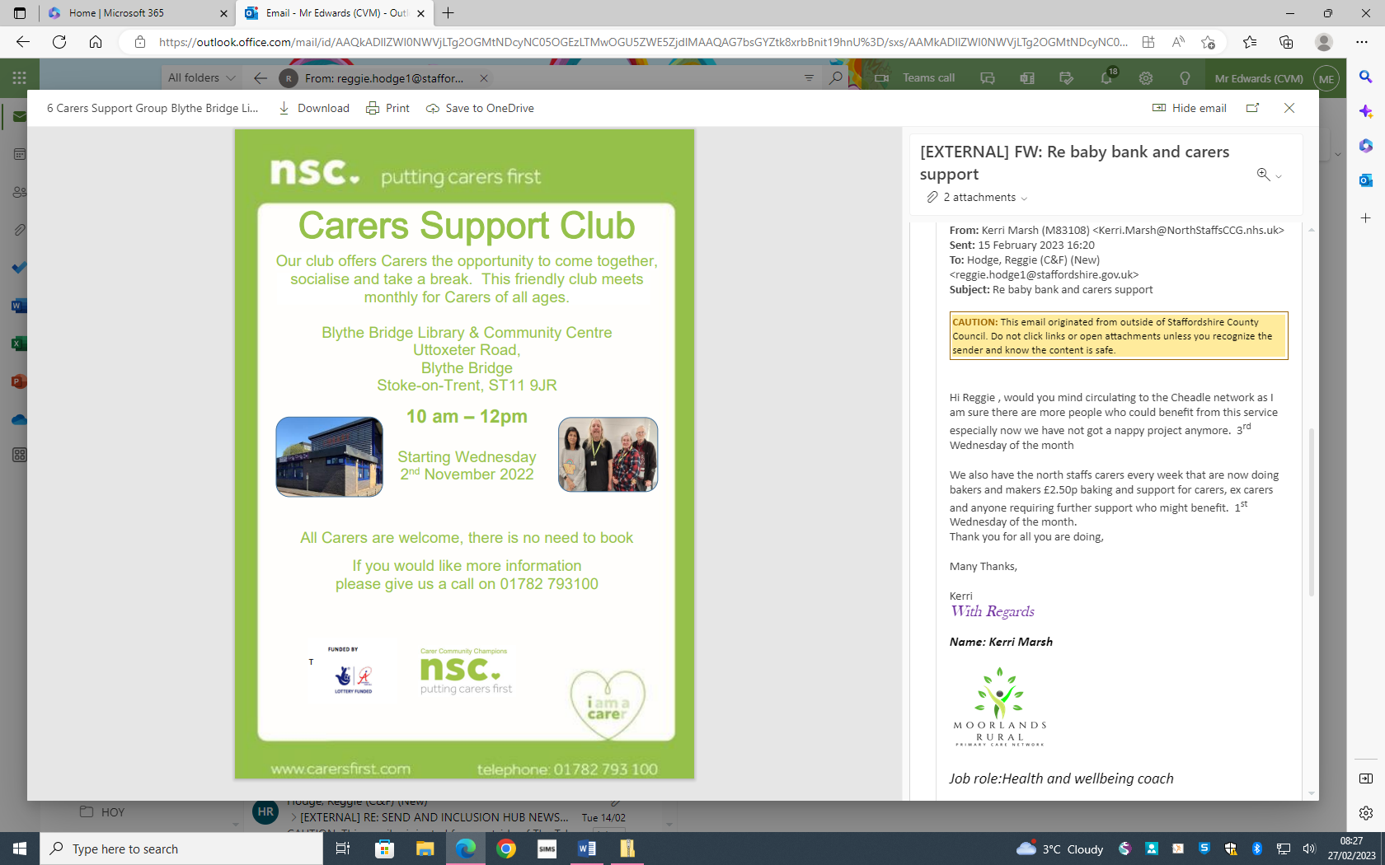

**Baby Bank**

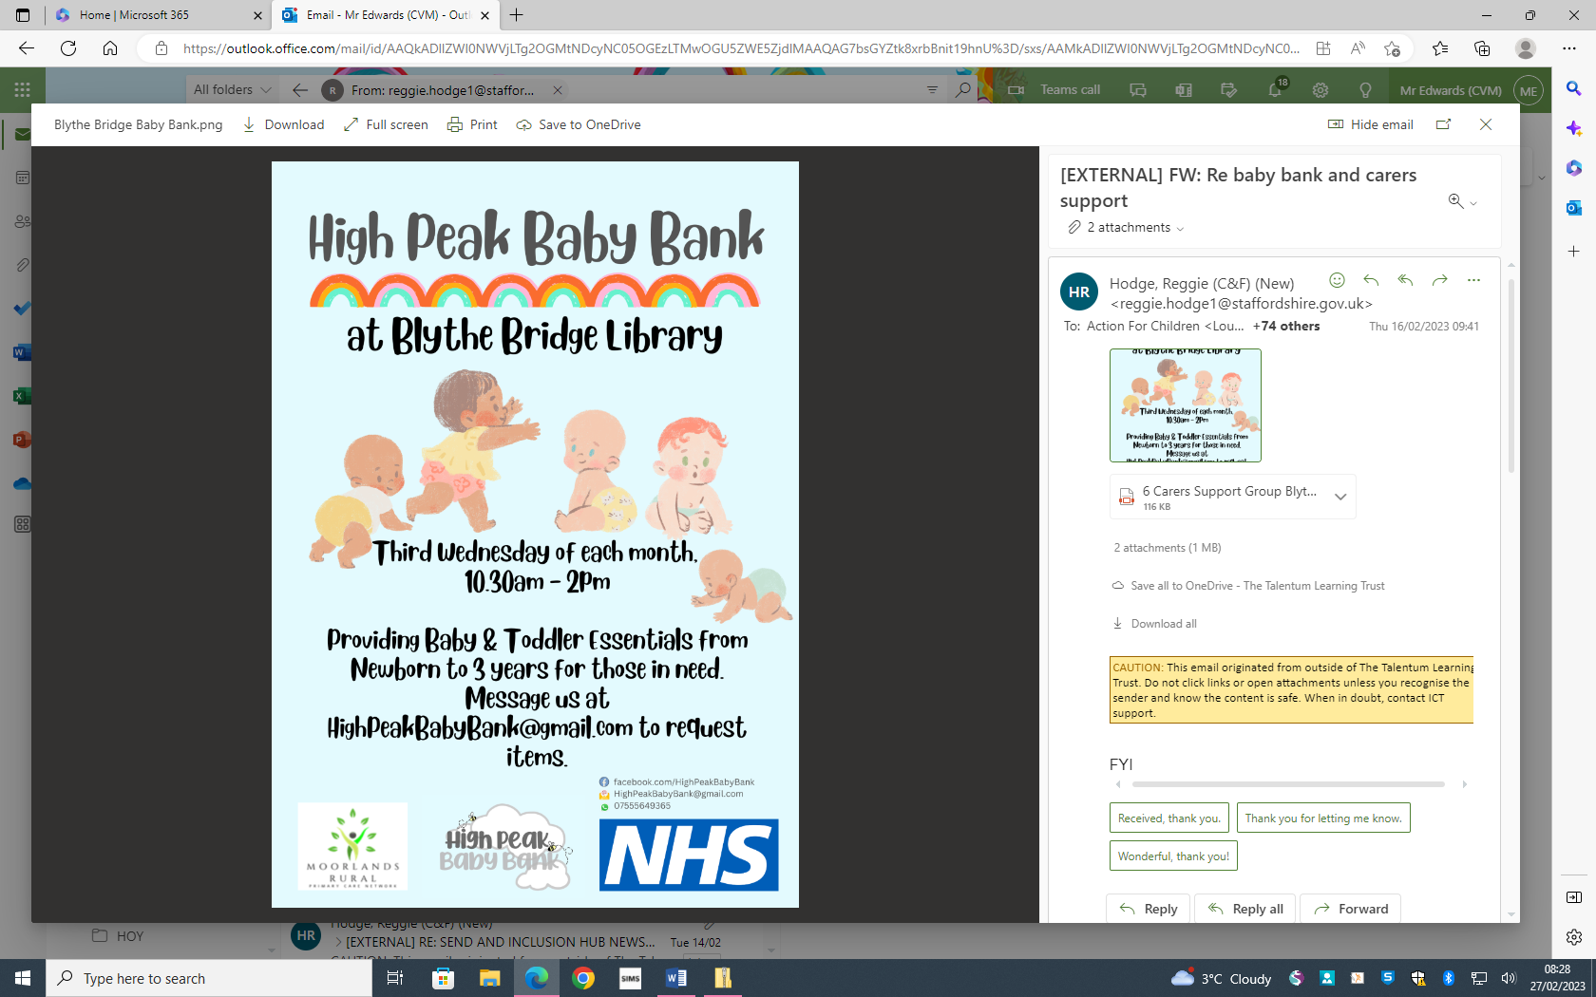

**Claire's Law - Know Your Rights**

‘**What is Clare’s Law’?**

Clare’s Law is named after Clare Wood who was murdered by her ex-boyfriend George Appleton in 2009.

Following her death and after five years of campaigning, Clare’s father, Michael Brown, managed to change the law to allow police to inform people of their partners’ criminal records and relevant past convictions.

Clare’s Law was finally introduced in England and Wales in 2014 under the official title of the Domestic Violence Disclosure Scheme (DVDS).

**Under Clare’s Law, you have the right to:**

·      Make an application to the police requesting information about the person **you are** in a relationship with because you are worried they may have been abusive in the past, and believe they may pose a risk to you in future.

·      Request information from the police about**a person in a relationship with a close friend, neighbour, or family member**, because you are concerned that they might be at risk of domestic abuse in future. This is called the ‘right to ask’.

Abuse isn’t only limited to physical abuse. It can also include harassment, verbal abuse, stalking, psychological threats or manipulation, sexual assault, and violent behaviour. Anyone can experience domestic abuse regardless of age, race, ethnic or religious backgrounds, sexuality, class or disability.

If we do have information to share about the person you've made a request about, we'll only share that information with the person who is at risk of harm or the person who is best placed to protect that person from harm.

We aim to complete applications within 35 working days, but there may be reasons why it takes longer than this. If it does, we will let you know.

If you think someone is at risk, or you suspect or know about domestic abuse happening, please call us on [101](tel:101) or report it to us [online](https://s-url.co/JEUDAA).

More information can be found at : [Request information under Clare's Law: Make a Domestic Violence Disclosure Scheme (DVDS) application | Staffordshire Police](https://s-url.co/JUUDAA)

**Staffordshire Fire & Rescue Service Community Safety News**

Please see below attached:



**FREE Training for partners**

**Promoting Healthy Parental Relationships – understanding parental conflict (delivered via Zoom)**

**One day course – face to face**

This one-day course will give delegates an overview of the keep principles of healthy parental relationships and the impact of parental conflict. It is suitable for people from a range of backgrounds and will provide practical tools and resources to help delegates identify, explore and support parents in conflict.

**Target Audience** – anyone who works directly with children, young people & their parents including school pastoral staff

**Aims**

* To explore the key research and evidence linked to parental conflict in the UK, the effects on children and young people
* To be able to confidently define parental conflict and understand the difference between that and domestic abuse
* To understand the key principles of conflict and how it manifests
* To have knowledge of a range of practical tools to identify, explore and support parents in conflict.
* To consider the importance of our approach and how we build effective relationships with parents
* Have an understating of referral and signposting options for further support.

28th February 2023                   9.30 a.m. – 4.30 p.m.

27th March 2023                        9.30 a.m. – 4.30 p.m.

Places can be booked by emailing delegate name, email address and organisation to [children.families.training@staffordshire.gov.uk](mailto:children.families.training@staffordshire.gov.uk)

**Promoting Healthy Parental Relationships - OnePlusOne’s practitioner training (delivered via TEAMS)**

**Who is the training for?**

This training is for Family Practitioners.

You will be trained in the use of three digital resources designed to reduce parental conflict with three different audiences:

• Me, You and Baby Too for new parents

• Arguing better for parents experiencing stress and conflict

 • Getting it Right for Children for separating or separated parents

Having constructive, supportive relationships has never been more important. These evidence-based resources have been built to help couples strengthen their relationship and manage their conflict better, and to help separated parents understand how conflict can affect their children.

**What can I expect to learn?**

The sessions aim to enhance your knowledge, understanding, skills, and confidence to work with parents.

By the end of the training you will be able to:

• Raise parents’ awareness of the issue of parental conflict. • Use digital resources to help parents recognise conflict

 • Enable parents to develop positive communication skills and helpful conflict behaviours.

**How is the training delivered?**

This is a digital training, which takes place on Microsoft Teams. It is delivered over two consecutive half-days.

Each day’s training is three hours.

**Session 1:**

• The impact of parental conflict on children’s outcomes. • Background to the design of the digital resources.

 • Introduction to OPO digital resources.

**Session 2:**

• A chance to explore the digital resources for yourself.

• Skills for working with parents.

• Further help and support.

**Dates/times**

Monday 27th March, 9.30 - 12.30

Tuesday 28th March, 9.30 - 12.30

Thursday 30th March, 9.30 - 12.30

Friday 31st March, 9.30 -12.30

Monday 17th April, 9.30 - 12.30

Tuesday 18th April, 9.30 - 12.30

Monday 24th April, 9.30 - 12.30

Tuesday 25th April, 9.30 - 12.30

Places can be booked by emailing delegate name, email address and organisation to [children.families.training@staffordshire.gov.uk](mailto:children.families.training@staffordshire.gov.uk)

**FSOS Factsheet**

Please see below attached:

