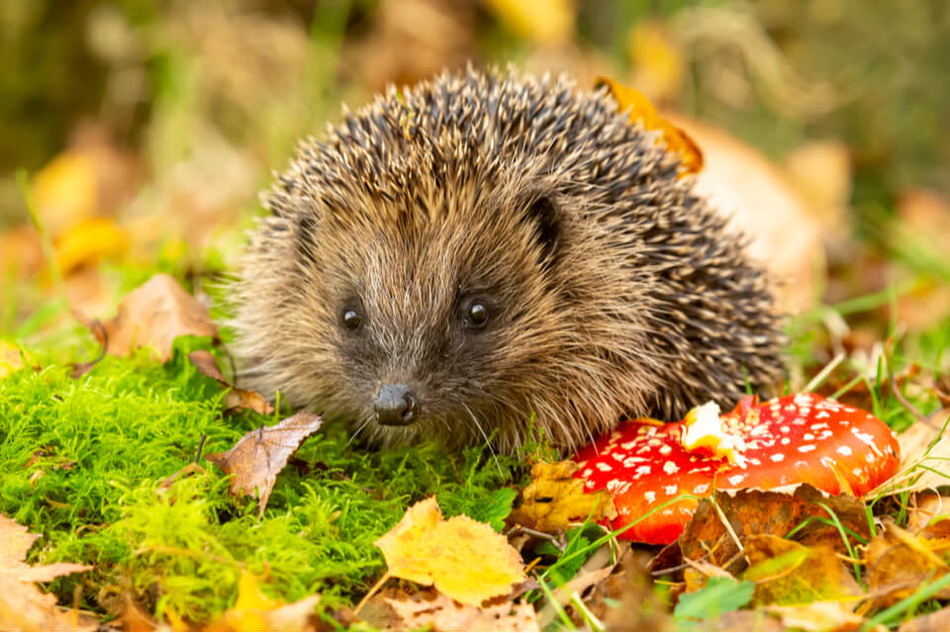
Hedgehogs Blog - W/B 10.10.2022

Hi everybody,
We have had a lovely week in Hedgehogs class this week! We have been exploring Harvest activities such as going on an autumn walk and hunting for pumpkins in the sensory garden!

Here are some key things we have done this week:
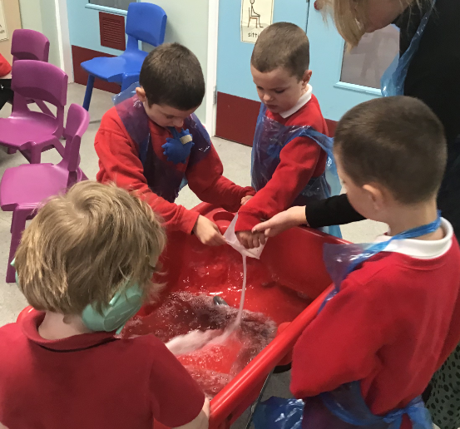
- Harvest song with Makaton – ‘Dingle Dangle Scarecrow’
- Phase 1 and 2 Phonics – exploring sounds and identifying the ‘a’ sound
- Maths – Representing and comparing 1, 2, and 3
- Fine motor skills – making our own Autumn sensory bottles
- Art – Fruit and vegetable printing to make Harvest pictures
- Music – Exploring sounds using metallic everyday items
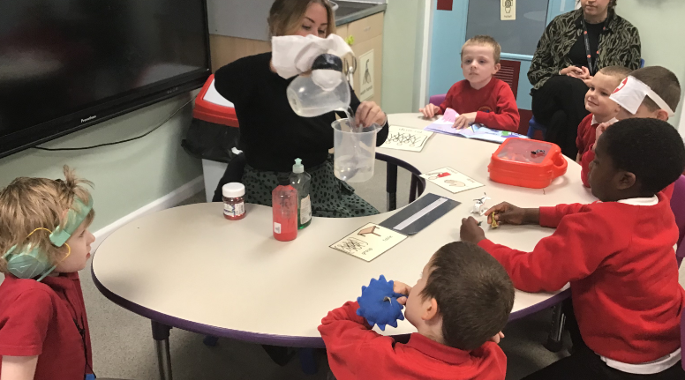
- History – Florence Nightingale sensory story and practising our pouring and mixing skills to create our own magic medicine
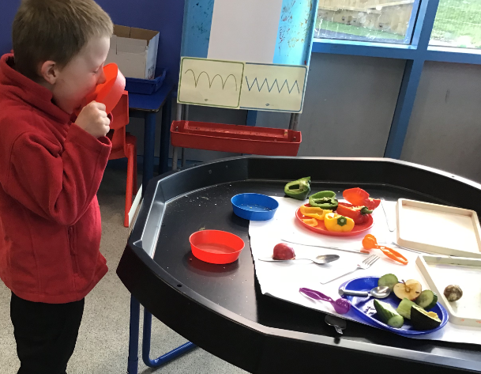

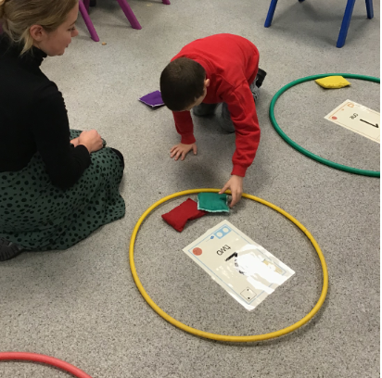
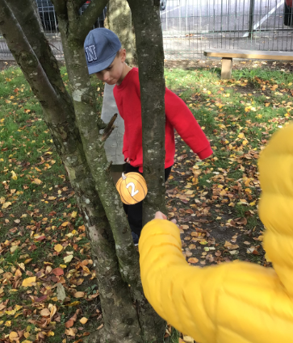
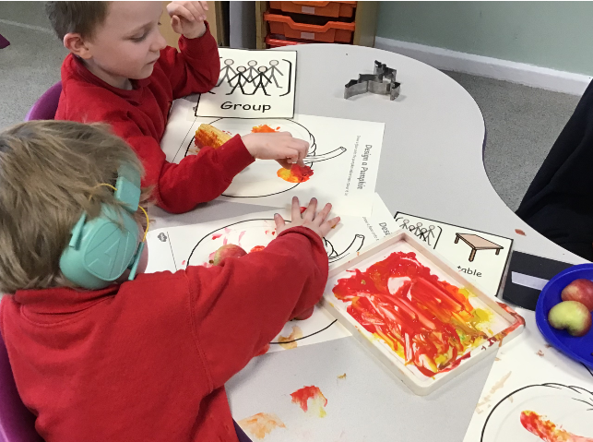

Please can I remind you to send in waterproofs, wellies and a warm, waterproof coat as we will be making the most of learning opportunities outside throughout the autumn/ winter.
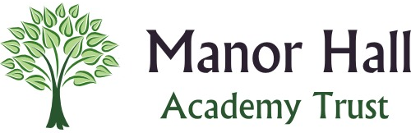
Many thanks,
Demi and the Hedgehogs Team ☺

