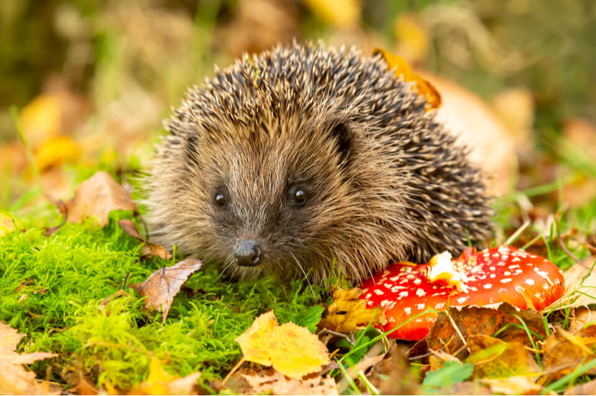
Hedgehogs Blog - W/B 03.10.2022

Hi everybody,

It was World Animal Day this week – thank you for sending in your child’s favourite toy animal! We loved exploring the reptiles with the animal man!

Here are some key things we have done this week:
- Sensory story – ‘Cops and Robbers’
- Phase 1 and 2 Phonics – exploring sounds and identifying the ‘s’ sound
- Maths – Creating repeating patterns and exploring the sensory garden to create patterns with the autumn leaves
- PE – Practising our ball skills and travelling in different ways/ Swimming!
- RE – Story: ‘The Good Samaritan’ – sharing and turn taking through pass the parcel
- Art – Selecting our own colours via PECs and exploring mixing colours
- Music – Playing the drums to represent animal sounds
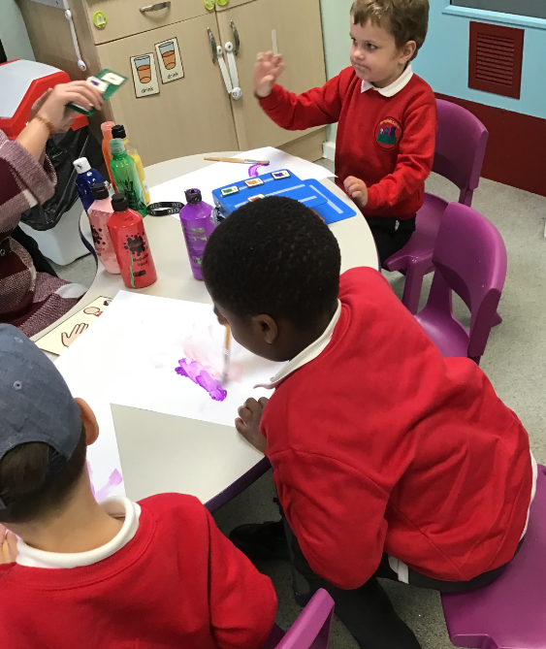
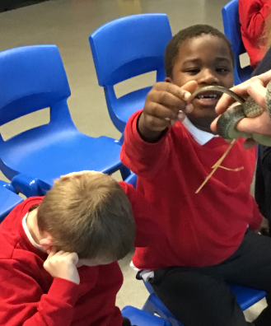
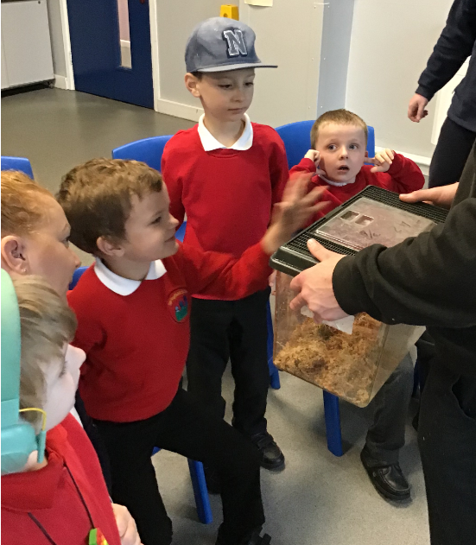

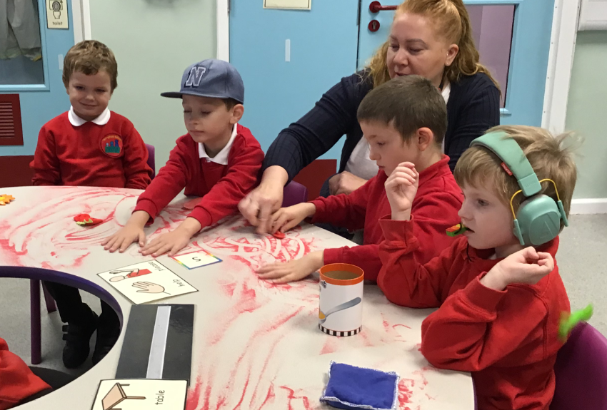
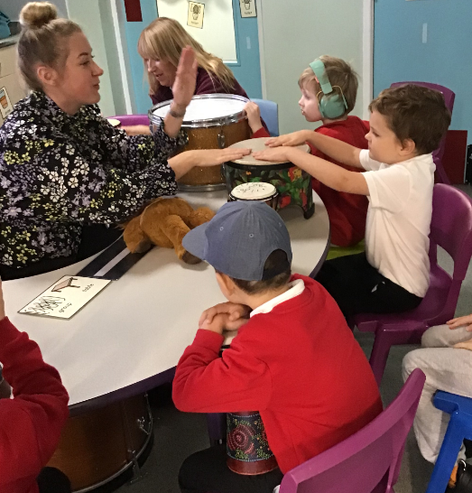
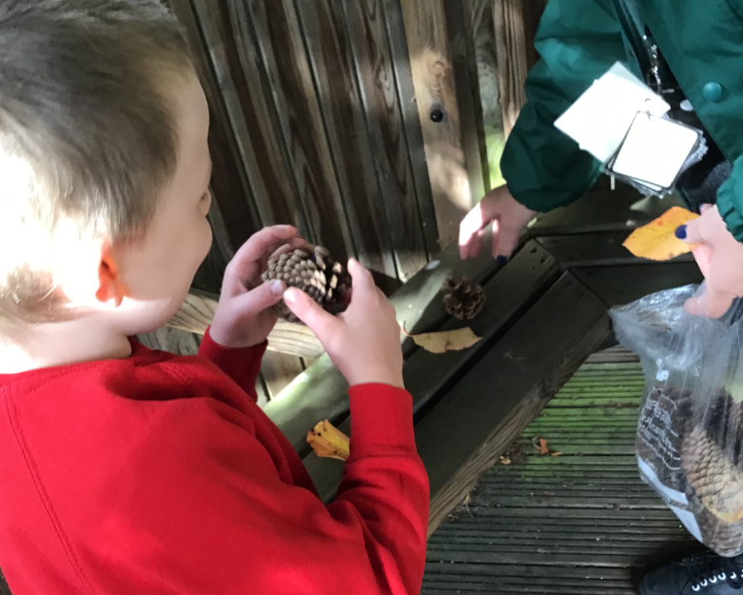

Please can I remind you to send in waterproofs, wellies and a warm, waterproof coat as we will be making the most of learning opportunities outside throughout the autumn/ winter.

Many thanks,

Demi and the Hedgehogs Team ☺

