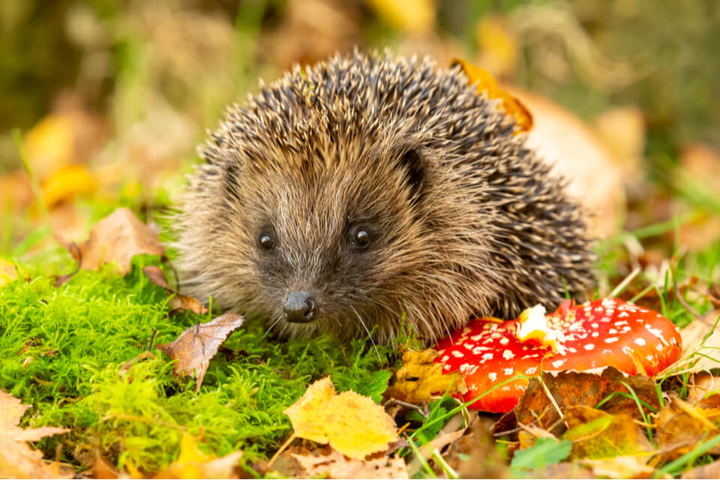
Hedgehogs Blog - W/B 26.09.2022

Hi everybody,

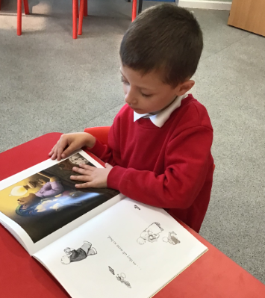
We have had a hardworking week in Hedgehogs class this week! Here are some of the things that we have been up to…

Here are some key things we have done this week:
- Sensory story – ‘Cops and Robbers’ – exploring the props
- Maths – Exploring ‘big’ and ‘small’
- Science – collecting autumn leaves on an autumn walk to explore seasonal changes
- PE – Exploring the glow in the dark equipment and practising our throwing, catching, rolling and kicking ball skills
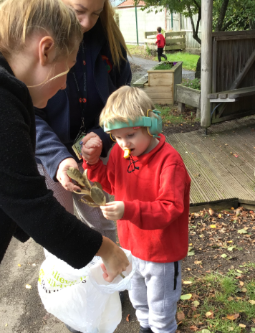
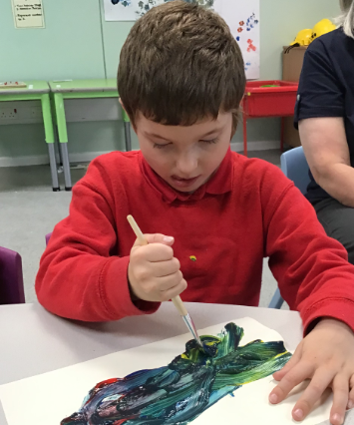
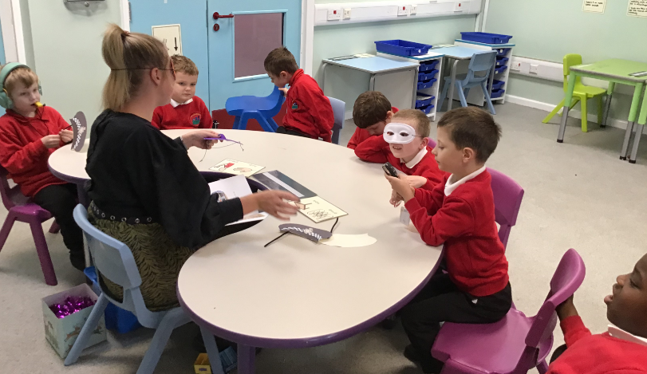
- Exploring the sensory room
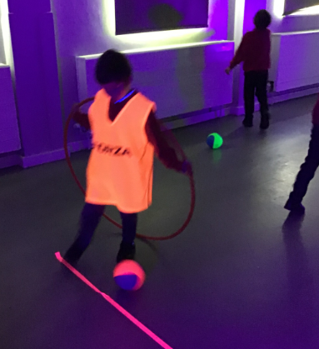
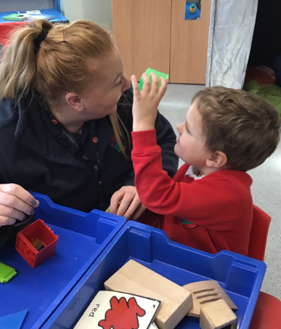
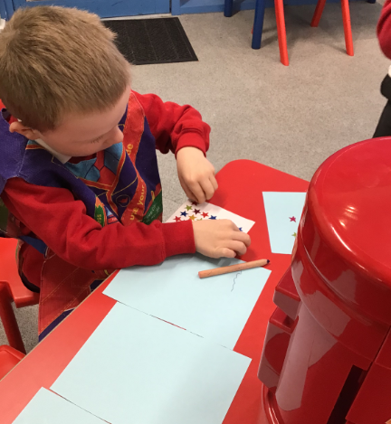

Please can I remind you to send in waterproofs, wellies and a warm, waterproof coat as we will be making the most of learning opportunities outside and in the Forest School area.
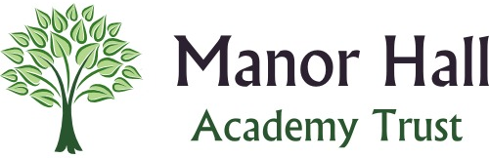
Many thanks,

Demi and the Hedgehogs Team ☺

