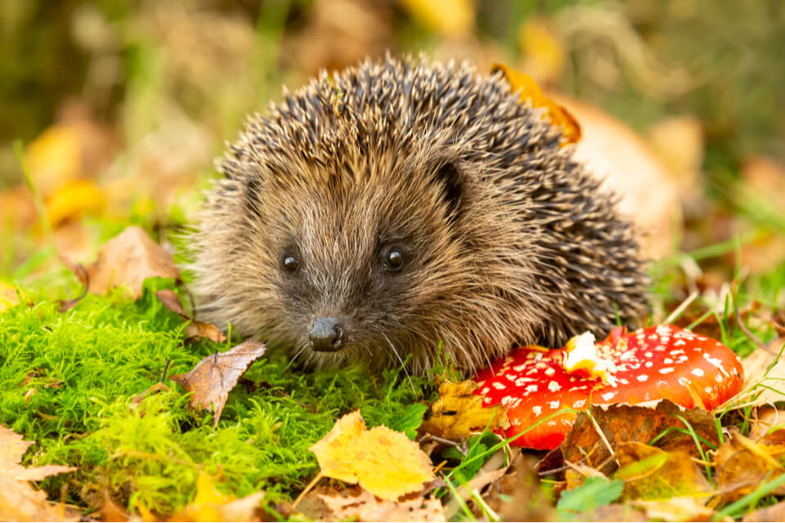
Hedgehogs Blog – Spring Term

Hi everybody,

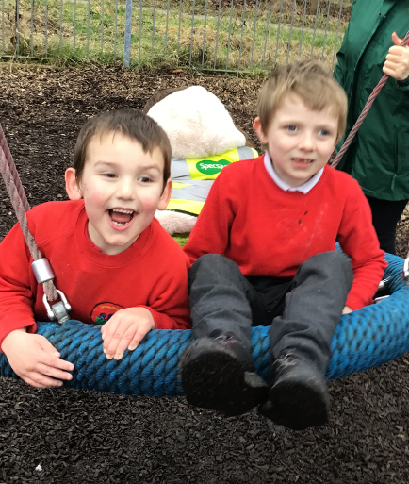
It has been a fun-packed term exploring our topic: ‘Space’. We have had a visit from an astronaut in class, practised our moon walking, made moon sand, explored Earth from our in-class space shuttle (using our new sensory tent), engaged in many space themed attention autism sessions, and explored sensory stories such as ‘How to Catch a Star’ and ‘The Way Back Home’.

We have also visited a church for an Easter Egg hunt as part of our RE topic ‘Why do Christians celebrate Easter?’ and we have been exploring our local area by going on minibus journeys and visiting our local park. We are hoping to continue to explore our local community in the summer term too!

Have a lovely Easter and we will see you back in school on Monday 8th April 😊
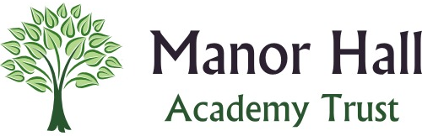
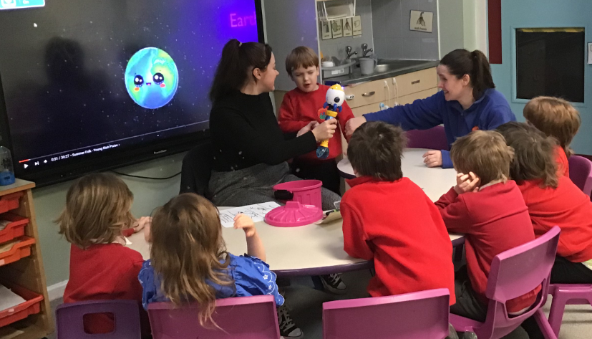
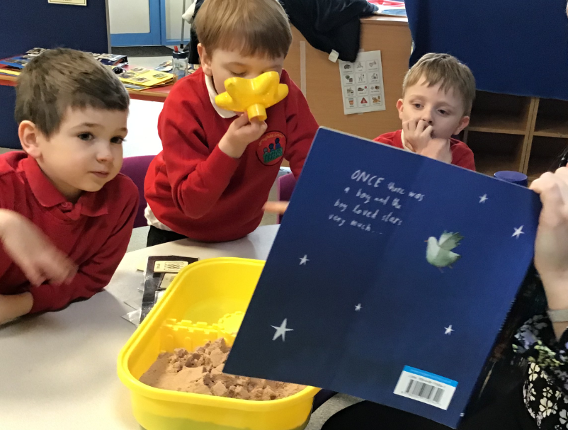
Many thanks, Demi and the Hedgehogs Team


