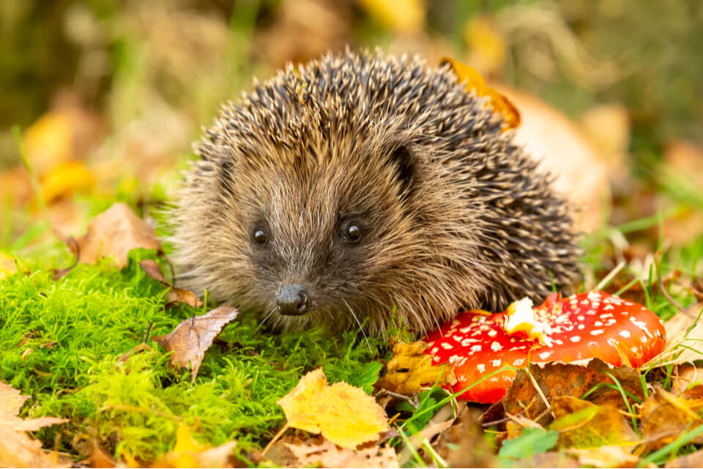
Hedgehogs Blog – Autumn Term 1

Hi everybody,

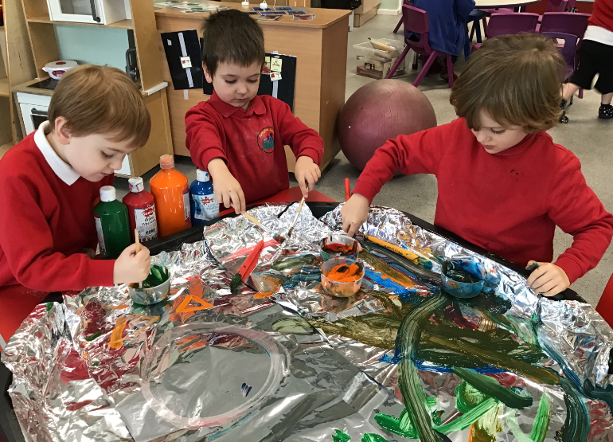
We have had a lovely start to the year, exploring a range of activities linking to our topic ‘Everyday Life’. Everyone is settling into their new class really well and all the children are beginning to make friends with each other, which is lovely! We are beginning to develop our skills in turn taking activities, Intensive Interaction, sensory diets and sensory circuits, and transitioning. We have also been developing our attention and listening skills through regular ‘Attention Autism’ (bucket time) sessions, where we started at stage 1 and some of us are now exploring all 4 stages! Here are some photos of what we have been up to this half term!
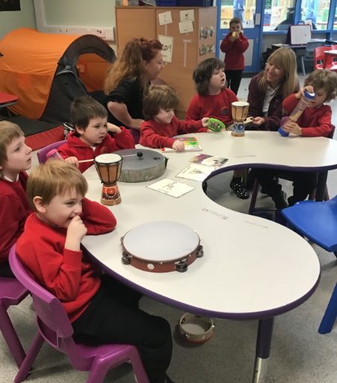
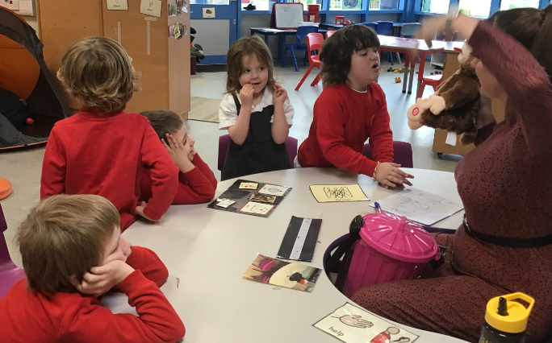
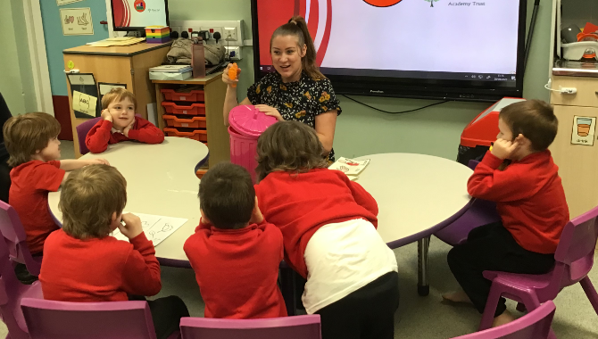

Please remember to check dojo for any messages and photos! Have a lovely half term 😊
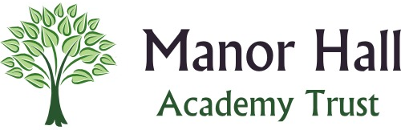
Many thanks,
Demi and the Hedgehogs Team ☺

