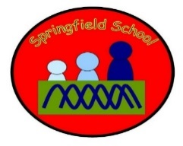 Badgers Class Medium Term Planning for Geography Spring Term 2024
Topic  Seas and Oceans  Investigate the oceans of the world.  Sort land/sea animals and habitat features, | Geography will be incorporated into other lessons including English through texts, art and Design Technology each week. There will be specific planned opportunities to support the children’s progress and may be altered to suit the needs of the children during the term.  Continuous provision will also enhance the opportunities to explore Seas and Oceans through play and sensory activities.  Key vocabulary – Sea, ocean, water, salt water, land, beach

Week 1  CC Science  Explore marine environment through sensory exploration | Week 2  Name and match sea creatures | Week 3  Explore sands and rocks and relate to different types of beaches. | Week 4  Model rivers into seas by pouring salt water through channels into the ‘sea’ | Week 5  Explore sea pollution by adding litter to model rivers

Take the objectives for the LO stickers from this section
Substantive Knowledge (Content) | Disciplinary Knowledge (Skills)
Children learn to match and name the plants and animals of the seas and oceans  Children learn that beaches can be sandy or rocky  Children learn about the movement of water and the flowing of rivers into the sea.  Learn that the sea can be polluted. | - Show attention to rivers and sea exploration  - Explore and engage in creating sea environments  - Match sea creatures and plants.
Progression of Learning History

