Weeks | 1 | 2 | 3 | 4 | 5 | 6 | 7 | 8 | 9 | 10 | 11 | 12
Autumn | Number and Place Value  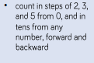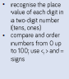  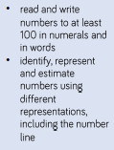 |  |  |  | Addition and Subtraction  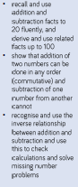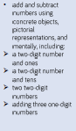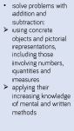 |  | Measurement  Money  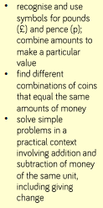 |  | Number  Multiplication and Division  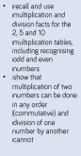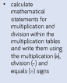

Weeks |  | 1 |  | 2 | 3 |  | 4 |  | 5 |  | 6 | 7 | 8 | 9 | 10 | 11 |  | 12
Spring | Number and Place value  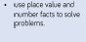 |  | Number Multiplication and Division  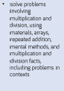 |  |  |  | Statistics  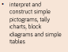  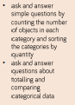 |  |  | Geometry  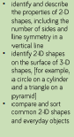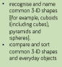 |  |  |  | Number Fractions  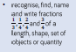  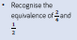  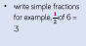 |  |  | Measure  Height  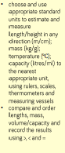
Summer | Number and Place value |  |  |  |  | Geometry Position and Direction  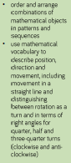 |  | Problem  Solving |  | Measurement Time  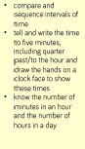 |  |  |  | Measurement Mass, Capacity  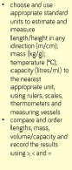 |  |  | Investigations

Weeks | 1 | 2 | 3 |  | 4 |  |  | 5 | 6 |  | 7 |  | 8 |  | 9 | 10 |  |  | 11 | 12
Autumn | Gorilla -Anothony Brown |  |  |  |  |  | Voices in the Park – Anothoy Brown |  |  |  |  |  | Handwriting |  |  |  | Creative writing.
Spring | Poerty and Poetry Techniques |  |  |  |  |  | Non fiction – 100 Remarkable Women who made History |  |  |  |  |  | The Worst Witch- Jill Muphy
Summer | Charlie and the Chocolate Factory – Raold Dahl |  |  |  |  |  |  |  |  |  |  |  | Report Writing
Communication | Use of symbols  Use of PECs and GRID  Use of sign  Discussion
Speaking and Listening | Responding with 1-2 word answers. Responding with 3-5 word phrases. Developing clarity of speech sounds.  Sitting in group and listening/attending. Develop length of concentration.  Develop discussion and debate through contribution.  Exploration of vocabulary.  Through questioning articulate and justify answers.
Reading for pleasure opportunities | Choice of recommended texts:  See bags in Library area. Pupils choice.  Class stories: George’s Marvellous Medicine – Roald Dahl  Billionaire Boy – David Walliams |  |  | Range of non-fiction texts around topic themes –  Great Fire of London  Wonder Women  Pioneers |  |  |  |  |  | Research on motivating topics using ICT. |  |  |  | Appropriate News Papers and magazines
Phonics | Daily phonics session  4 part lesson  Use of BUG Club  Phase 2-5 including grammar, spelling and comprehension group- These pupils are beyond Phonics.
Individual Reading | Reading books - Individual books that are shared at home that the children can succeed at and have changed on a regular basis. Reading takes place with a variety of staff in the class; however changing the books is the responsibility of the class lead to ensure books are well matched to their level of communication or phonics. Reading schemes include: Personalised books, Oxford Reading Tree & Bug Club
Reading Opportunities | Reading symbols, matching pictures, reading words, reading sentences, building symbol sentences, building word sentences. Reading text, development of comprehension and inference.
Writing Opportunities | Writing will follow a range of frames: TALK for WRITING, Parts Tips and Examples, Colourful Semantics. These will be used to develop grammar and sentence structure.  Opportunities will include: the use of symbols, articulate and copy write, and independent writing using the above structures.  Content will be specific to the key text or learning aspect and working walls will include structures and key vocabulary and texts. Target grapheme, phoneme correspondents.
Handwriting | Daily practice – pre writing skills: the use of media. Handwriting patterns, writing names. The use of taught sessions: Handwriting to develop ascenders, descenders and caterpillar letters. Range of structures including specific lines and boxes to encourage precision handwriting.
Spelling | Linked to phonics, given as homework and practised within phonics and the wider English curriculum.
SPAG-  Y2 ARE | Grammar – Conjunctions  - Nouns, adjectives and verbs  - Expanded noun phrases |  |  |  |  | Punctuation –Questions and Question marks  - Exclamation sentences  - Using commas in lists |  |  |  |  |  | Spelling – Homophones  Prefixes  Suffix  Using apostrophes – contractions  Plural noun |  |  |  |  |  | Vocabulary – Progressive verbs  - Past and present tense  - Expanded nouns phrases

