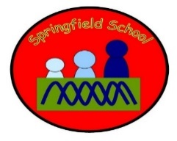 Rabbits Class Medium Term Planning for English Summer Term 1 2023
Topic: Pirates
Where’s Mr Pirate?
(Week 1-2)
The King’s Pants (King’s Coronation Links)
(Week 3-4)
That’s not my pirate
(Week 5-6)
Attention Autism – linked to texts /theme | Intensive Interaction | Dough disco
Individual SALT programmes | Fine motor skills | Squiggle Time – Mark making
Phonics - for identified pupils | Gross motor skills – Including sensory circuits | Matching tasks

