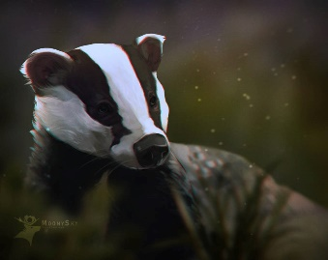 Blackbirds Weekly Blog 7th to 11th September 2022
This Photo by Unknown Author is licensed under CC BY-NC-ND
Monday | On Monday, we took our PE skills outside and did some brilliant balancing on lots of the PE equipment. In Science we explored materials that bend.  We also worked on our personal targets and read
Tuesday | On Tuesday, we worked on full and empty with dried pasta and then explored with other materials. We did some choosing and communicating with the Tap Tap box and listened and signed to some transport songs
Wednesday | On Wednesday we chose and listened to our favourite rhymes using PECS, we also continued our work on bendy materials.
Thursday | Today in D and T we explored and had a go at building wheeled toys with lego, carried on with volume work using coloured water and got very wet. We also worked on our personal targets. In the afternoon we explore transport toys that travel on water and by road outside in the sunshine
Friday | This morning we followed our schedules, read and worked on communication. In the afternoon we had sensory play and choice with a celebration of Ollie’s Birthday and cake at snack time!
Things to remember | Labels on all clothing and belongings please.  Parents evening Tuesday 18th October.

