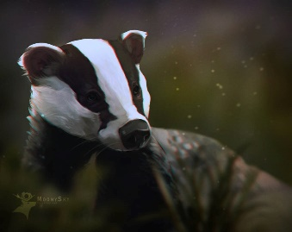
This Photo by Unknown Author is licensed under CC BY-NC-ND
Badgers Weekly Blog 10th to 14th October 2022
Monday | On Monday, we took advantage of the sun and again practiced our PE skills outside. We were balancing on lots of the Forest Schools equipment including tyres and wooden boards. We used our balancing skills really well. In Science we explored materials that can be twisted including cheese strings!  We also worked on our personal targets and read
Tuesday | On Tuesday, we worked on pattern making and had fun with a messy Attention Autism! We did some choosing and communicating with the Tap Tap box and listened and signed to some transport songs
Wednesday | On Wednesday we chose and listened to our favourite rhymes using PECS. In maths we carried on with repeating patterns. We also had our first trip on the minibus with a drive around the local area to get used to transitioning onto and off the bus. We did really well.
Thursday | Today in Geography we role played a plane journey and explored lots of items related to a foreign holiday including ice-cream and lollies! We also continued our work on our twisty materials in science and did some music.
Friday | This morning we followed our schedules, read and worked on communication. In the afternoon we had sensory play and choice with a celebration of Jamie’s 30th Birthday and cake at snack time!
Things to remember | Labels on all clothing and belongings please.  Parents evening Tuesday 18th October.  Don’t worry if you don’t have an appointment, it will be very informal so pop along between 3.30 and 5.30 on the day.  Do however, please let me know if you wish to speak privately.

