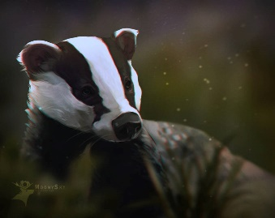
This Photo by Unknown Author is licensed under CC BY-NC-ND
Badgers Weekly Blog 14th to 18th November 2022
Monday | Today we worked hard on communication using PECS making choices, did some number work and read.
Tuesday | On Tuesday, we worked on number and had fun with a messy Attention Autism! We did some choosing and communicating with PECS, read and explored sensory materials.
Wednesday | Today some of us went swimming and the others enjoyed lots of physical activities outside with the soft play, trampoline, bikes and scooters. In the afternoon we did messy play and dough disco.
Thursday | Today we did printing shapes with potatoes, read our books, practiced for our Christmas concert and worked on communication.
Friday | Today we mixed yellow icing and decorated biscuits, we also enjoyed a visit from Pudsey Bear and had choice in the afternoon.
Things to remember | Swimming kits for Wednesday mornings.

