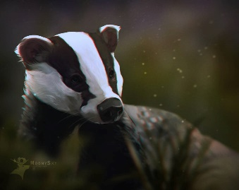
This Photo by Unknown Author is licensed under CC BY-NC-ND
Badgers Weekly Blog 21st to 25th November 2022
Monday | Today we worked hard on communication using PECS making choices, did some number work and read. In the afternoon some of us had a turn at a visit to Morrisons café and the rest of us did Intensive Interaction and Christmas songs
Tuesday | Today we worked on number through Attention Autism. We did some choosing and communicating with PECS, read and explored sensory materials. In the afternoon we did music and movement in the hall.
Wednesday | This morning we worked on communication and number. In the afternoon some of us had out turn at swimming and the others enjoyed lots of physical activities outside with the soft play, trampoline, bikes and scooters.
Thursday | This morning we were amazing at having our photographs taken by the school photographer. We then did reading, schedules and Christmas song practice
Friday | This morning we did work on ‘one more’ in maths and fed a greedy crocodile! We also worked on communication and had choice in the afternoon.
Things to remember | Swimming kits for Wednesday mornings.

