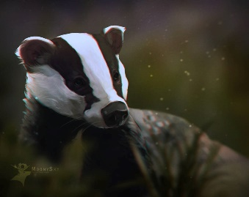
This Photo by Unknown Author is licensed under CC BY-NC-ND
Badgers Weekly Blog 7th to 11th November 2022
Monday | On Monday we danced to some transport songs, did lots of work on communication using PECS and decorated firework biscuits
Tuesday | On Tuesday, we worked on number and had fun with a messy Attention Autism! We did some choosing and communicating with PECS, read and explored and sorted hard and soft materials in science. We also enjoyed lots of bouncing on our new trampoline.
Wednesday | On Wednesday we worked hard on communication, used the bridge area, read,
Thursday | On Thursday some of us went on a little trip on the minibus to the park at Sainsburys. We had fun! We had a fun science lesson making mixtures as well as a mess!
Friday | This morning we painted Remembrance poppies with fingers, hands, rollers and paintbrushes. We also followed our schedules, read and worked on communication. In the afternoon we had choice, there were quite a few iPads out!
Things to remember | Labels on all clothing and belongings please.  Children in Need on Friday. Bring £2 and wear your pyjamas!

