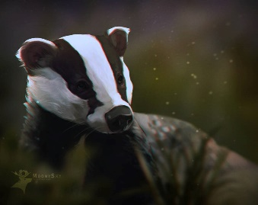
This Photo by Unknown Author is licensed under CC BY-NC-ND
Badgers Weekly Blog 13th to 17th February 2023
Monday | On Monday we worked with our improved communication methods, read and did some sensory activities.
Tuesday | On Tuesday, we made Friendship cards for Friendship day with gluing, choosing and painting. In the afternoon we did sensory PE
Wednesday | In the morning we worked on long and short in maths and made mug cakes in Design Technology. There was a lot of mess! In the afternoon on Wednesday some of the class went swimming and worked on the swimming awards and the rest had some Intensive Interaction.
Thursday | On Thursday we read, looked at our sensory story and learned about family pets! We also did PHSE body parts awareness in the classroom and sensory room.
Friday | This morning we had music and experienced some new and old food songs. We also followed our schedules, read and worked on communication. In the afternoon we had choice, there were quite a few iPads out!
Things to remember | Have a great half-term, it is Shrove Tuesday next week so get your frying pans out!

