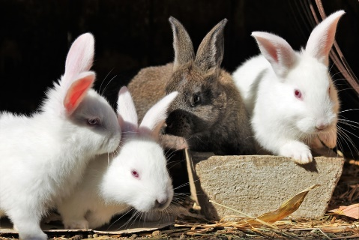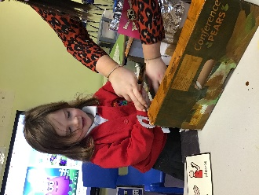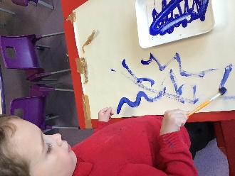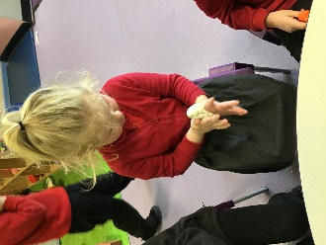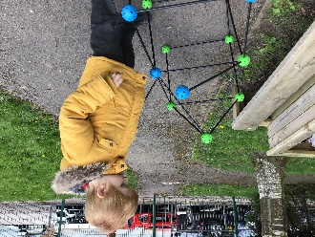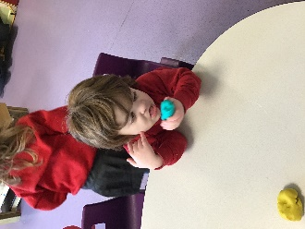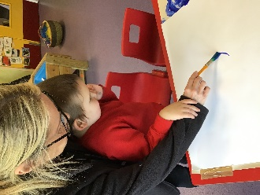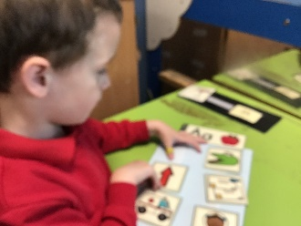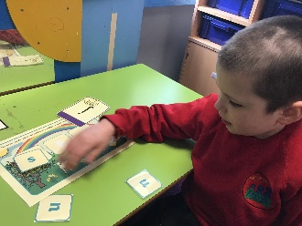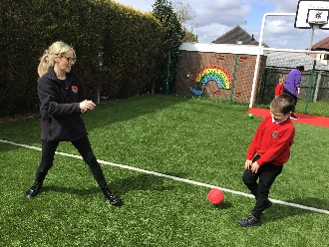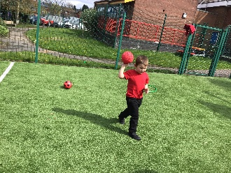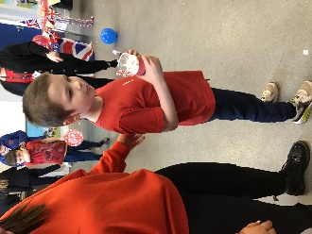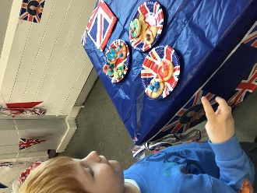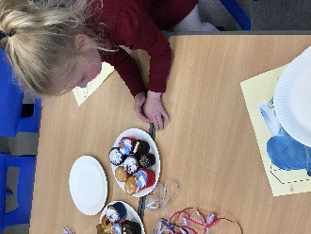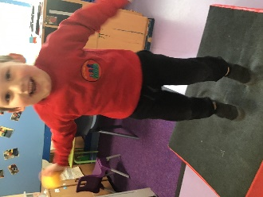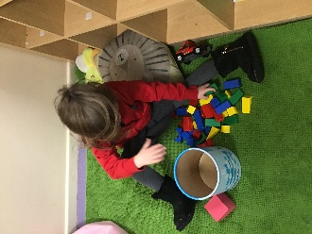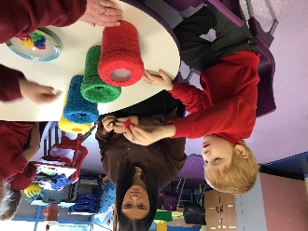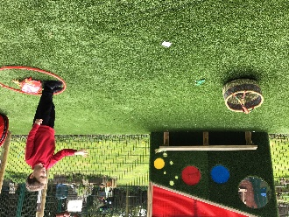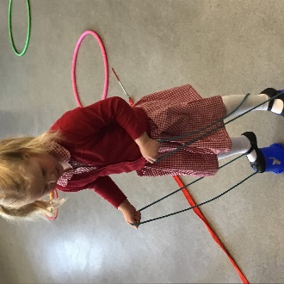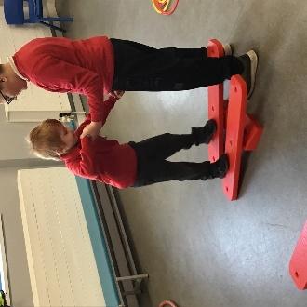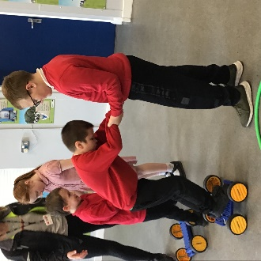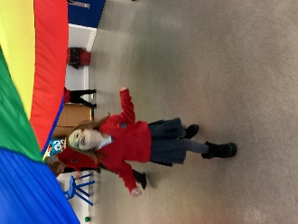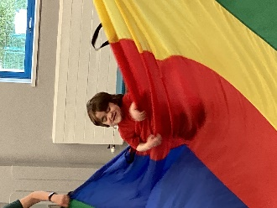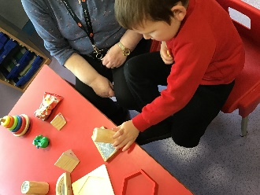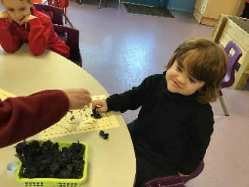

Rabbits Blog

Autumn 2

Well, I think it is safe to say that we are all ready for the Christmas break in Rabbits Class! We have had an amazing first term with the children and have been explored lots of new things. Rabbits are now enjoying mark making and will take any opportunity they can to draw/colour and paint – sometimes we even miss the paper and add a new handprint to the wall 😊

This half term we have learned lots of new things. We have done lots of phonics activities and can recognise different animal sounds. In Maths, we have been ordering numbers and sorting things into big and small and we have enjoyed lots of attention autism activities. We especially love the ones that splat!

We have also had lots of time on the minibus this half term. We have been travelling around Leek looking at the different animals in the farmers fields and getting to know our local area. We even went to meet Santa in his Grotto at Beaverhall! He read us a story as we ate our dinner and gave us an early Christmas present. Rabbits have explored The Nativity and enjoyed listening to the story.

This last week we have been focusing on Christmas and have completed lots of activities based on the tradition. We have explored biscuit making, decoration making, hot chocolate. We have made cards, calendars, hats and have even tried mince pies – although we didn’t like them.

We hope everyone has a lovely Christmas and a Happy New Year, you have all worked very hard and deserve the break! Our next topic is Down in the Garden so make sure to bring your wellies to jump in the muddy puddles!

