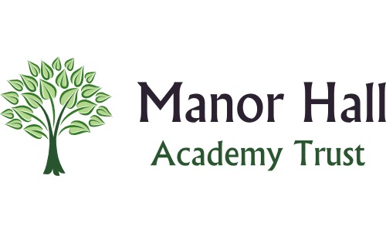
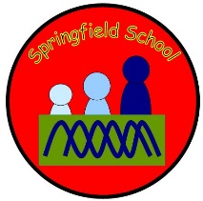 Springfield Newsletter
We are well and truly into the second half term – it’s flying by!
We would like to congratulate Sarah on the birth of baby Alexander Frederick. We can confirm that he is absolutely gorgeous and he had a little visit into school just before half term.
Acting Headteachers are Anna Latos and Helen Summers.
Christmas Events
Blackbirds, Foxes and Badgers
Wednesday 7th December (Afternoon) Christmas Performance
Squirrels and Butterflies
Monday 12th December (Afternoon)
Christmas Performance
Hedgehogs and Rabbits
Friday 9th December (Afternoon)
Chrsitmas Crafts with family
Transport
The queue to drop of pupils is looking very long both in the morning and in the afternoon. Where children are able to walk in can we please ask that parents park on the staff car park at the bottom of Leek High and then walk round with your child. It will be a quicker process for you than waiting in the queue.
If you are in the car please ensure that you pay due care and attention to pedestrians on the pavement as you leave school grounds.
Key Dates for the rest of Autumn Term 2022
Friday 11th November 2022 Remembrance Day
Charity Children in need 18.11.22 – dressing up (or down!) in our pyjamas. £2 donation.
14th – 18th November - Antibullying Week
Thursday 10th November – Y4 transition meeting at the Family Hub
World cup begins 20.11.22
Road Safety week 14th to 20th Nov.
Christmas jumper day 8.12.22 for Save the Children

Recent Ofsted Inspection
We want to say a huge thank you to the whole of the Springfield family. Our recent inspection has gone really well and you should all have received a copy of the report. It can also be found on our school website and on www.gov.uk
Thank you to those that took the time to give your views either online or verbally with the inspectors. Your input was invaluable.
As with any inspection we have targets to work on and we will communicate our development plans around these targets with you very soon.

