Rabbits Class
There will be three adults and 6 pupils in Rabbits class. The pupils are a mixture of Reception and Year One.
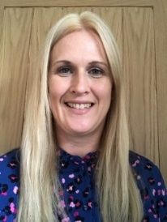 Anna
(I will be based in class part- time as I am Acting Headteacher alongside Helen Summers (Foxes class) for this year)
Sue
Sue will lead the class when I am not based in class.

Molly Jayne

