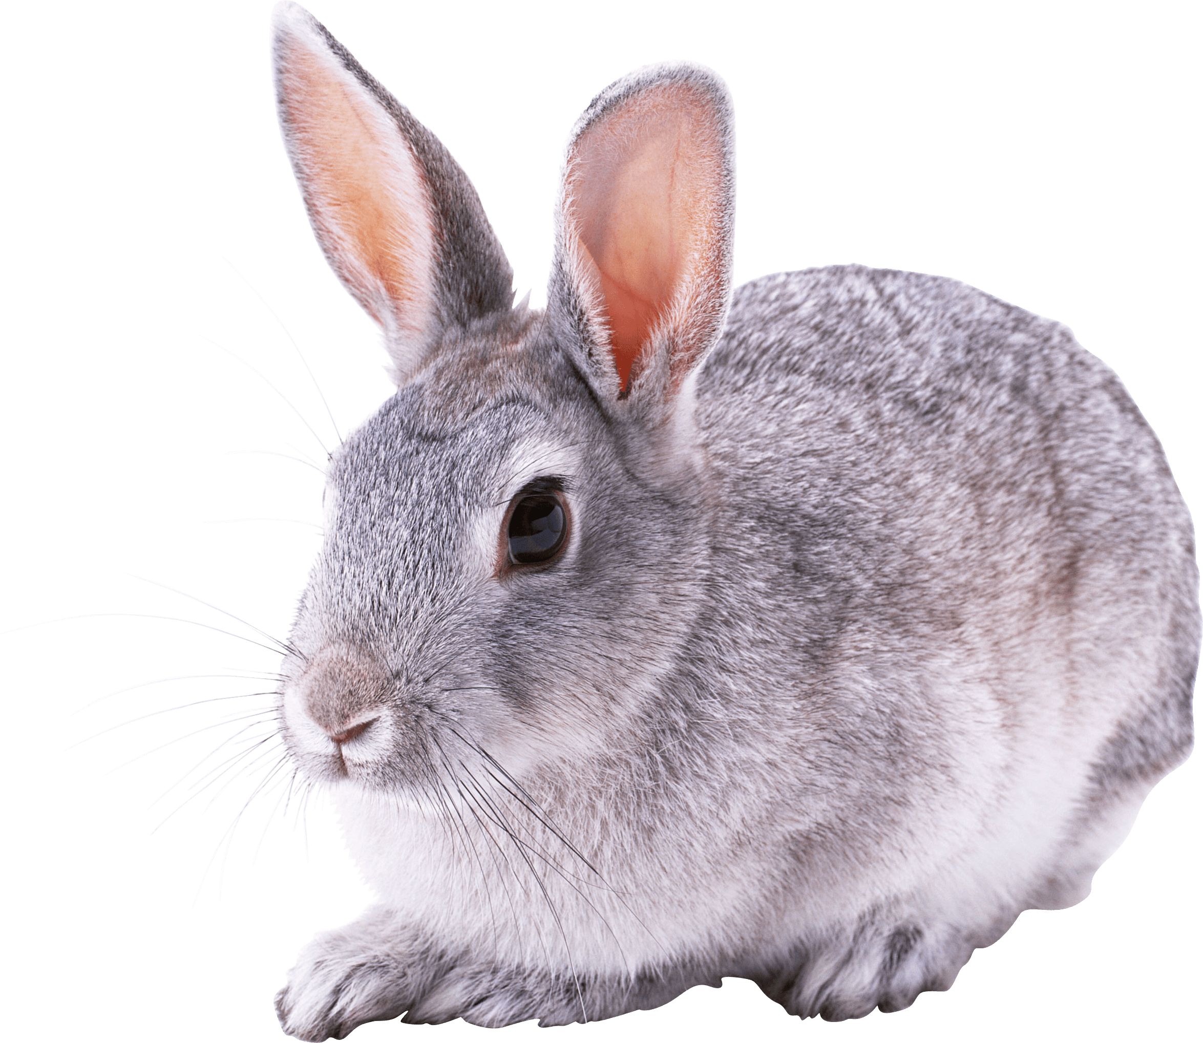Rabbits Blog - W/E 9.12.2022
Hi All,

This week in Rabbits class we have engaged in a range of activities including:

Our activities have been based around Christmas this week. The children have done lots of Christmas activities – however I am not going to share too much as we want to surprise you with the things they have been doing. All I can say this week is that they have done loads and they have something very special to keep of their Christmas 2022 memories in school.

Our PECS is developing really well. We have been working on exchanging a photo for something that we want. We are starting to request a range of items now.

Some of us went swimming this week. We are really loving this! Remember to keep their kit at school if an extra opportunity to go swimming comes up then we can! A couple of us have improved in confidence so much in such a short amount of time!

We have had Christmas jumper day this week and thank you to the parents and grandparents that came into class and had some fun playing with us and our Christmas activities on Friday afternoon.

Scroll down for a few photos of us this week. (Saving the Christmas ones!)

Kind regards
Anna Latos (Rabbits Class Teacher)

