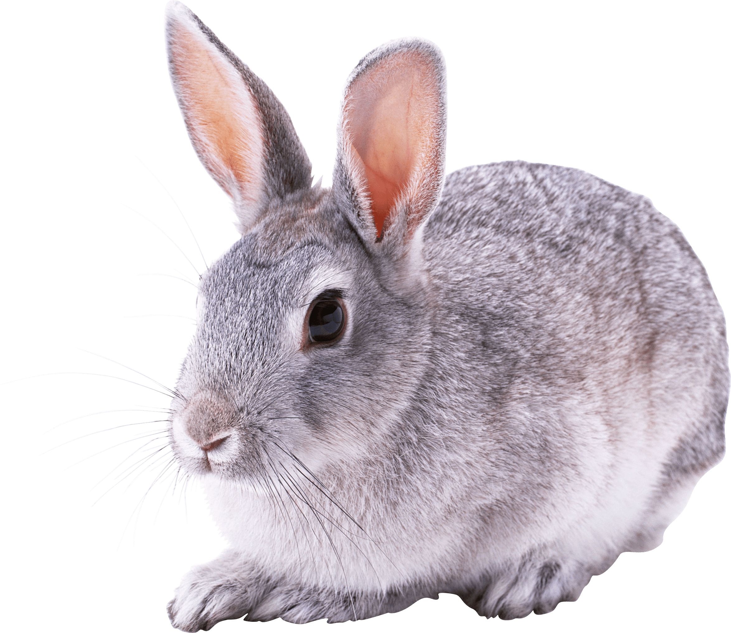Rabbits Blog - W/E 2.12.2022
Hi All,

This week in Rabbits class we have engaged in a range of activities including:

Our activities have been based around Christmas this week. The children have done lots of Christmas activities – however I am not going to share too much as w want to surprise you with the things they have been doing.

Our PECS is developing really well. We have been working on exchanging a photo for something that we want. We are starting to request a range of items now.

Some of us went swimming this week. We are really loving this! Remember to keep their kit at school if an extra opportunity to go swimming comes up then we can!

We have been to the shop today and brought Christmas presents for family. This has been fun and we all went in small groups during the morning.

Scroll down for a few photos of us this week. (Saving the Christmas ones!)

Kind regards
Anna Latos (Rabbits Class Teacher)

