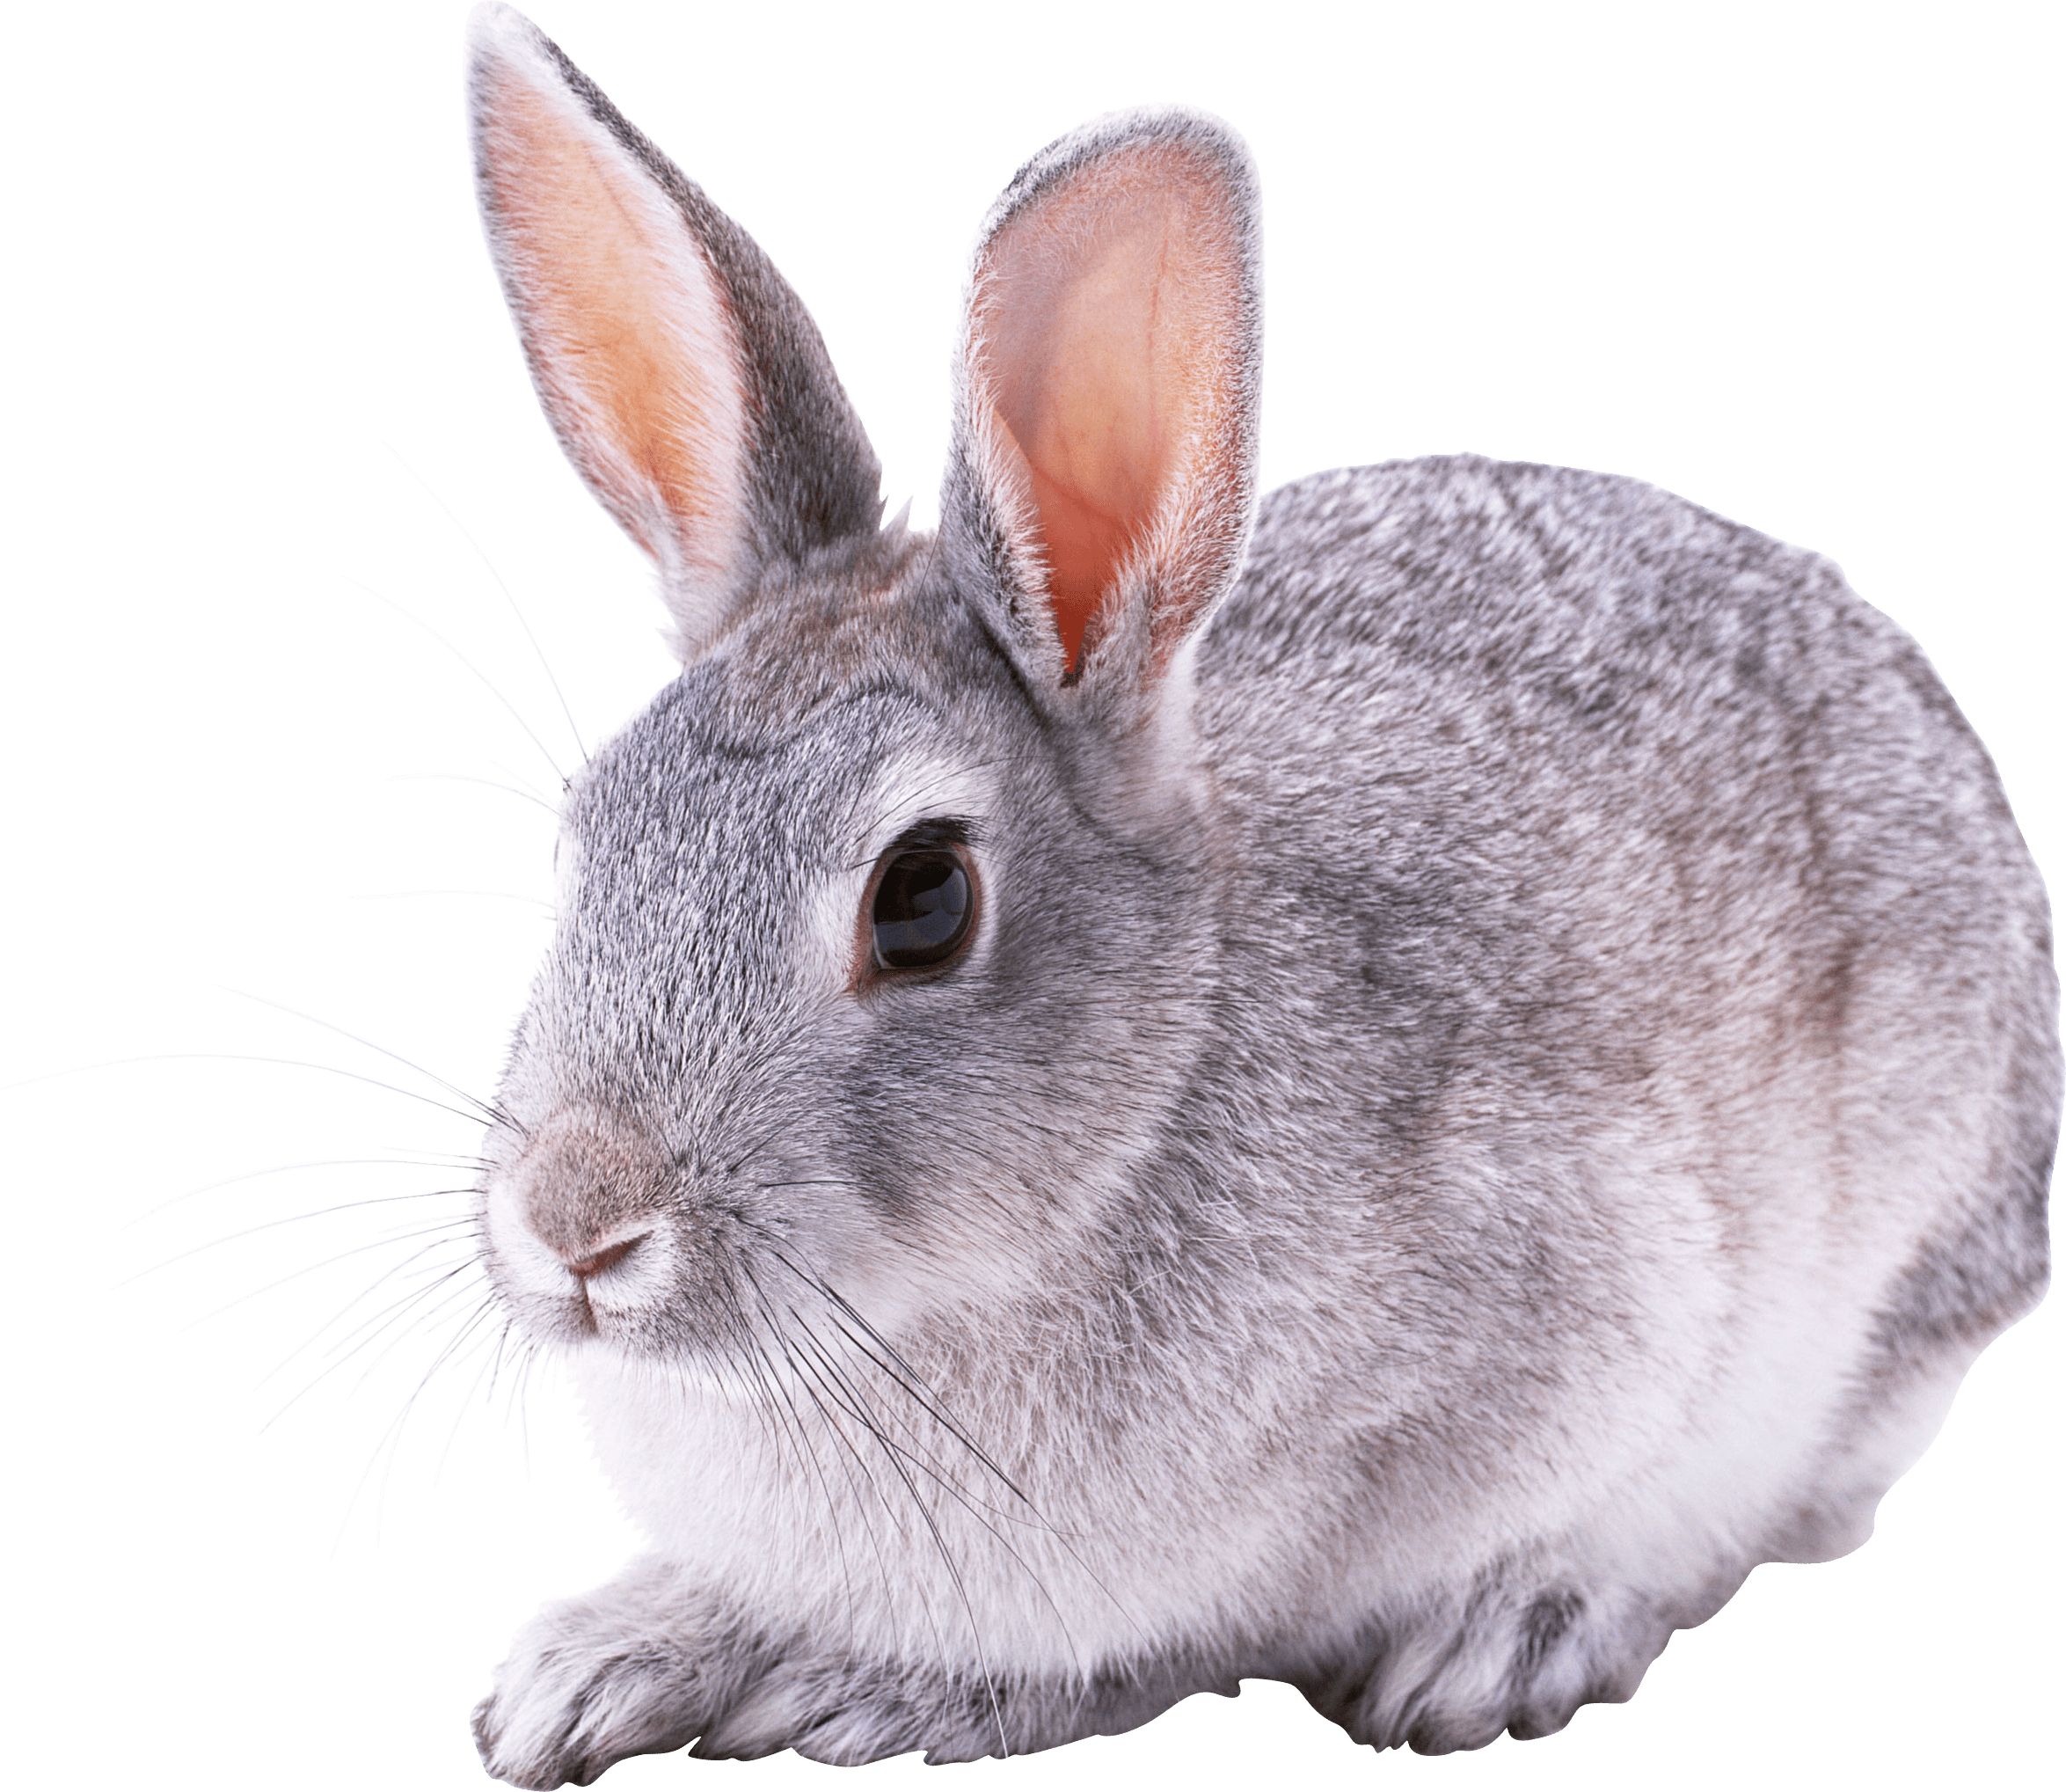**Rabbits Blog - W/E 27.1.2023**

Hi All,

This week in Rabbits class we have engaged in a range of activities including:

We started exploring the story of Goldilocks and the Three Bears.

We have continued looking at 2D shapes in greater detail; matching shapes, sorting shapes, finding shapes upon request and naming shapes.

We are enjoying a sensory trampoline mat in the class this week.

We had a swimming session this week. Keep sending kits in each week, including swim nappies for those that need them please.

Scroll down for a few photos of us this week.

Kind regards

Anna Latos (Rabbits Class Teacher)

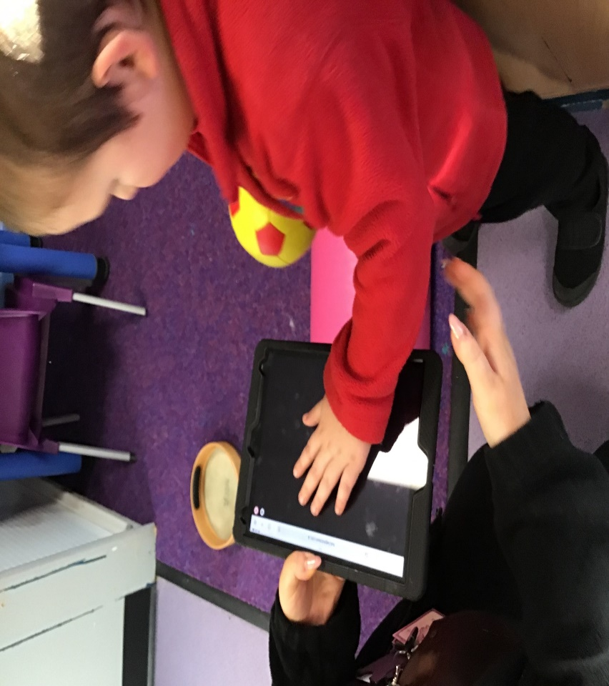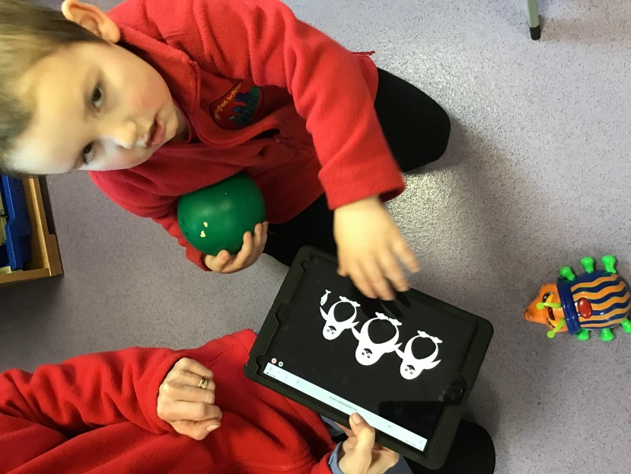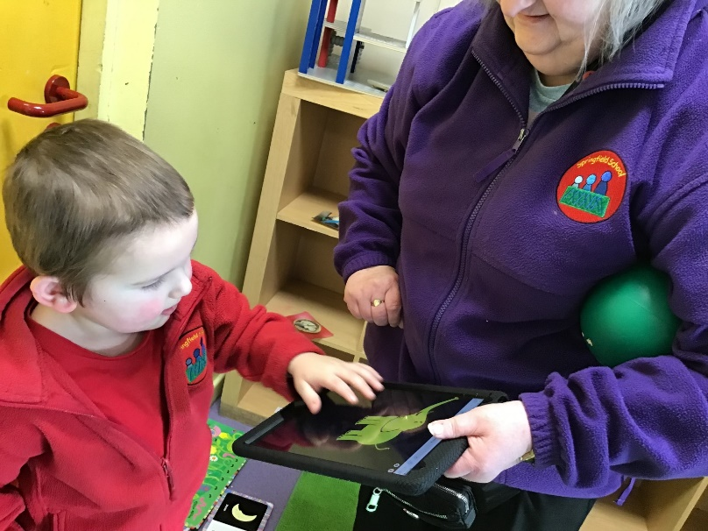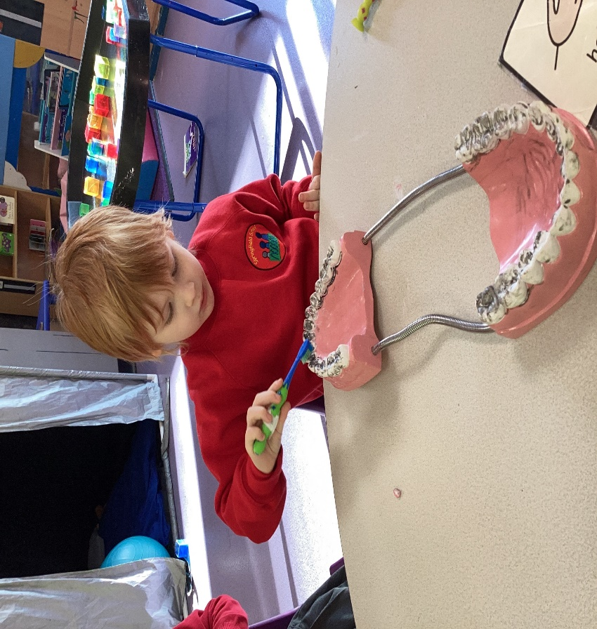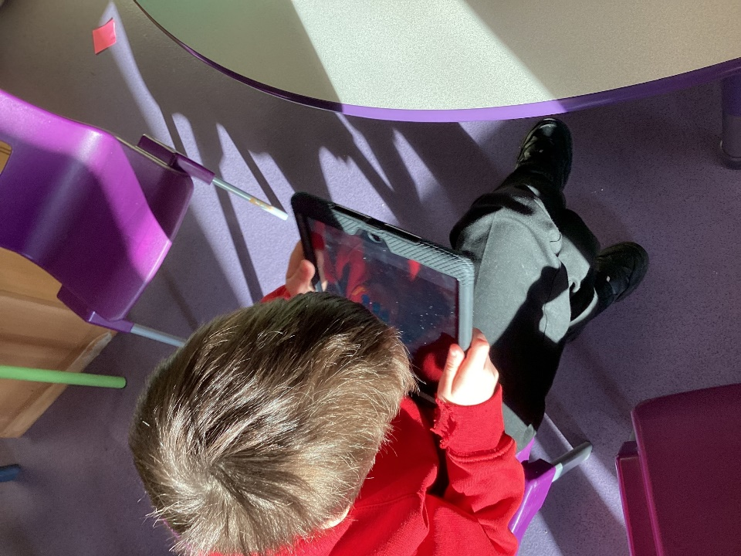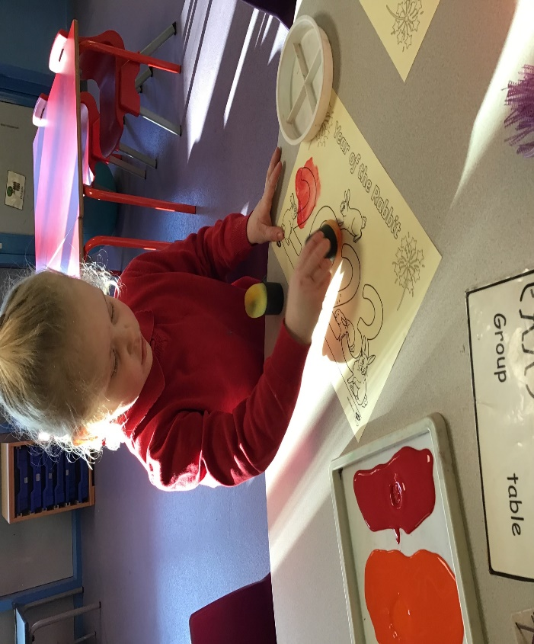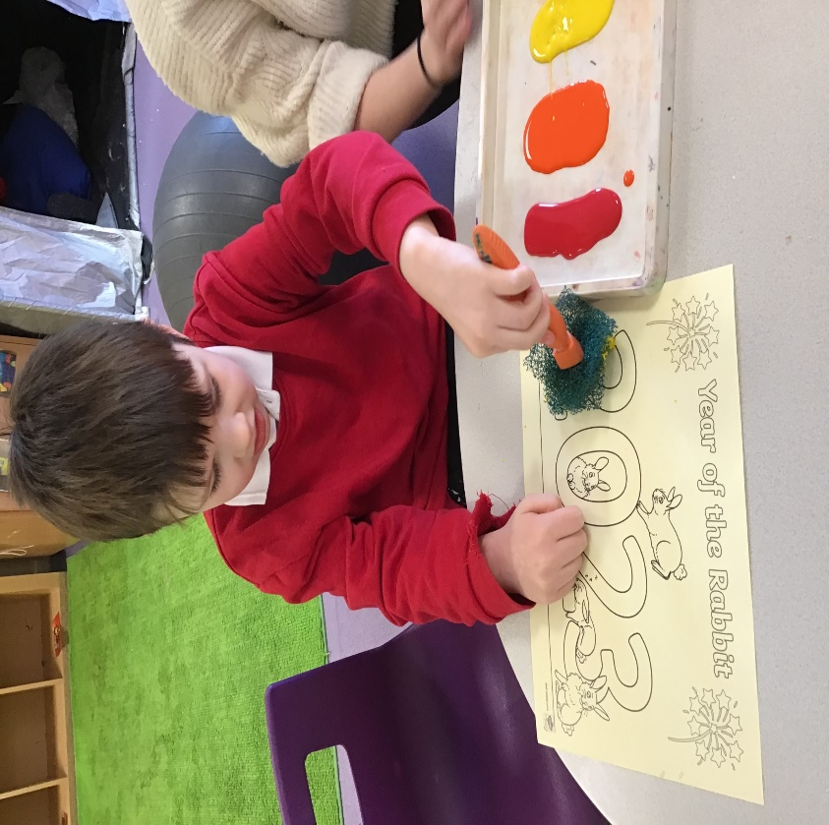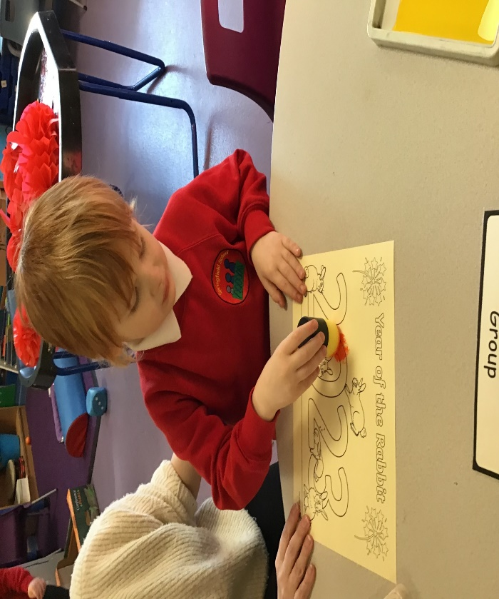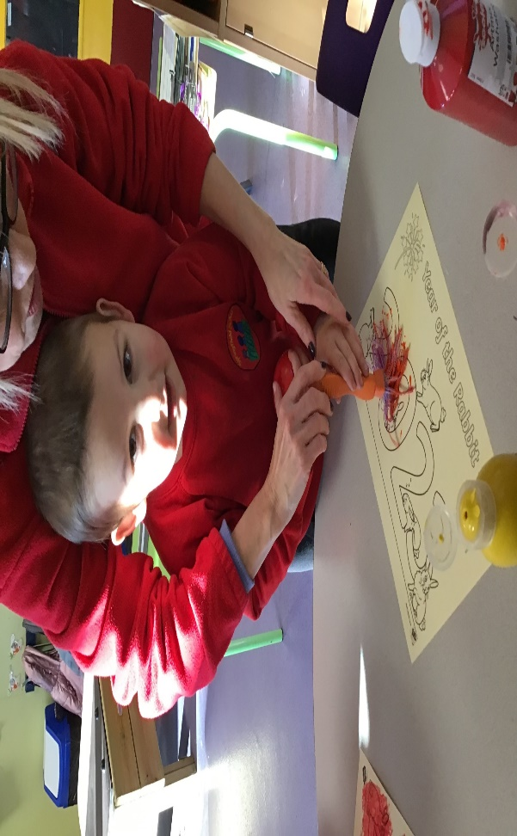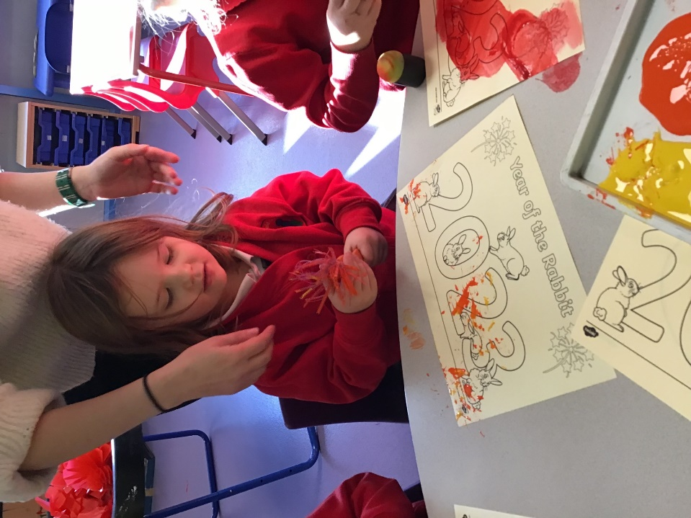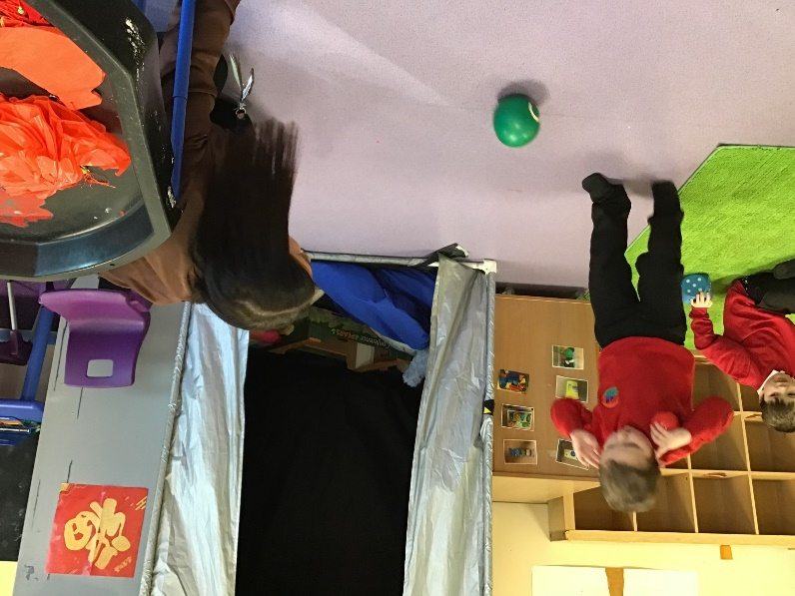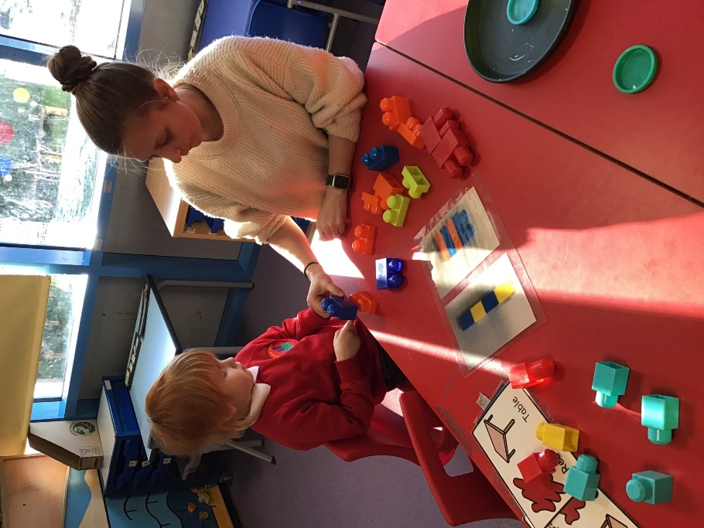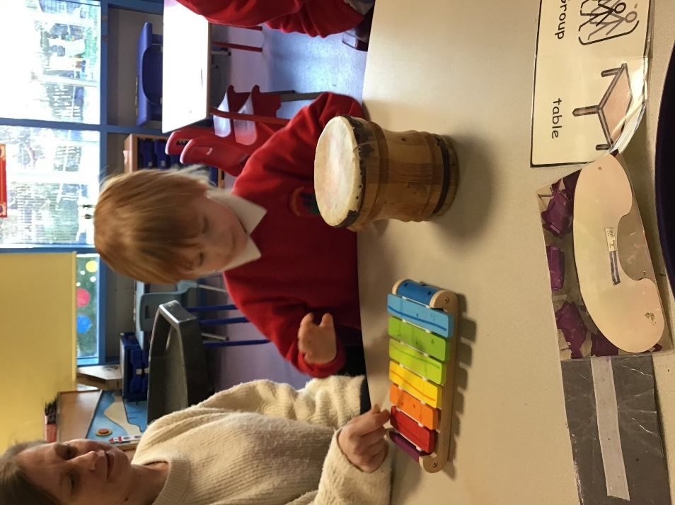

P’,,’;

