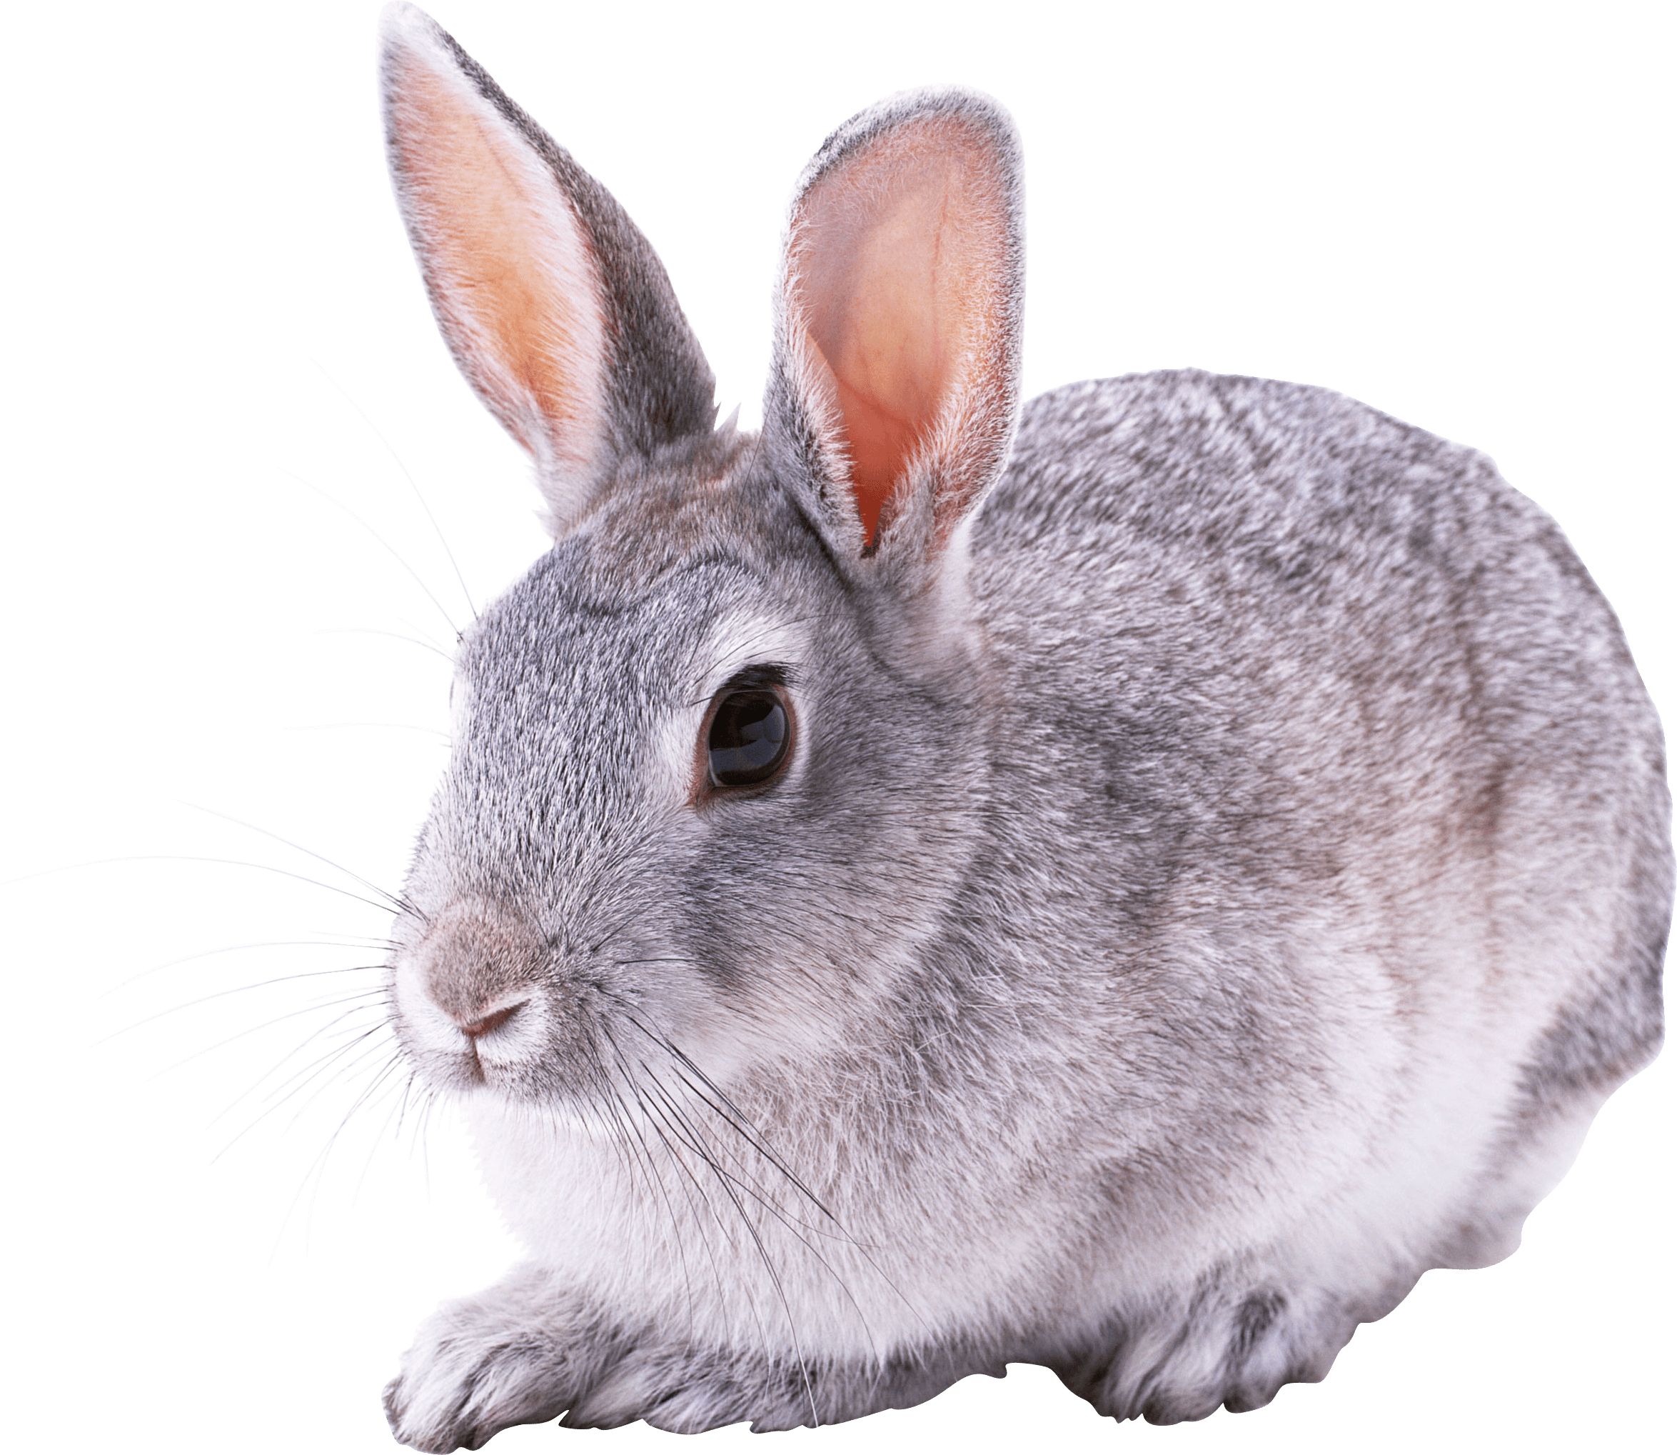Rabbits Blog - W/E 25.11.2022
Hi All,

This week in Rabbits class we have engaged in a range of activities including:

Our activities have been based around Christmas this week. We’ve begun to share versions of the nativity and played with props.

Our PECS is developing really well. We have been working on exchanging a photo for something that we want. We are starting to request a range of items now.

We have enjoyed attention autism sessions around sounds and positional language (on, in, under)

Some of us went swimming this week. We are really loving this!
Rabbits class have a high level of need in the pool and we need to develop the children’s confidence on a one to one basis. Therefore in order to staff this well the children will not be able to go every week. We will be going on a rota basis and it’s likely to be every few weeks that they go. However if someone is poorly, too upset on the day (at that particular time) or have forgotten their kit then that may mean your child can get an extra session unexpectedly – so it would really help to have a swimming kit in school all of the time.

I would like to take the children to the shop to buy a present(s) for someone at home for Christmas. Please send in some money so that we can do this. If you email me I can make sure we buy for the correct person / people!! (There is no pressure to do this)

Scroll down for some photos of us this week.

Kind regards
Anna Latos (Rabbits Class Teacher)

