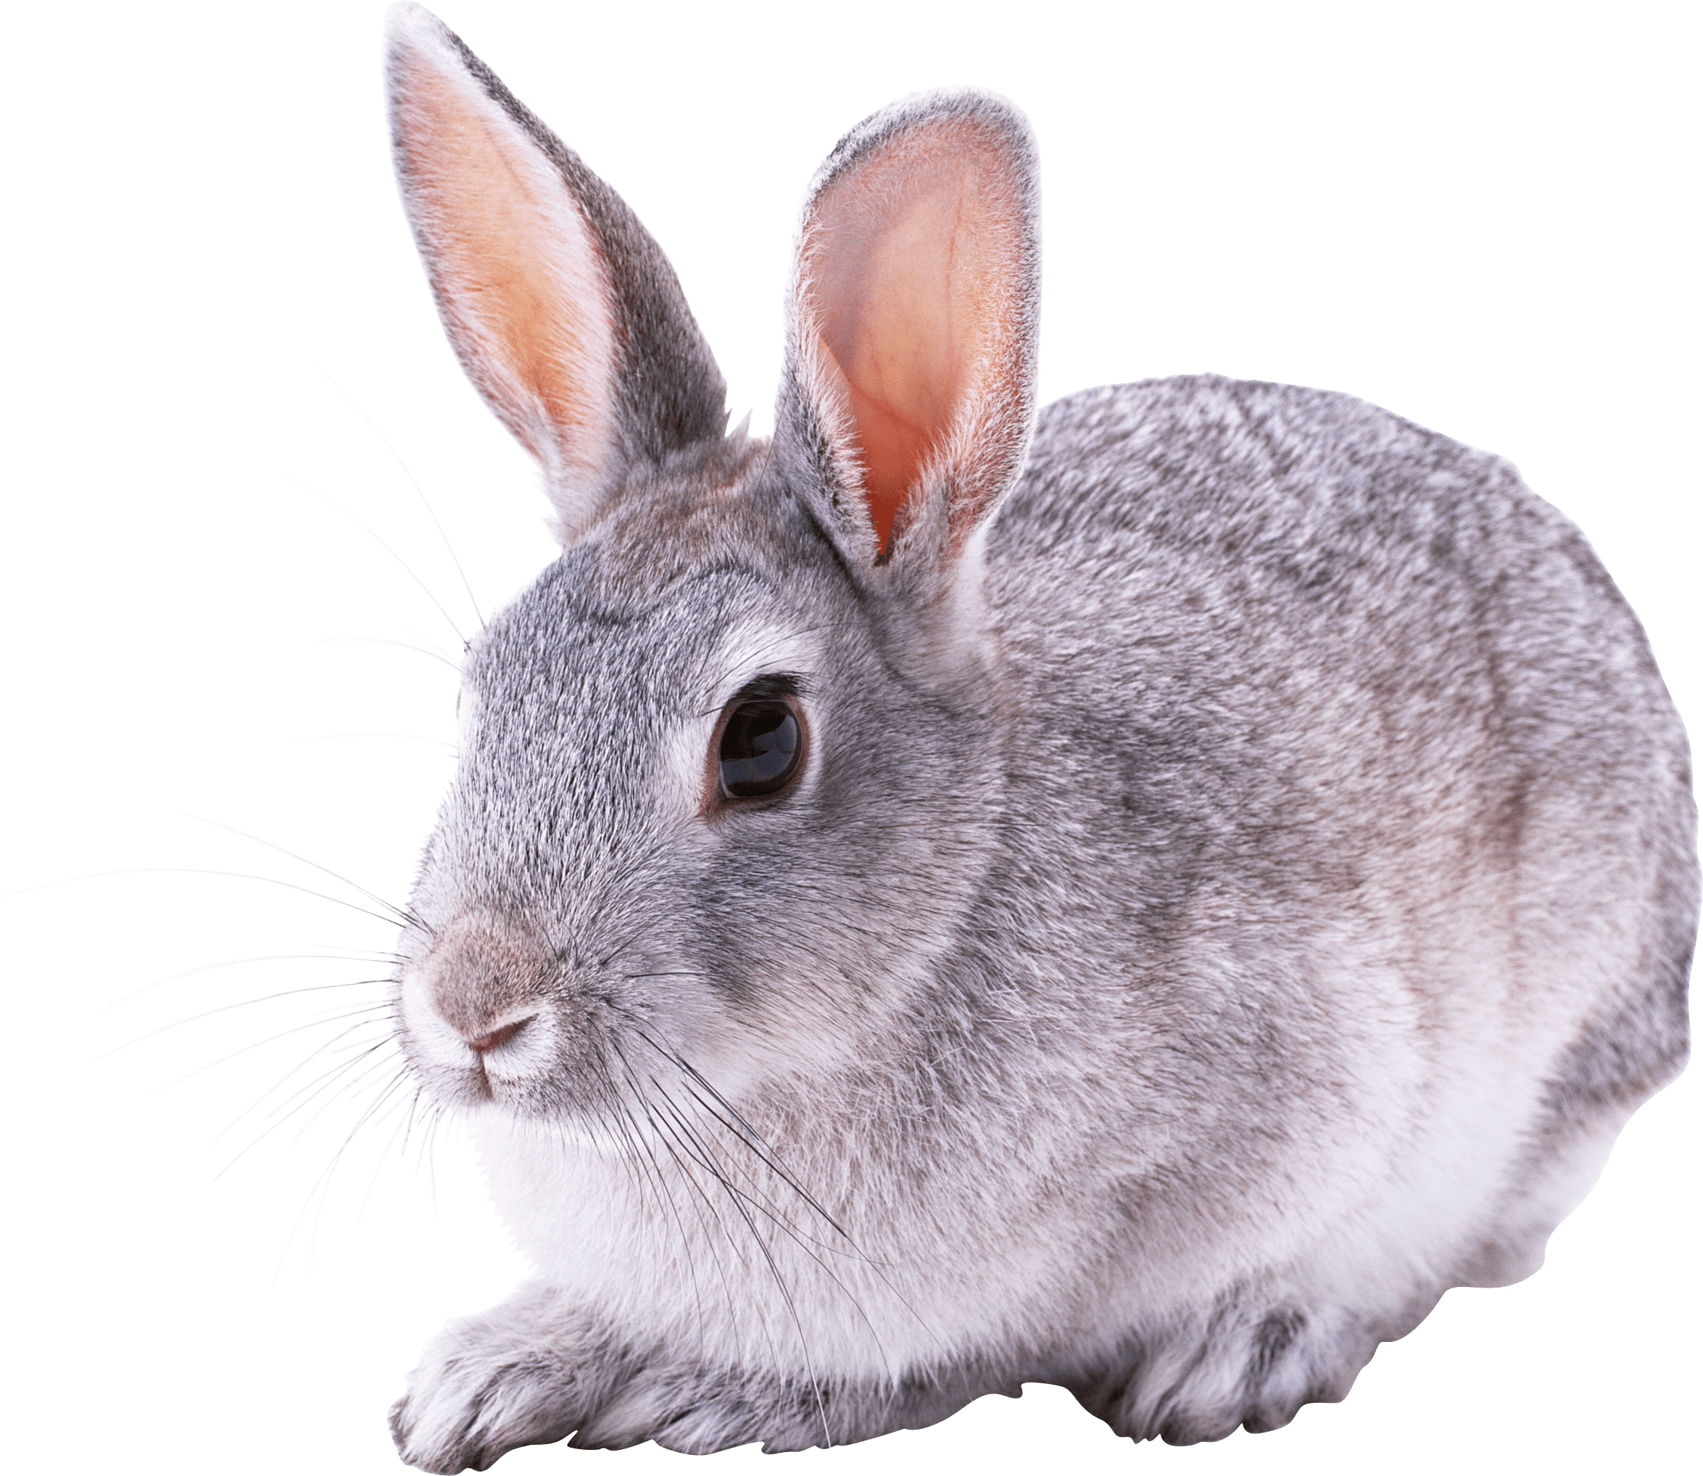Rabbits Blog - W/E 21.10.2022
Hi All,

This week in Rabbits class we have engaged in a range of activities including:

We have looked at the festival of Diwali using Peppa pig’s Diwali story book.
We have made Diya lamps out of clay. We have tasted sweets that are eaten during Diwali..

We have finished this terms design and technology learning – building with different types of construction.

We have also completed our computing work on cause and effect – being able to press and hold knowing that something will happen when we press.

We have got to know a song for Harvest – Cauliflowers fluffy – put it on at home and see if your child recognises it. We have explored some vegetables too.

Scroll down for some photos of us this week.
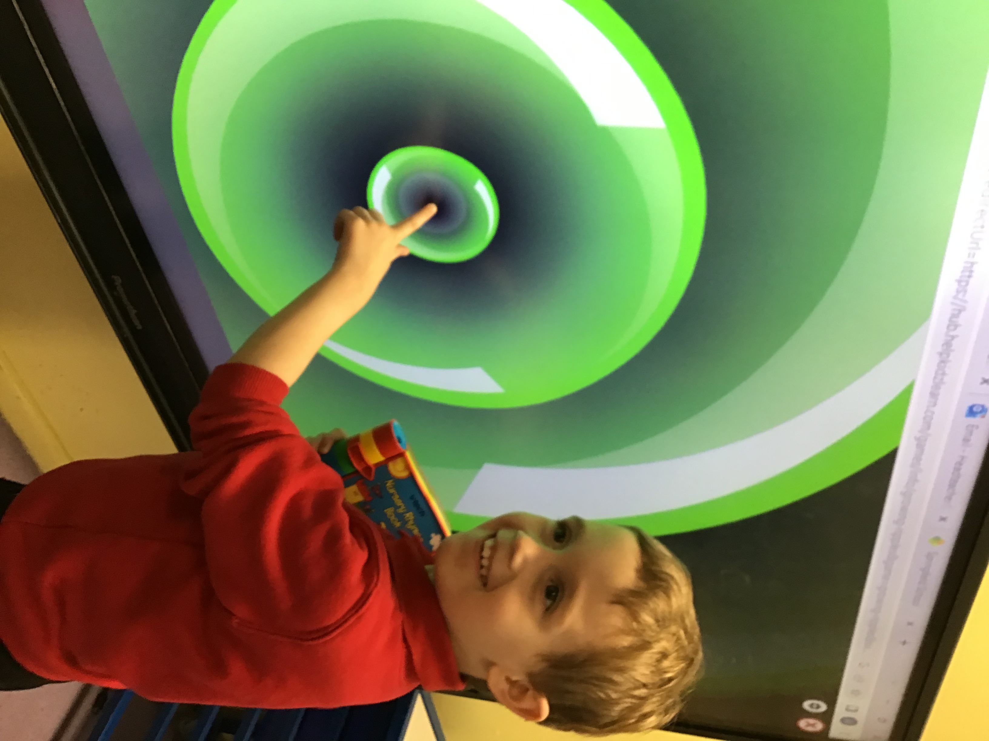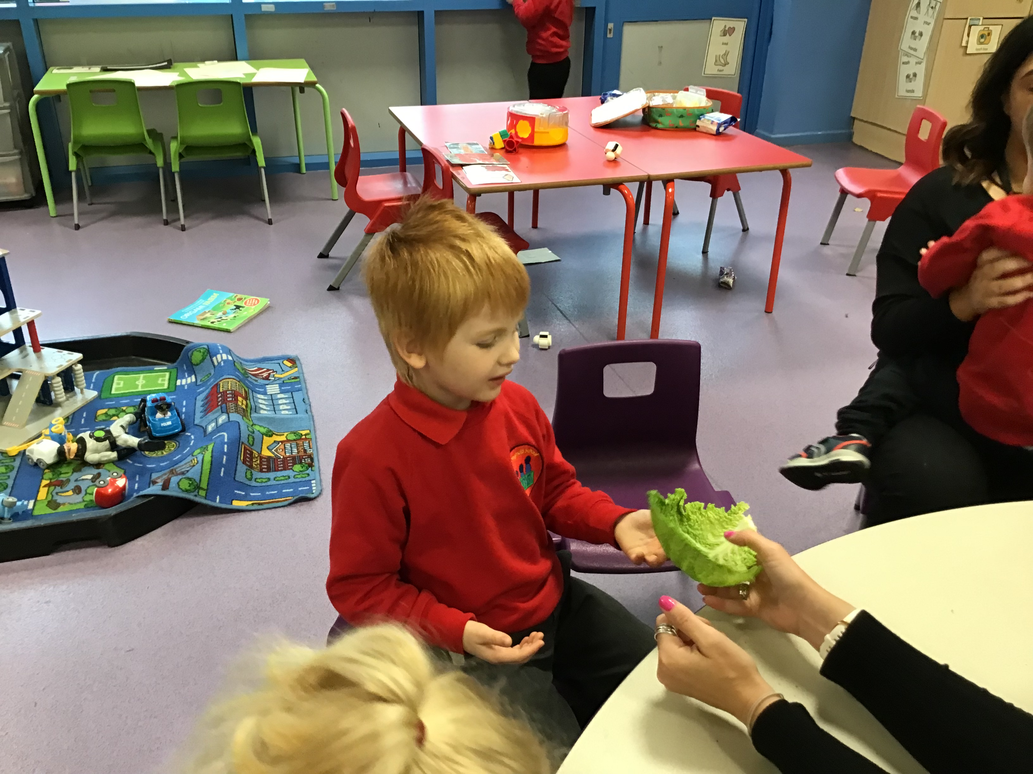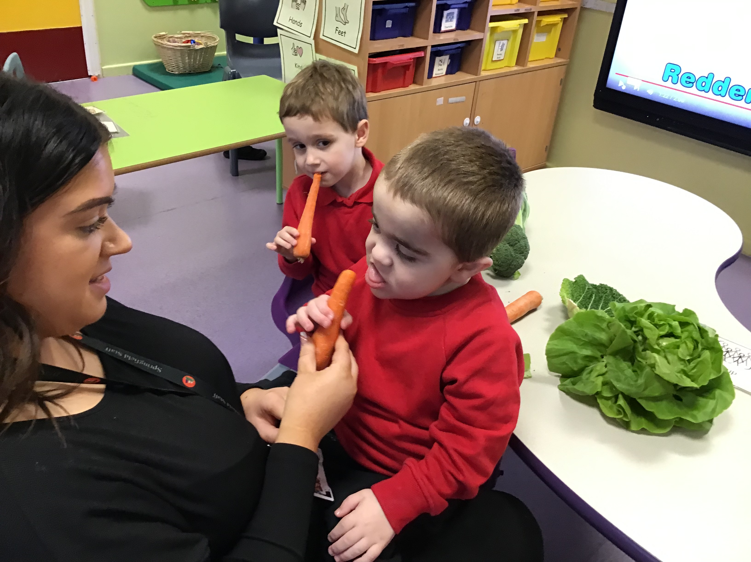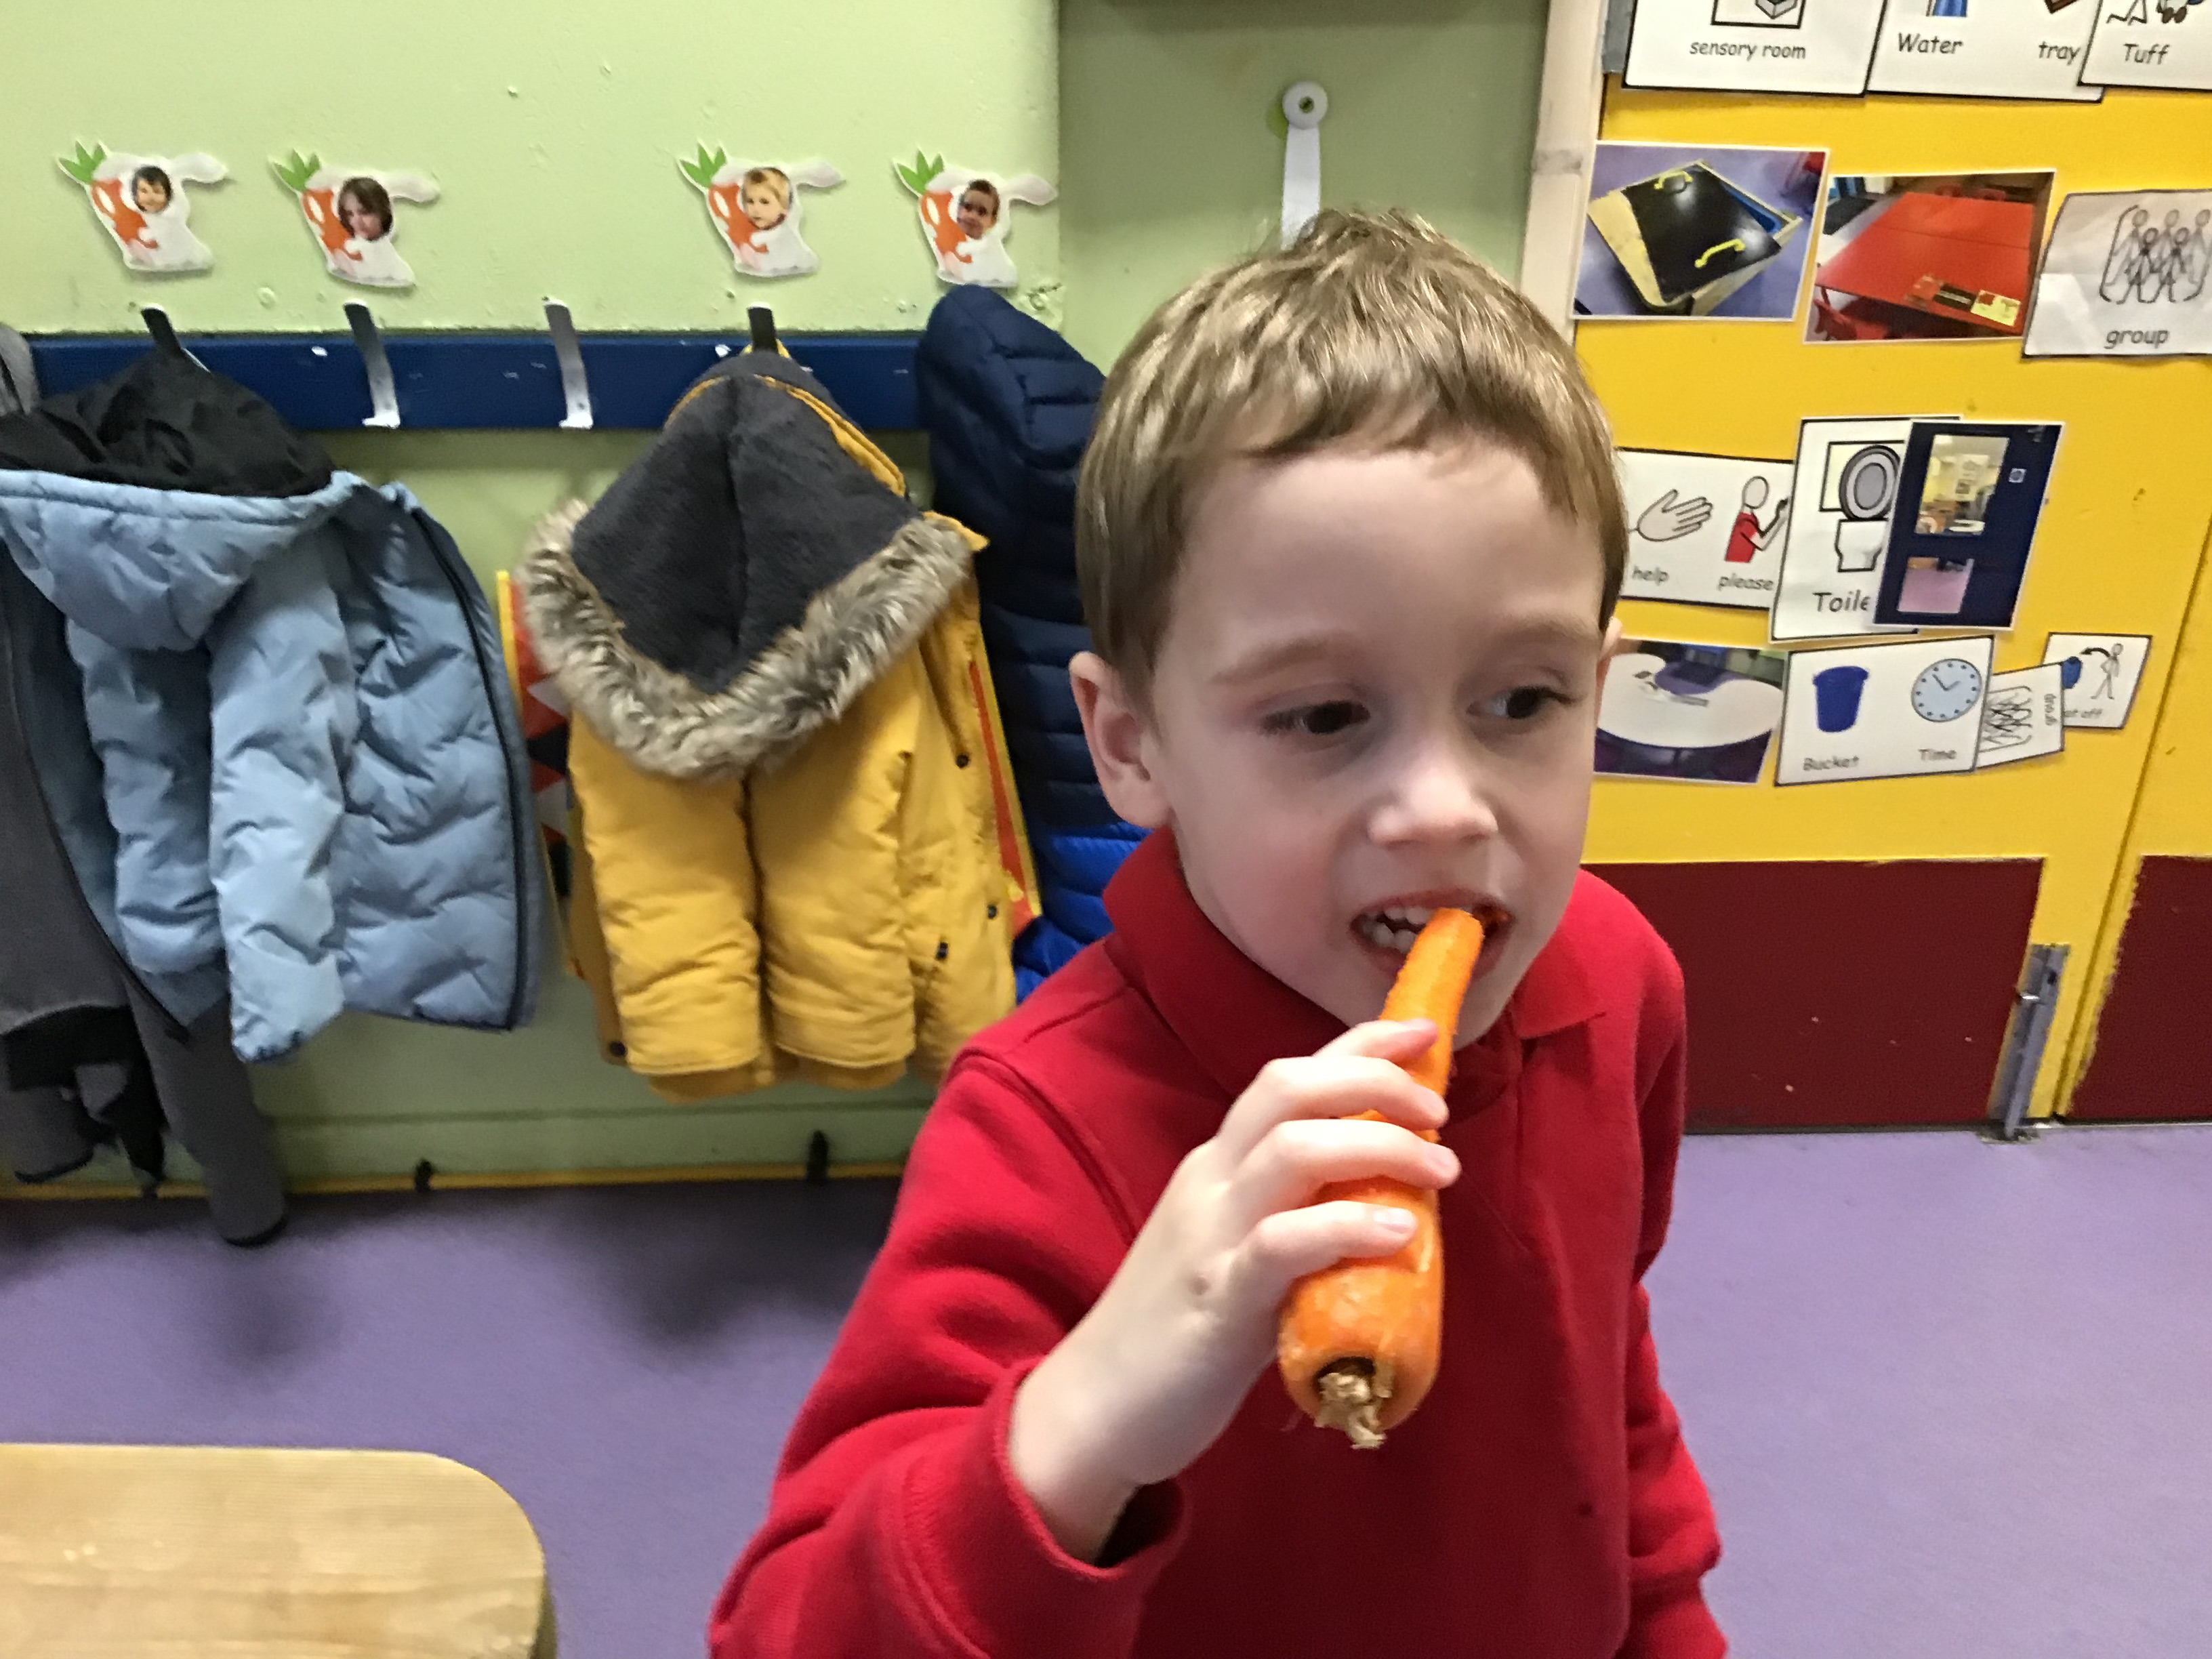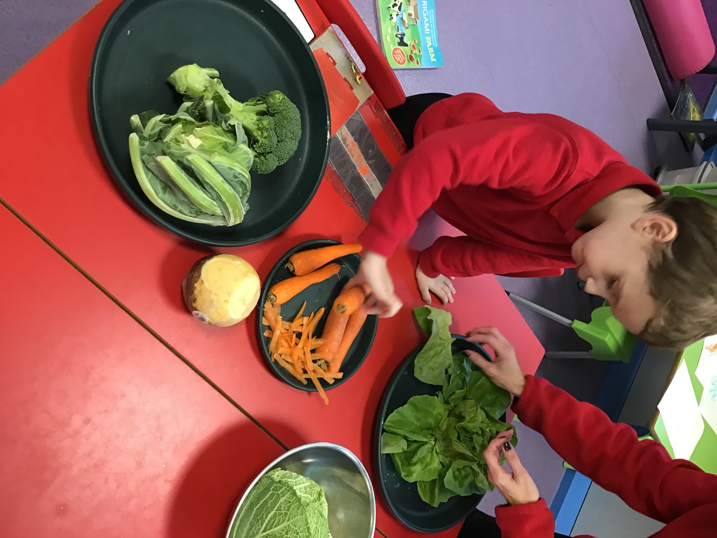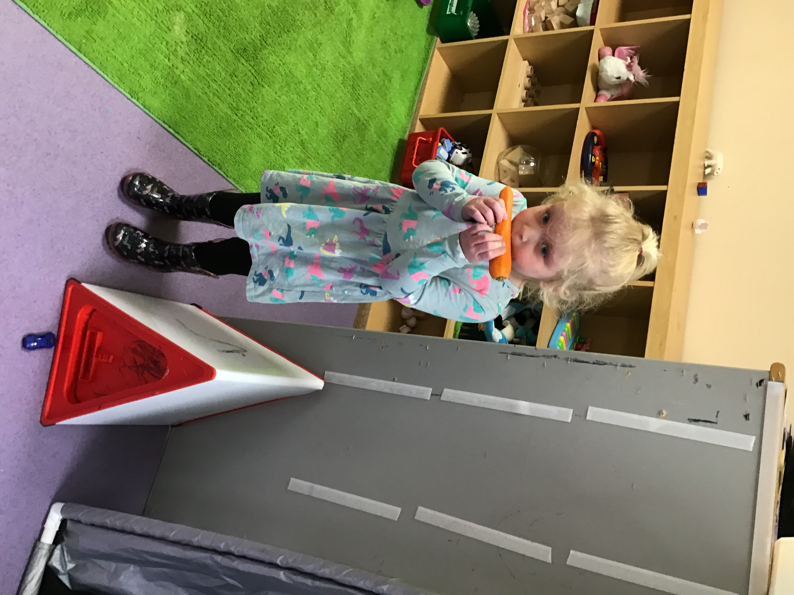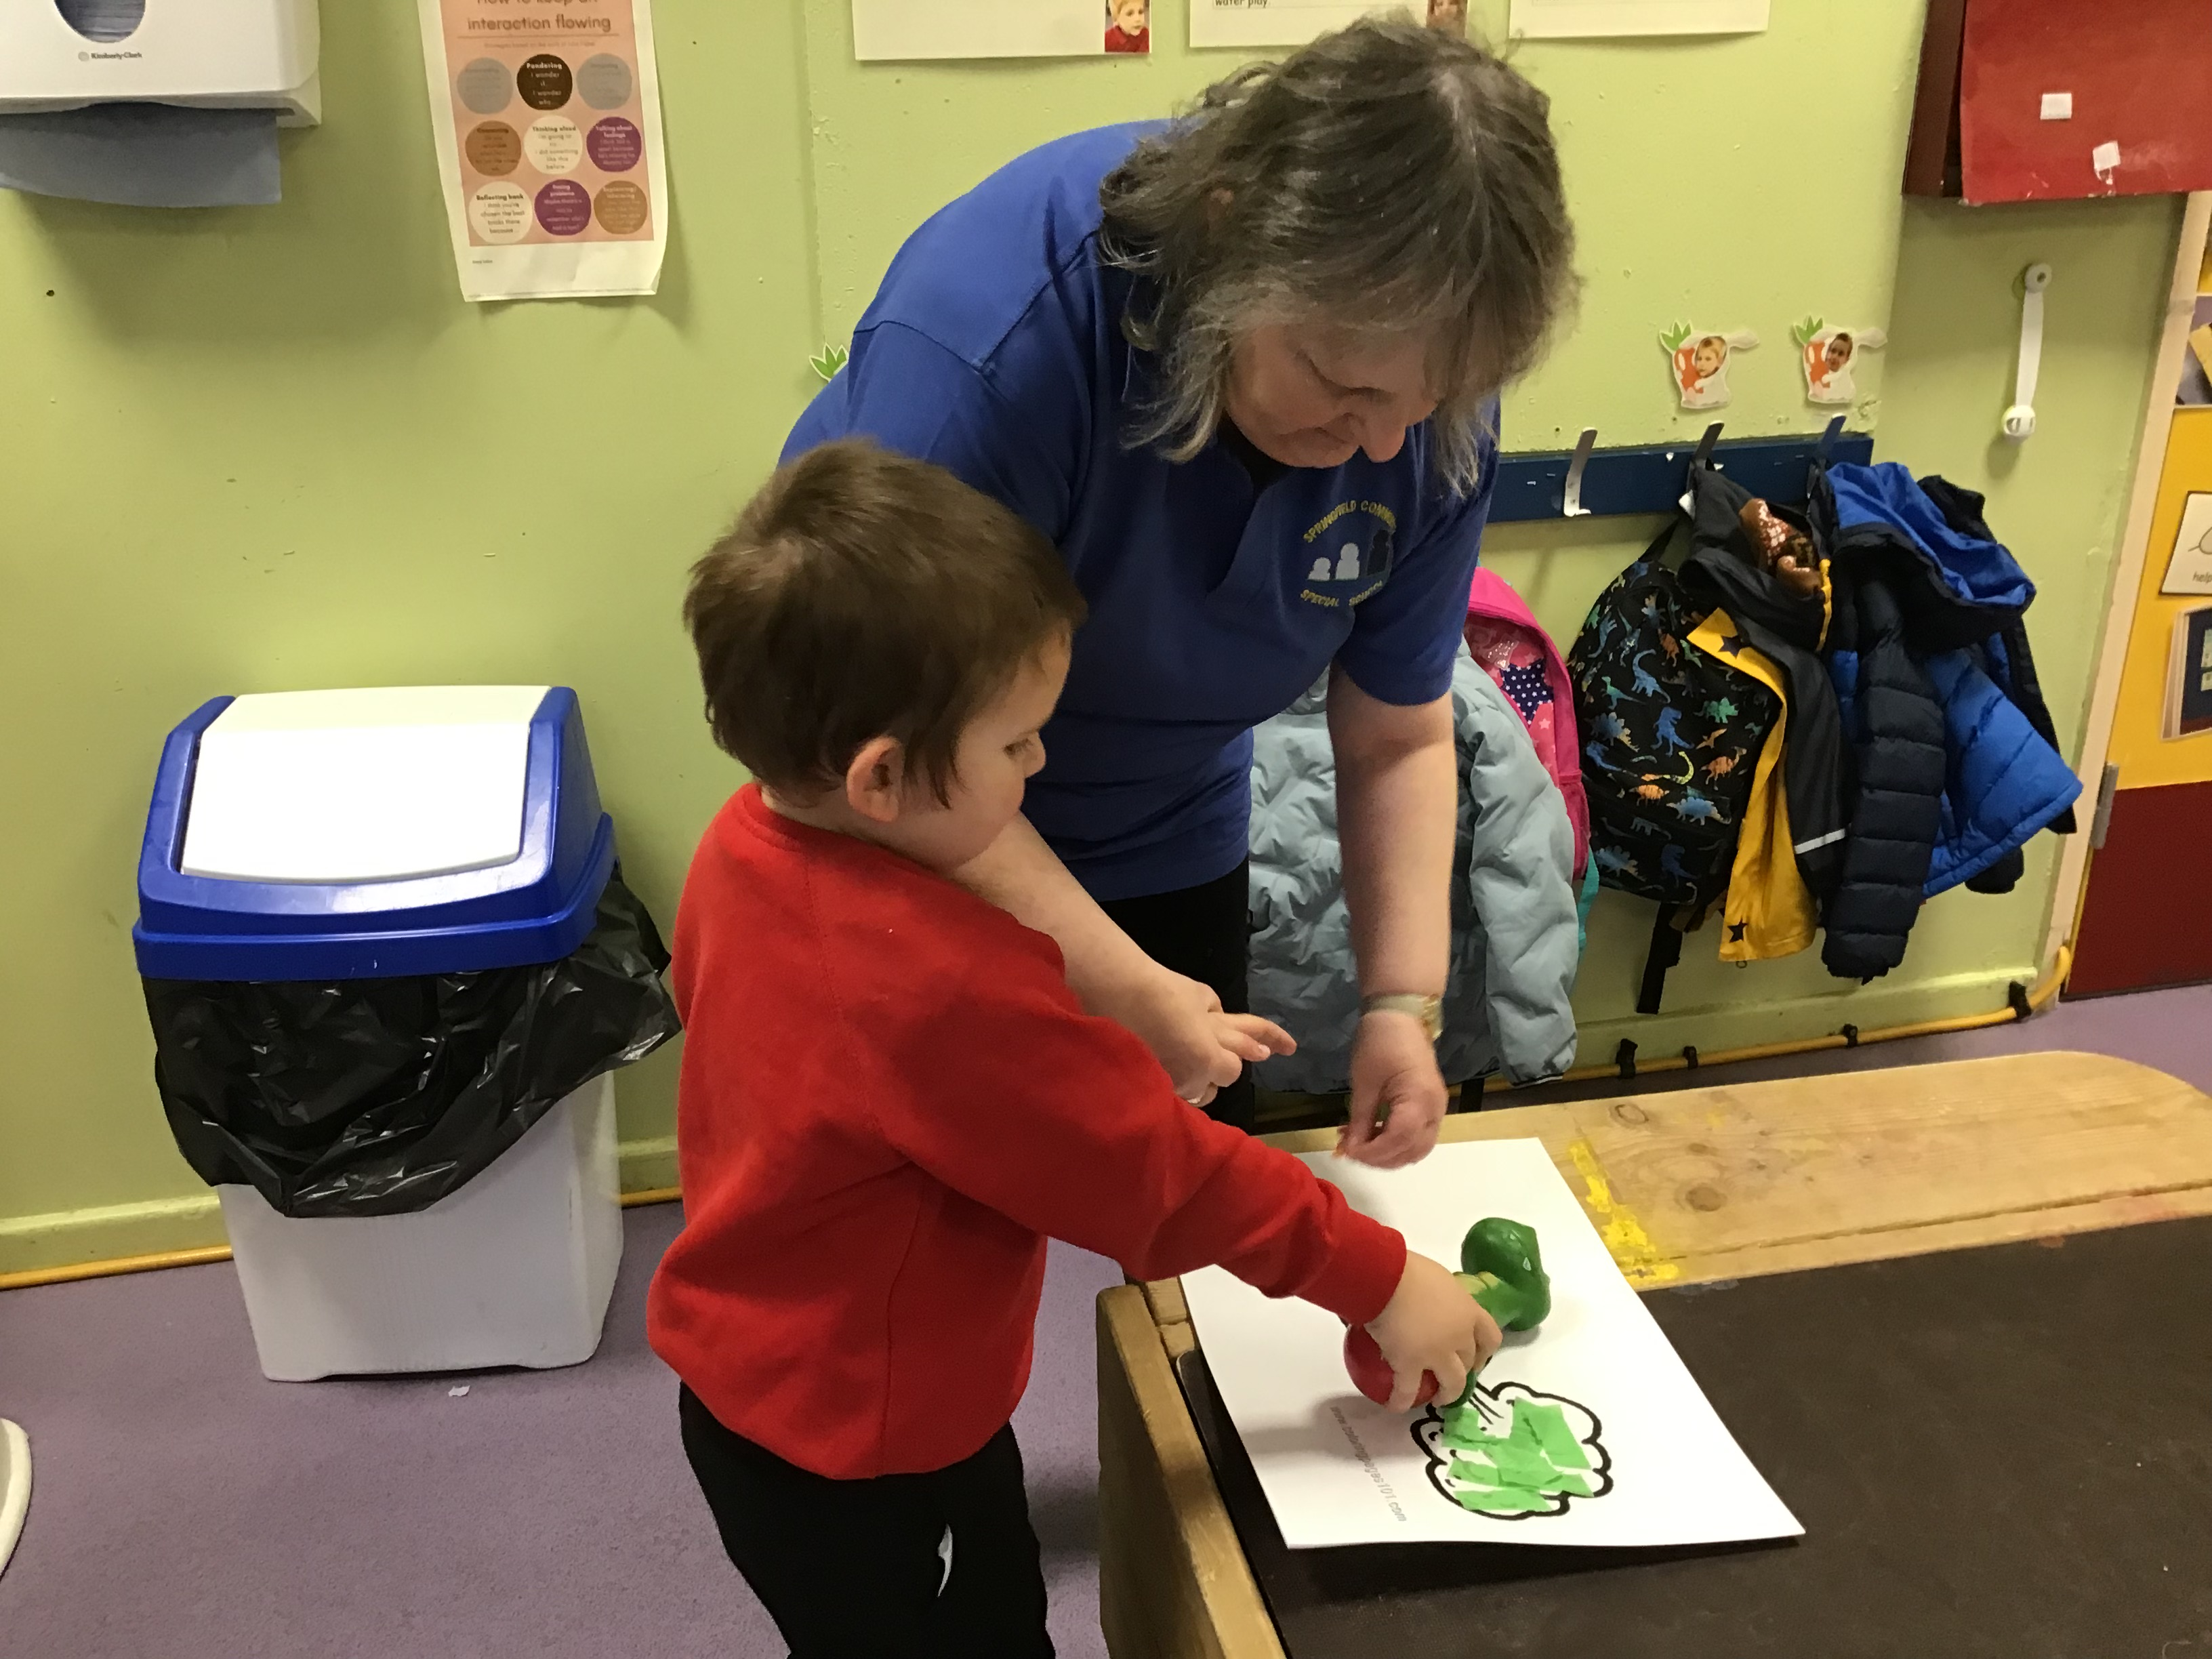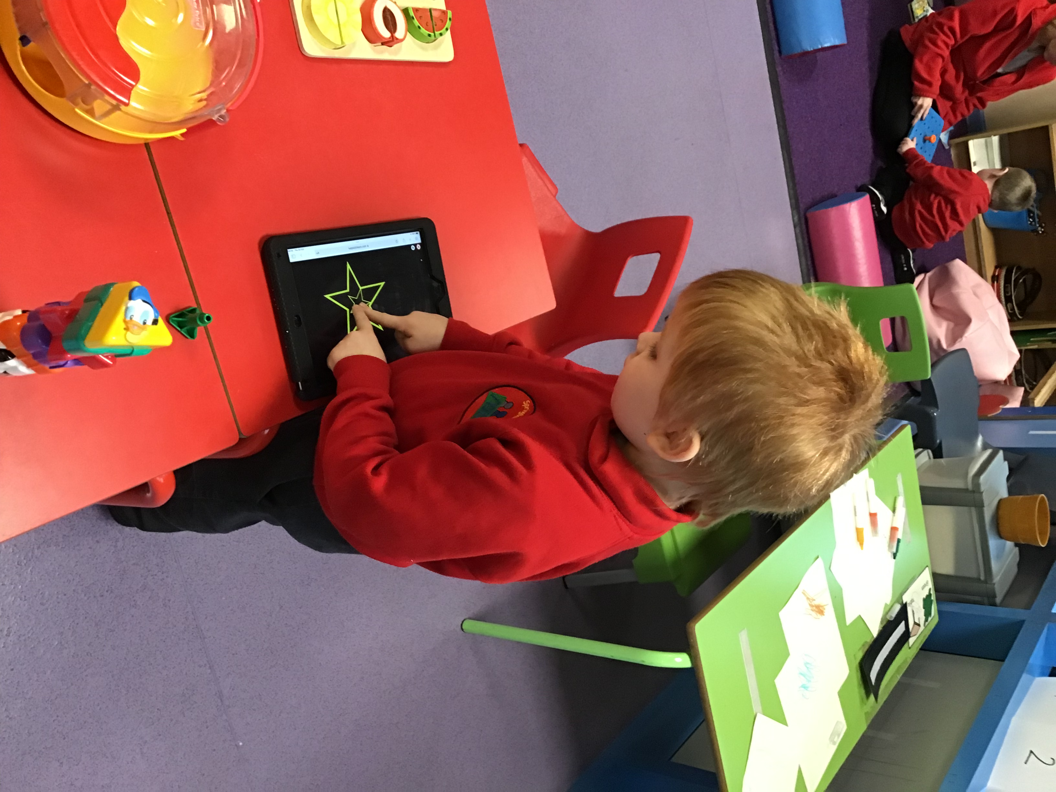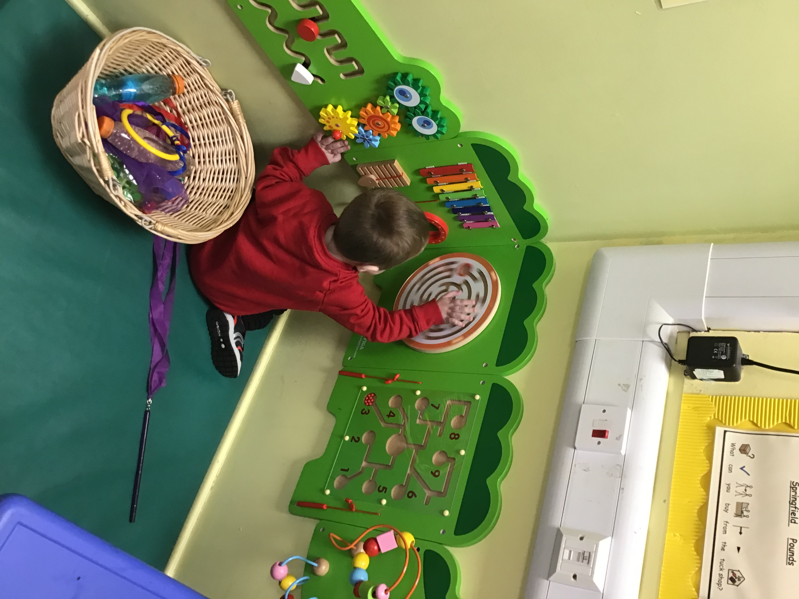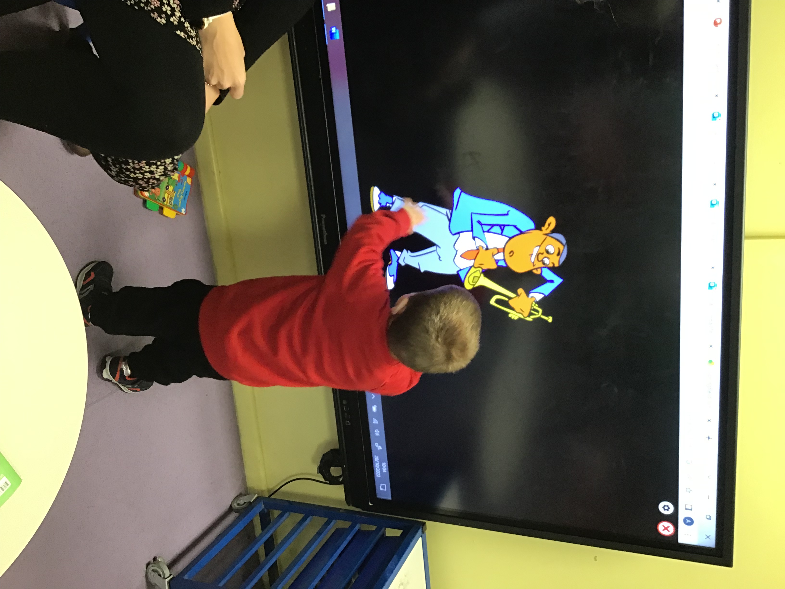

Kind regards
Anna Latos (Rabbits Class Teacher)

