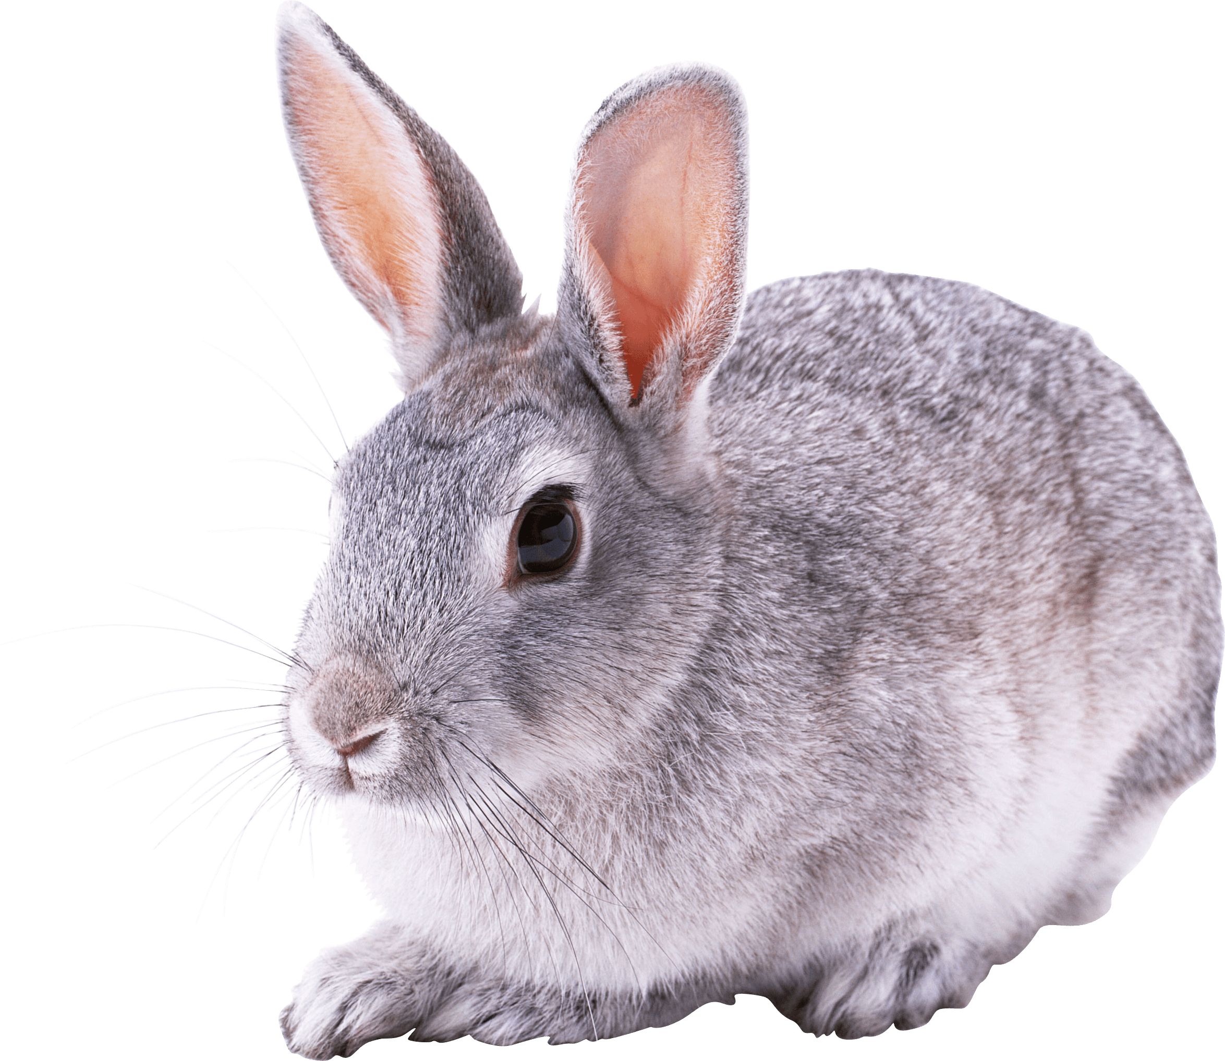Rabbits Blog - W/E 18.11.2022
Hi All,

This week in Rabbits class we have engaged in a range of activities including:

Our activities have been based around Room on the Broom again this week before dare I say it…….we move onto Christmas next week! We’ve played with the props and got to know the story a bit better.

We have been working on exchanging a photo for something that we want. This is still going really well!

We have enjoyed attention autism sessions around sounds and triangles.

We have had our first swimming session this week!! We had a fab time in the water.
Some of us weren’t here this week but will have a turn next time. Please send swimming kits back into school as soon as you have washed them so then we are prepped for the next available time for us to go.
Rabbits class have a high level of need in the pool and we need to develop the children’s confidence on a one to one basis. Therefore in order to staff this well the children will not be able to go every week. We will be going on a rota basis and it’s likely to be every few weeks that they go. However if someone is poorly, too upset on the day (at that particular time) or have forgotten their kit then that may mean your child can get an extra session unexpectedly – so it would really help to have a swimming kit in school all of the time.

Some of us have been to Asda today to buy some things for the classroom.

In a couple of weeks I would like to take the children to the shop to buy a present(s) for someone at home for Christmas. Please send in some money so that we can do this. If you email me I can make sure we buy for the correct person / people!!

It’s also Children in Need today – thank you for your donations. Pudsey Bear visited the classrooms today – We enjoyed this but we didn’t want to get close!!

Scroll down for some photos of us this week.

Kind regards
Anna Latos (Rabbits Class Teacher)
