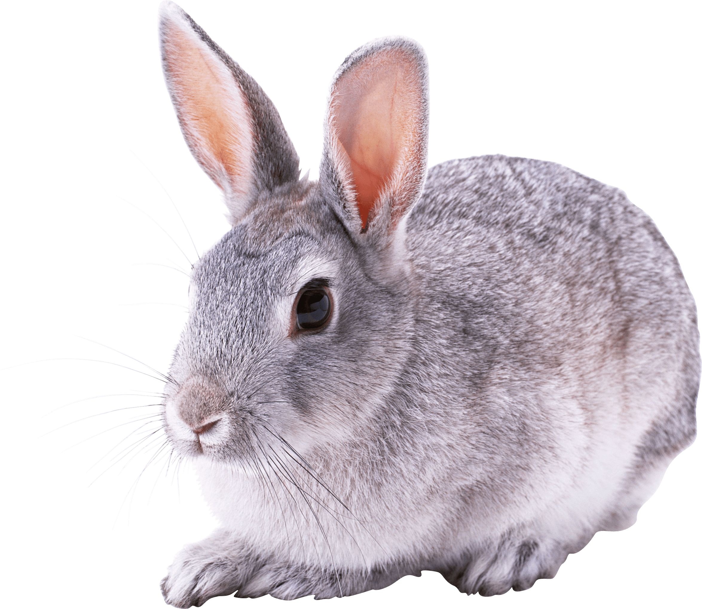Rabbits Blog - W/E 13.1.2023
Hi All,

This week in Rabbits class we have engaged in a range of activities including:

Requesting the toys we want to play with using photos. We have some structure to our room now and we are moving from one activity to another around the classroom as well as having time to access activities when we want to too.

We have continued to look at the story One Snowy Night by Nick Butterworth.
You can find the link to this on our homework padlet, or go straight to you tube.

We have been looking at colours in greater detail; matching colours, sorting colours, finding colours upon request and naming colours.

Just a reminder that PE is now on a Monday, so children are welcome to come into school in their PE for the day. If you forget don’t worry – they will still take part.

Scroll down for a few photos of us this week.

Kind regards
Anna Latos (Rabbits Class Teacher) 