Rabbits Blog - W/E 11.11.2022
Hi All,

This week in Rabbits class we have engaged in a range of activities including:

Our activities have been based around Room on the Broom. We have got to know the story and characters this week. We have played with props from the story. We have enjoyed making shape witch pictures too.

We have been working on exchanging a photo for something that we want. We have all done really well with this. Everyone has made progress since last week!

We have enjoyed attention autism sessions around sounds, circles and room on the broom.

We took part in the two minute silence today.

Some of us went to our first celebration assembly too!

Scroll down for some photos of us this week.

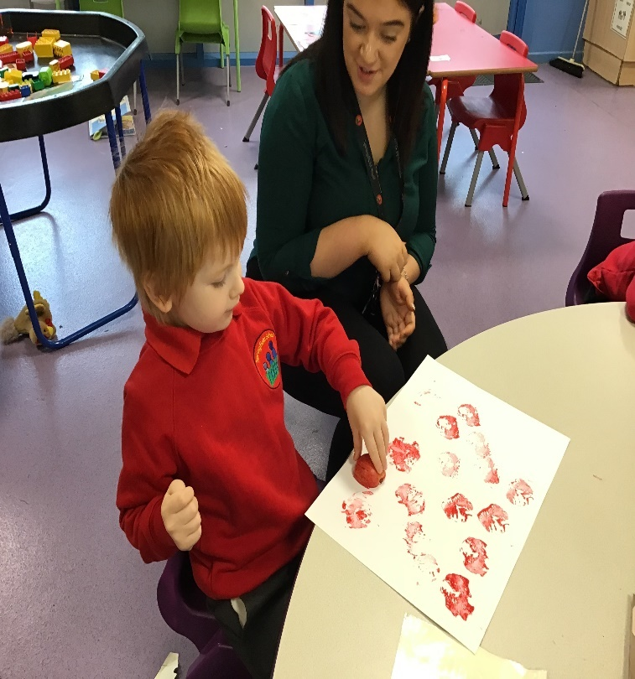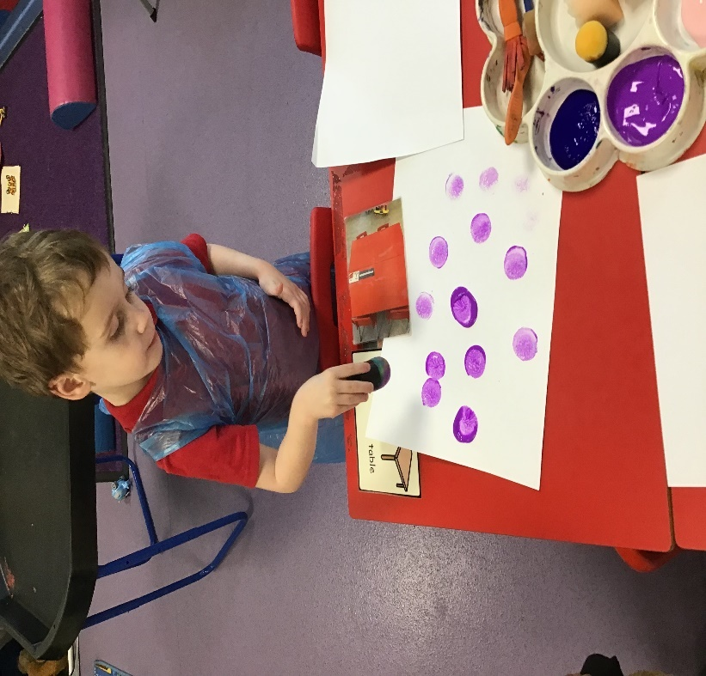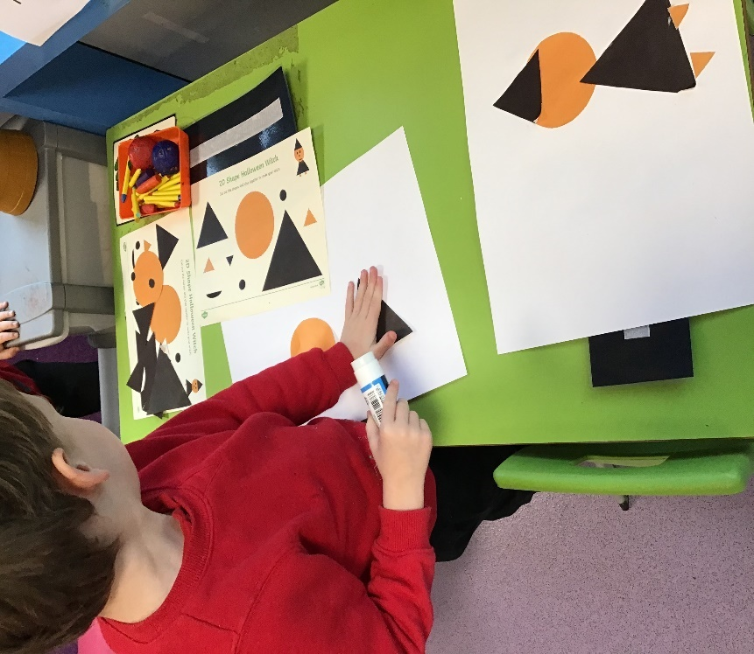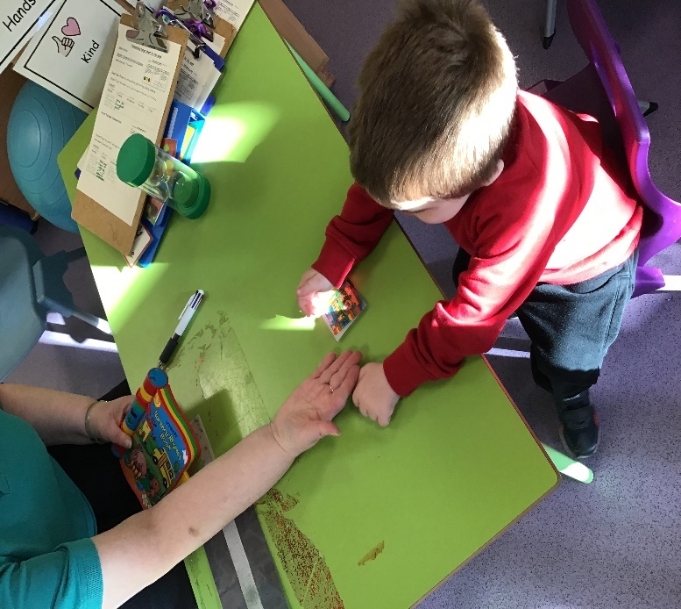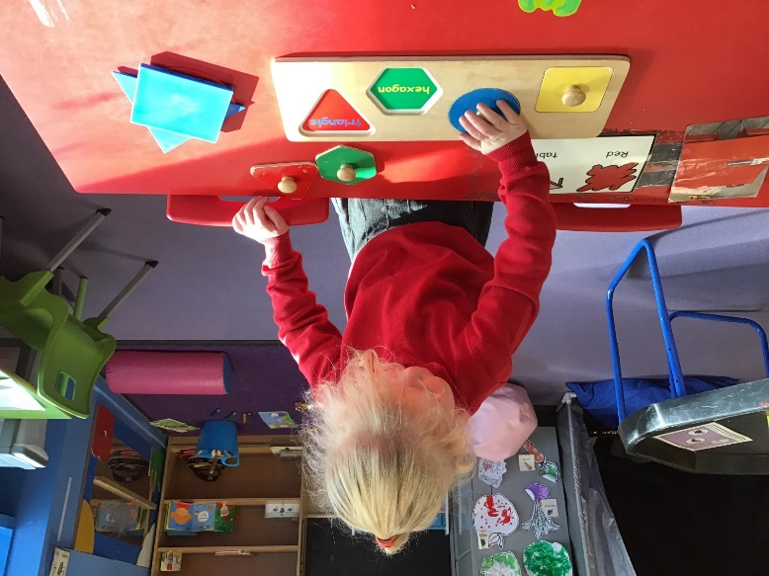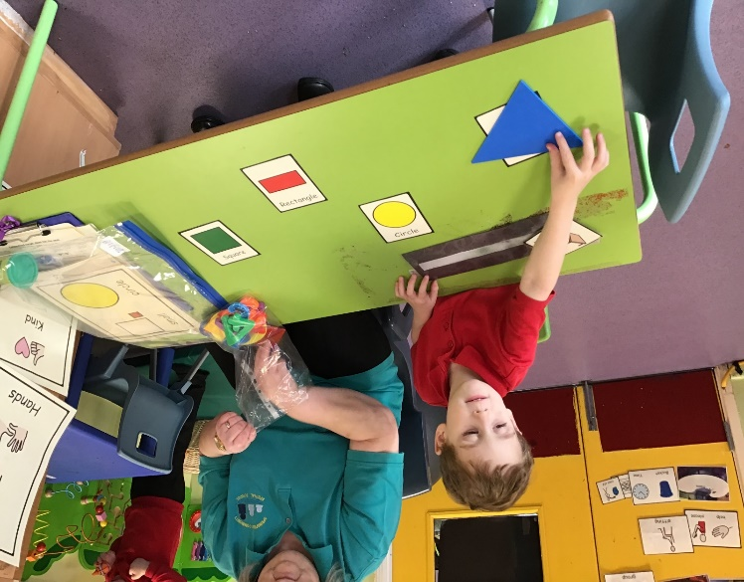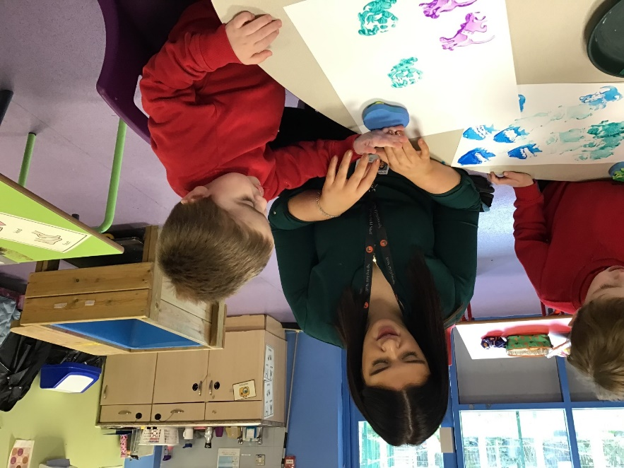

Kind regards
Anna Latos (Rabbits Class Teacher)

