Badgers Blog
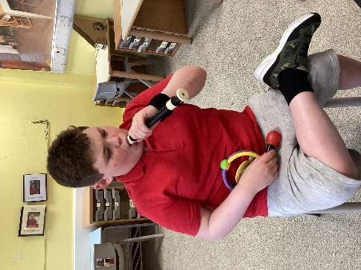
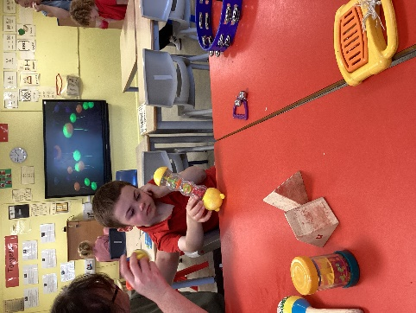
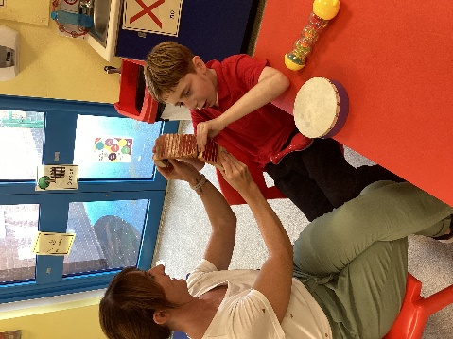
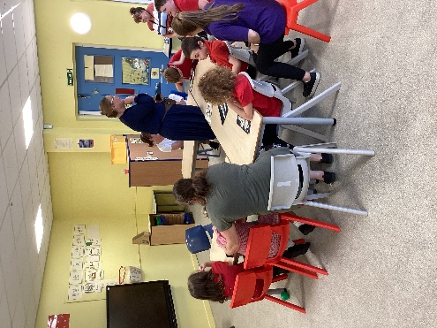
W/C 04.09.2023
Monday | Training day
Tuesday | Training day
Wednesday | Today we settled into our new classroom and explored instruments in the afternoon.
Thursday | Today we started our phonics with attention autism and ‘s’ sound. We looked at our class rules of using kind hands, kind feet, good looking, kind words and good listening. In the afternoon we went to the sensory room and painting badgers using different tools.
Friday | This morning we went to the hall for soft play then used our schedules to move around the room. We enjoyed choice activities in the afternoon.
Things to remember! Roald Dahl day dressing up on Wednesday, Swimming Wednesday and PE kits for Monday. School snacks £2 per week

