Springfield School Parent/Carer Survey Results
Autumn Term 2018

Thank you to everyone who took the time to complete and return the survey, we value all feedback from parents and carers. Out of a possible 59 surveys, 45 surveys were returned giving the school a 76% return rate.

We are delighted that 98% of parents and carers agreed that they would recommended our school to another parent and the vast majority of you either ‘strongly agreed’ or ‘agreed’ with the quality of provision addressed in the questions.

 |  | Strongly Agree | Agree | Disagree | Strongly Disagree | Don’t Know
1 | My child feels safe at this school. | 82% | 18%
2 | My child is making good progress at this school. | 76% | 20% | 4%
3 | This school meets my child’s particular needs. | 71% | 27% | 2%
4 | This school ensures my child is well looked after. | 80% | 18% | 2%
5 | My child is taught well at this school. | 76% | 22% | 2%
6 | This school helps my child to develop skills in communication, reading, writing and mathematics. | 80% | 18% |  | 2%
7 | There is a good standard of behaviour at this school. | 71% | 27% |  |  | 2%
8 | My child’s lessons are not disrupted by bad behaviour. | 60% | 26% | 5% |  | 9%
9 | This school deals with any cases of bullying effectively. (Bullying includes persistent name-calling, cyber, racist and homophobic bullying). | 67% | 22% | 2% |  | 9%
10 | This school helps me to support my child’s learning. | 80% | 18% | 2%
11 | This school responds well to my concerns. | 82% | 13% | 2% |  | 2%
12 | This school keeps me well informed. | 76% | 22% |  | 2%
13 | We have made use of the Family Support Worker | Yes  33% |  | No  67%
14 | The support we received from the Family Support Worker was effective. | Yes  100%
15 | Would you recommend this school to another parent? | Yes  98% | No  2%
Please note: Figures were calculated on the number of responses per question, as not every returned survey answered every question. Please note that not all figures add up to 100% due to rounding up/down. (2% represents 1 response)

Bar Chart Illustration: Number of responses per question.

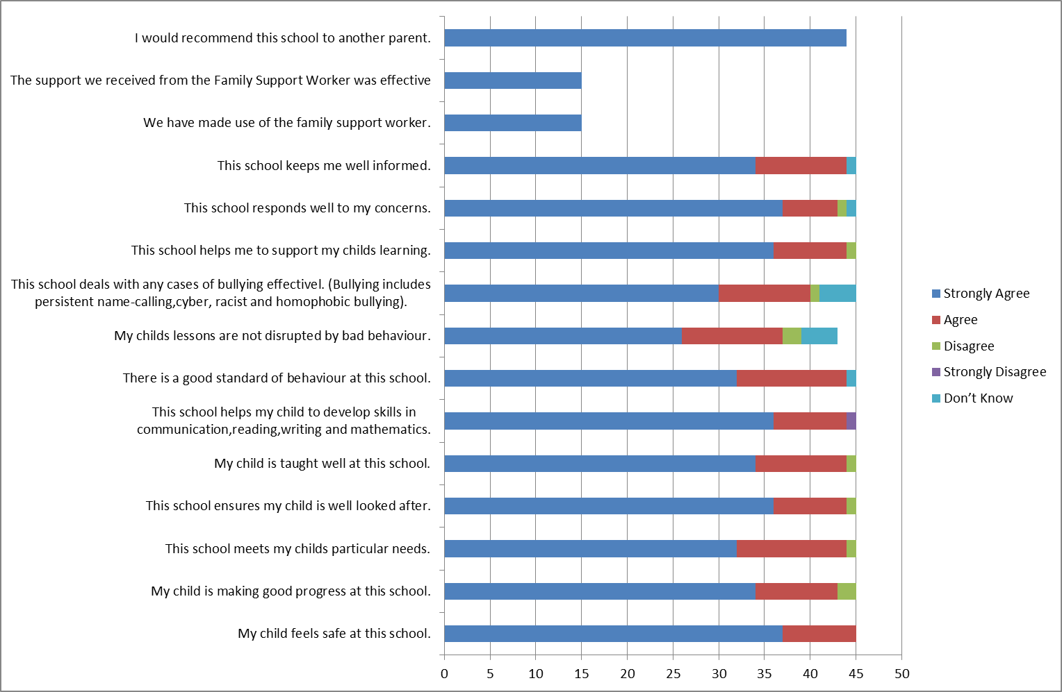
KEY RESULTS:

Of all the responses received, everyone ‘strongly agreed’ or ‘agreed’ that:
- My child feels safe at this school

Of all the responses received all except one response ‘strongly agreed’ or ‘agreed’ that:
- This school meets my child’s particular needs.
- This school ensures my child is well looked after.
- My child is taught well at this school.
- This school helps my child to develop skills in communication, reading, writing and mathematics.
- There is a good standard of behaviour at this school.
- This school helps me to support my child’s learning
- This school keeps me well informed.

Out of the 15 parents/carers who have accessed the School Family Support Worker:
- 100% found the support they received effective.

We continue to evaluate, develop and improve as a school and endeavour to explore areas that have not been considered satisfactory. Please contact the school should you wish to discuss any area of the questionnaire in more detail.
Thank you for your continued support.

PARENT/CARER COMMENTS:

“Springfield School is absolutely fantastic all the staff and pupils are like one big happy family, the atmosphere is fab. We love the school and thank you so much to all the hardworking staff.”

“I think the parking at Meadows is very dangerous for the pupils at Springfield. Taxi’s and cars using the pavement to exit Springfield and children trying to walk up the path.”

“Thank you so much for making my boy so welcome your school is like a family. I can now go about my day as I feel all my child’s needs are been met.”

“I would like more communication between myself and my husband with the class teacher. I feel that I am not sure of what my child is learning in class at the moment.”
“My child has come on so much since starting this school and he now believes in himself.”

“Our concerns as parents are always listened to and actioned and concerns don’t happen often. The staff are proactive and work extremely hard.”

“I feel SALT/PECS does not get reviewed often enough to help at home, I have found SALT over the phone not very helpful.”

“I can’t fault Springfield School. All the staff are amazing. They work well with parents; we have great school-home relationship, supporting each other to achieve the best education.”

“Springfield is a wonderful school and has done wonders for my child and the support is tremendous. Thanks all.”

“The last two years have been disrupted due to teacher absence. We are looking forward to more consistency this year. Thank you.”

“We can’t begin to describe how our child has grown and developed since starting at Springfield, every member of staff is a huge credit.”

“A beautiful school for beautiful children.”

As well as completing the survey, you can use Ofsted's online survey, Parent View, at any time during the school year to give Ofsted your opinion of your child’s school. You can also use Parent View to see survey results for schools across England. Visit www.parentview.ofsted.gov.uk, or look for the link on the main Ofsted website: www.ofsted.gov.uk

From your responses and comments on the 2018 questionnaires we will endeavour to improve in the following areas:-
- We are not complaisant so we will always endeavour to continue to make progress and improve all of the areas you are already very positive about.

Access to our site and parking:
- We are very aware that the access to our site during drop off and pick up times is an ongoing issue due to the high volume of traffic, and the fact that we are on a shared site.

Actions taken to date:

- We have applied for 2 government bids to improve the situation; unfortunately these have not been accepted. The bid has been submitted again so we hope to have a positive response this time.
- Our transport co-ordinator continues to monitor the situation and talk to all taxi drivers and parents about safe access to the site on a daily basis.
- If walking from The Meadows car park is causing anyone any problems as we have said in our correspondence please join the transport queue and staff will collect your child from your vehicle and bring them to you at the end of the day.
- We have requested that as many parents as possible walk to school to reduce the number of vehicles on site.
- We are very mindful we must respect we are a shared site.
- Access rules are continuously being discussed with all taxi drivers about NOT going onto the pavement at the bottom of the drive if there are pedestrians, and to wait for a clear pathway, and we request that parents do the same.

- Increased communication between the class teacher and yourselves.

We currently communicate with you in a variety of ways

- We endeavour to communicate with you all as much as possible via letters, texts, emails, weekly blogs and information on the web site.
- I.E.P’s are written on a termly basis, we hold 2 parent evening a year and E.H.C.P. meetings are held annually. We also attend additional meeting such as C.I.N, and Epep, meetings whenever possible.
- Parents are invited to join us for special celebrations and events.
- On a daily basis staff communicate to parents in a range of different ways either face to face discussions, written notes and telephone calls. Parents are more than welcome to arrange to come into school at any time to discuss concerns or celebrations with the class teacher/team or myself.
- We have an ‘open door policy’ and pride ourselves with being approachable and welcoming at all times.
- Please do not hesitate to contact us if you wish increased contact with us – and how, we are always happy to accommodate where possible. If you have any great new ideas please let us know.

- Speech and Language Therapy Service (S.A.L.T):
I have been in discussions with the S.A.L.T service following your comments and informed them of this concern. They will endeavour to ensure the S.A.L.T programmes are reviewed on a regular basis and take on board the comments about the telephone service. Unfortunately S.A.L.T is funded via the N.H.S and they have very limited resources, including therapists.

- Disruption due to teacher absence:
As a school we acknowledge that during last academic year we did experience a high teacher absence due to a variety of circumstances.

When staff members are off we do make sure that the pupils have a consistent and familiar team within the class base who can ensure that the familiar routines and learning continues.

We hope that this year will be more positive and consistent, however unfortunately we do not always have any control over staff absence.

On a serious note – it is clear that we have 1 parent who is not very happy with our school and would not recommend us. I am very sad about this and if that parent would like to contact me directly I would be more than happy to discuss their concerns with them.
On a very positive note can I thank all of you who took the time to complete and return the survey. It is vital that we hear your voice so that we can have the opportunity to move forward with any concerns or issues you raise, and celebrate the successes.
I am absolutely thrilled with all the very positive outcomes and the lovely comments you have made and look forward to sharing them with the staff team who work so hard to support all the pupils.
As always if there are any concerns, issues or celebrations you want to raise with us at any time of the year please contact us via the school office on 01538 383558 to arrange a mutually convenient time to talk or meet or email me directly on headteacher@springfield.staffs.sch.uk
Kind regards & thank you for all your continuing support.
Diane

