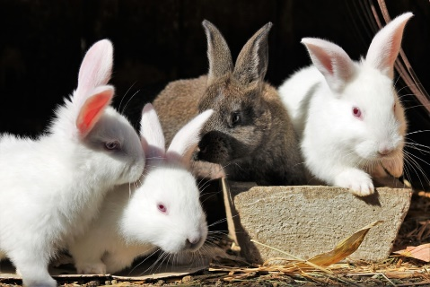

Rabbits Blog

Spring 2

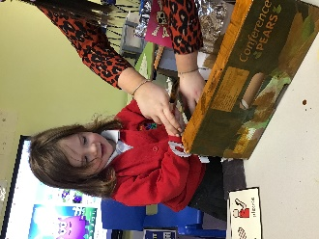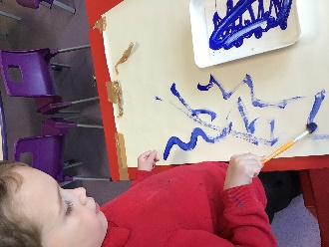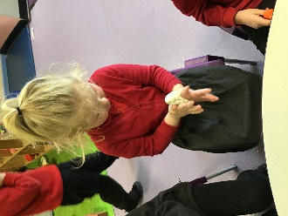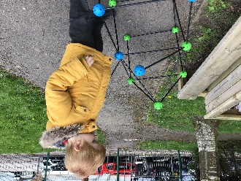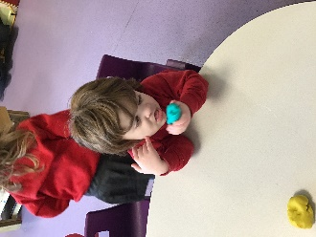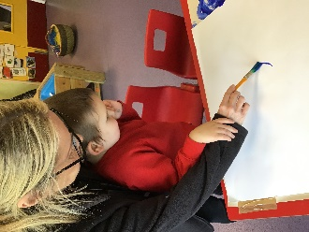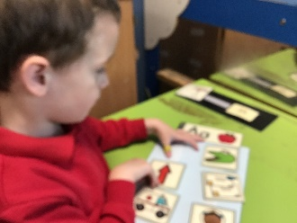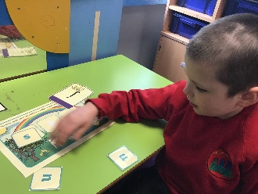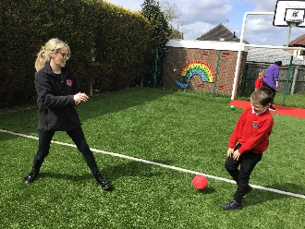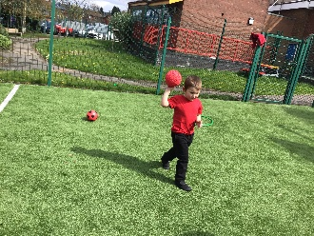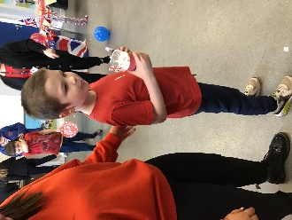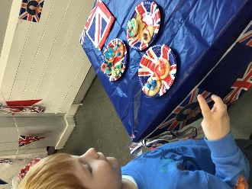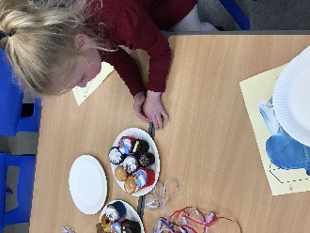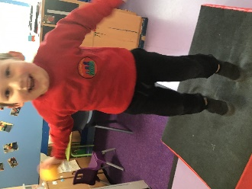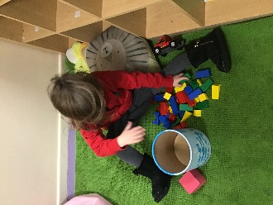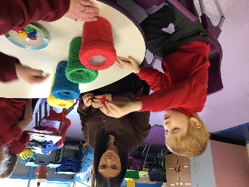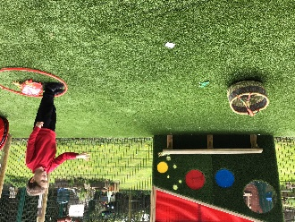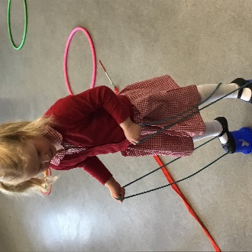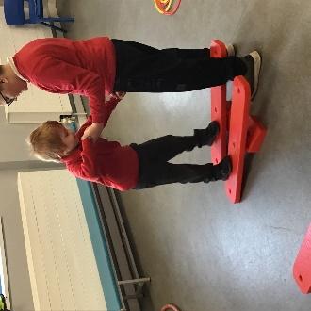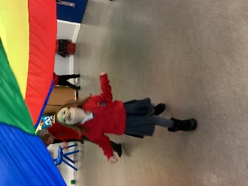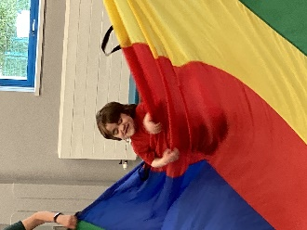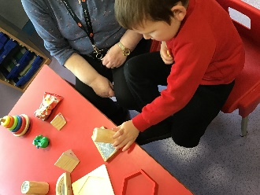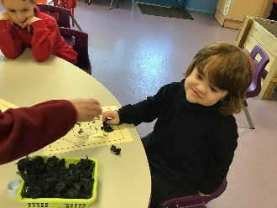

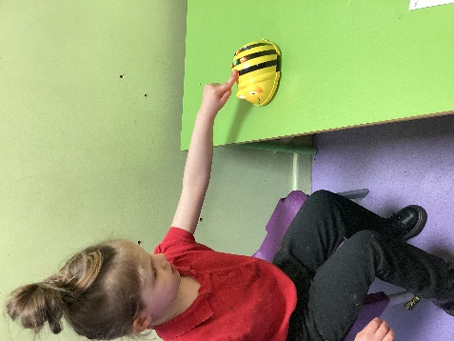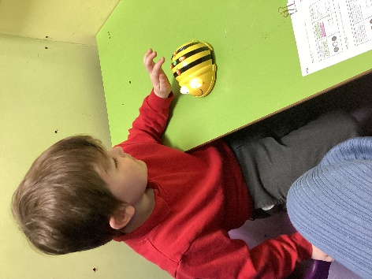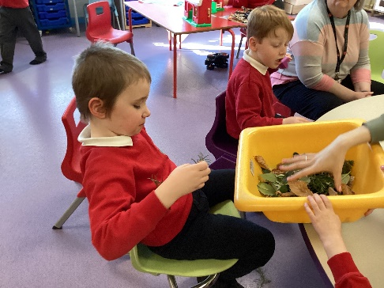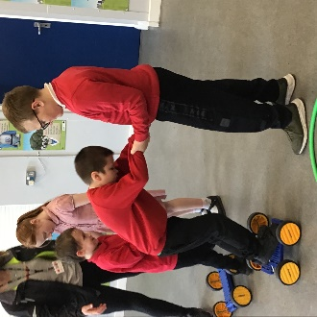

After a lovely Christmas half term break, we have returned to school happy and ready to start the new term. During this term, Rabbits staff have noticed that the children now feel comfortable within their new routines and the school itself. This has been evident through smoother transitions around the school and the beaming smiles that enter the classroom every morning!

Although it has been a short term, we seem to have packed a lot into it. Our topic ‘Down in the Garden’ has continued and we have completed lots more activities relating to this. We have been exploring the changing seasons this half term. We have been playing outside in the rain in our waterproofs, we have taken weekly pictures of the scenery to see how it has been changing and we transferred our flowers to the sensory garden to make it brighter! They were so tall that we had to use sticks to make them stronger and to stand up!

In Maths we have been looking at position and direction. We all explored the BeeBots which made us all really excited. We experimented with the different buttons which made the bees move in different directions. It was funny watching the fall off them table when they didn’t stop in time.

In P.E we have all taken part in Yoga. We have all been really good at yoga and it made us all very calm – Eve, Jayne and Sue couldn’t believe how quiet and relaxed we were! We even took the bubble machine into the hall so we could stretch up high and pop the bubbles. The floor got very slippy!

Our favourite part of this half term was making friends within the school. We have been joining up with Hedgehogs and Butterflies over dinner and in the hall. We have made lots of new friends and have met lots of different teachers who are extremely lovely!

We would like to take this opportunity to wish you all a super holiday, enjoy yourselves and don’t eat too much chocolate!

.

